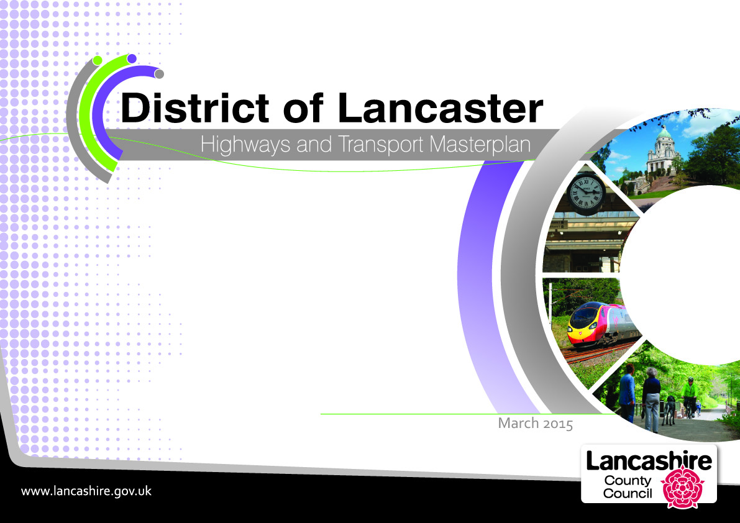

October 2016

Foreword
Lancaster's transport history is as long as it is innovative. From the first crossings of the river, to the port, to the canal with its magnificent aqueduct, to the first overhead electrified railway in the country, an early phase of the M6 with the Lancaster Bypass, and most latterly as a cycling demonstration town, Lancaster has never been afraid to take the lead.

Its history owes much to its transport links, and to its position as the lowest crossing point of the River Lune. Later the Lune brought prosperity and a golden age for the city in the 18th century as the port thrived on Atlantic trade. By the end of the 19th century, Lancaster was a world leader for linen cloth and famed for furniture and, more than anything else, lino, which gave the city its Town Hall and the Ashton Memorial.

The District's location on the edge of Morecambe Bay, the outstanding countryside of the Lune Valley, and the towns of Morecambe, with the finest promenade views in the country, and next to it Heysham, a bustling port and home to more innovation as part of the North West's Energy Coast, and Carnforth, which owes its growth to its rail and canal connections, all helped Lancaster's rapid economic growth during through the 19th and 20th century.

Now the District is ready to begin a new chapter in its history, driven by a vision and ambition which will link its key economic assets with others across Lancashire's 'Arc of Prosperity' and deliver on new opportunities for housing growth.

Key to the 'Arc' is Lancaster's offer of world class teaching, research and innovation, and its ambitions to lead the way in providing an integrated approach to healthcare and services for people who are growing older, renew and expand its city centre offer, and grow itself as an energy centre and port serving Lancashire and the wider North.

The challenge for us is to ensure that we overcome the transport issues that could come to hold back the whole district and we must act now to allow the district to grow and flourish as it once did.

What has been a substantial issue for the district will be solved with the opening of the Heysham to M6 Link, 'The Bay Gateway'. As well as giving the peninsula the direct connection to the strategic road network it so desperately needs, the completion of the link road is the lever to unlock fundamental change across the district.

But we have plans to do much, much, more. We want to build on Lancaster's past legacy and on its willingness to innovate by among other things, swapping clogged gyratories for user friendly public spaces, delivering green connections into the city and between its towns, and reinventing its relationship and connectivity to the national motorway network that has served it for more than half a century.

At its heart, the transport vision presented in this Masterplan sets out to support Lancaster as an exemplar of how a ’green’ district can also be an outstanding and sustainable success in attracting and supporting growth and development.

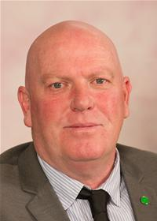
County Councillor John Fillis
Cabinet Member for Highways and Transport
Lancashire County Council

Executive Summary 1
Introduction - Lancashire's Highways and Transport Masterplans 4
Introduction – Lancaster's Masterplan 5
How consultation shaped this masterplan 6
Lancaster Now 7
Lancaster Now – People and Places 10
Lancaster Now – Transport and Travel 12
The Heysham to M6 Link Road 20
Looking To The Future 21
Looking to the Future – What are the challenges? 27
Developing Our Transport Vision 28
Our Transport Vision 29
Lancaster City Centre 31
South Lancaster 31
Morecambe 37
Heysham 41
Carnforth 42
Rural Lancaster 45
Lancaster Links 47
Ultra Low Lancaster 50
Next Steps 51
Indicative Milestones 52
Funding 54
Appendix 1: Heysham to M6 Link Road 56
Appendix 2: Glossary 57

Figure 1: The masterplan areas 4
Figure 2: Lancaster's masterplan area 7
Figure 3: Lancaster's people 10
Figure 4: Lancaster's places 11
Figure 5: Longer distance journeys 12
Figure 6: Commuting in the district of Lancaster 13
Figure 7: Our current road network 14
Figure 8: Our current sustainable transport network 15
Figure 9: Travel problems today 19
Figure 10: Traffic changes due to the completion of the Heysham to M6 Link Road (Bay Gateway). 20
Figure 11: Development and constraints 25
Figure 12: Our Transport Vision 30
Figure 13: What we need to do - Lancaster 36
Figure 14: The Morecambe Area Action Plan 37
Figure 15: What we need to do - Morecambe 38
Figure 16: What we need to do - Carnforth 42
Figure 17: Lancaster Links – Strategic Routes 49

Executive Summary
This document presents the Highways and Transport Masterplan for the District of Lancaster, setting out our vision for travel and transport to 2031 and beyond.

Lancashire County Council, as a highways and transport authority, has a Local Transport Plan (LTP3) that sets out its transport priorities. These priorities establish a commitment to support the economy and to tackle deep-seated inequalities in its people's life chances, revitalising communities and providing safe, high-quality neighbourhoods.

We have therefore produced five Highways and Transport Masterplans that reflect the county's economic areas:

- Central Lancashire, covering Preston, South Ribble and Chorley, approved in March 2013;
- East Lancashire, produced in cooperation with Blackburn with Darwen Council and covering Blackburn with Darwen, Burnley, Hyndburn, Pendle, Rossendale and Ribble Valley, approved in February 2014;
- West Lancashire, approved in October 2014;
- Fylde Coast, produced in cooperation with Blackpool Council and covering Blackpool, Fylde and Wyre, approved in July 2015; and
- Lancaster, approved in October 2016.

Collectively, these masterplans set out a cohesive highways and transport strategy for the whole county, linking economic development, spatial planning and public health priorities to the wider policy objectives of the County Council, Blackburn with Darwen Council and Blackpool Council.

Lancaster Now
Lancaster today is both a district within Lancashire and the city at its heart. The remarkable history of the city, combined with the district's location on the edge of Morecambe Bay (a RAMSAR site, internationally significant for wildfowl) and the outstanding countryside of the Lune Valley and the Forest of Bowland, helped Lancaster's economy grow rapidly in the years before 2008.

With a population of over 141,000 in 2014, the local economy now employs around 56,000. Key employment sectors include the service and knowledge-based industries, education, energy and health, with growth sectors in the low carbon economy, environmental technologies, creative and digital industries, and tourism.

Current highways and transport issues across the district include:
- Congestion in Lancaster city centre (especially around the gyratory system), Galgate and Carnforth;
- Delays to public transport, especially in Lancaster city centre;
- Barriers to pedestrian and cycle movement in Lancaster and Morecambe;
- Road Safety concerns for pedestrians and cyclists;
- Road safety concerns for children and young people;
- Environmental issues, especially relating to air quality;
- Rail connections are not as good as they should be;
- Ultra-Low Emission Vehicles are not well catered for; and
- Rural residents and businesses struggle without cars.

Looking to the future
Completion of the Heysham to M6 Link Road (now named the Bay Gateway) is one of the largest road construction projects by a local authority in England. At a cost of £128.62 million, it will directly connect the Heysham and Morecambe peninsula to a reconfigured Junction 34 of the M6. The link road is expected to open to traffic in the autumn of 2016, when it will fundamentally change traffic patterns, with huge implications for how we can realise our ambitions for transport and travel in the district.

The future development of the district is being shaped by policies and strategies being put in place now. These plans allow us to understand how economic development will be promoted and how public health will be improved. Key to Lancashire’s economic development is the Lancashire Enterprise Partnership (LEP) and the Growth Deals it negotiates with government.

A key objective of the Lancashire Growth Deal agreed with the Government in July 2014 is to maximise the value of the 'Arc of Prosperity' that sweeps across Lancashire linking key economic assets, high value business clusters, centres of research and training excellence and new housing growth opportunities. The 'Arc' encapsulates the importance of Lancaster district as a major location for economic and housing growth, underpinned by its world-class, research intensive university, a renewed city centre, and the prospect of further growth as an energy centre and port serving Lancashire and the wider North.

Whilst the Lancashire Enterprise Partnership provides the strategic vision for Lancashire’s growth, how land is used is a vital factor in how an area’s economy and people develop. Housing and other forms of development must support economic growth but also

ensure that public health and environmental considerations are taken into account and that development plans are sustainable in providing for today's needs without prejudicing those of future generations.

The key document that sets out how land-use and development will be planned for by a local authority is the Local Development Plan. This is made up of a suite of Development Plan Documents (DPD) that set out a range of planning policies and site allocations which cover the development of housing and commercial, either public or private, along with policies which seek to protect environmental and community assets. Since development should always be in accordance with the Local Development Plan, this provides the key background to the development of our highways and public transport networks.

Lancaster City Council is currently preparing a new Local Plan, key documents of which have already been adopted. Following the clear direction in the National Planning Policy Framework that local planning authorities must establish their own housing requirement by determining their objectively assessed need for housing, Lancaster City Council commissioned a Strategic Market Housing Assessment (SHMA) of the district's future housing needs. The SHMA was completed in October 2015 and recommended that there is an objectively assessed need for 13,000 to 14,000 new homes by 2031 (with a base date of 2011). This housing growth is within the context of economic potential to achieve around 9,500 new jobs over the same period.

One of the options suggested to meet this housing requirement would involve an urban extension of Lancaster to the south of the city, including land already identified at Whinney Carr. Around 3,000 new homes could be built over the next fifteen years on a very large site that, in addition to the Whinney Carr site, would comprise land to the west of the A6 opposite Lancaster University.

Lancaster City Council is exploring the possibility of developing a 'Garden Village' as an alternative to a traditional urban extension that will incorporate the existing Lancaster University campus along with the land referred to above to create a high quality residential environment integrated with the University. The Bailrigg Garden Village is expected to be included in the deposit draft Land Allocations Development Plan Document as part of the Council's new draft Local Plan to be consulted on in early 2017.

In addition, Lancaster University is in the process of refreshing its Campus Masterplan to accommodate the Health Innovation Campus and potential development to the east of the M6. Development at the University is currently restricted due to the congested nature of the surrounding road network.

The potential scale of development in South Lancaster will see a significant increase in the number of journeys, both local and longer distance, generated by the new housing and University expansion. To enable and support these transformational proposals, we have concluded that major improvements to the existing transport infrastructure that serves South Lancaster will be necessary. However, we also consider that they present an opportunity to support delivery of our proposed 'once in a generation' improvements to Lancaster's transport network, for example through a Community Infrastructure Levy. Furthermore, providing attractive alternatives to the car for local journeys could make the traffic generated by the new houses and jobs in the area potentially far less than would otherwise be the case.

Our Transport Vision
In 2031:
Lancaster city centre is vibrant and successful, with no air quality issues, no gyratory congestion and so no barriers to sustainable travel. Pedestrians and cyclists can move around easily and freely through safe and attractive public spaces. The centre is largely free of traffic and most of the vehicles that do need to be there are ultra-low emission.

Without the gyratory to contend with, public transport is also more reliable and new links to South Lancaster mean that the University has been able to expand and maintain its prestigious reputation. Those who work in the area almost all commute by sustainable modes: on foot, by cycle or using the 'Lancaster Reach' bus rapid transit services operated by ultra-low emission vehicles.

Morecambe is a revitalised town where everyone can get to where they want to go easily on foot or by bike and where the amazing promenade gives way seamlessly to an attractive and strong commercial centre. The town is now a 'must visit' attraction on the Lancashire Coast and Morecambe Bay tourist trails.

In Heysham, the old village is an attractive tourist destination now readily accessible without a car. South Heysham and the Port are a thriving focal point for industry, with the link road providing superb access to the motorway network, complemented by improved access by public transport and by cycle.
Carnforth is a hub for the north of the district, with redesigned public spaces making the centre a much more attractive place to visit. The station is now integral to the town centre and improved rail links provide easy access to jobs around Morecambe Bay and across into Yorkshire. The town is also a gateway for visitors coming to enjoy the countryside and wildlife of the area, as well as its railway heritage.

Galgate is a quiet village, no longer straddling the city's main link to the motorway.

The rail network provides high quality, fast services to and from Morecambe and rail travel around the Bay is straightforward. Many more passengers use the Bentham line as well. Public spaces around stations are now attractive and it is easy to walk and cycle to stations or to leave an electric car on charge.

The 'Lancaster Links' network for non-motorised users is now comprehensive. For those who want direct routes, the roads are much quieter and safer for cyclists on the main radial routes in the district. For those who don't want to ride on the roads, there are dedicated links for all users between the main urban centres with quiet routes linking to them.

The 'Links' network also connects the district to its neighbours to north and south through the long distance trails that bring a significant number of visitors to the district to explore the coast, the Lancaster Canal and the valley of the River Lune.

How do we make it happen?
This masterplan presents our ideas for making the city centre work more effectively for public transport users, pedestrians and cyclists in the longer term. It sets out an indicative timetable for the further work needed to finalise all our options and to consult on detailed plans. This consultation is likely to take place in late 2018 or early 2019. However, the opening of the Heysham to M6 Link Road does allow us to start the process of changing how traffic is routed around the district.

Caton Road will become the principal Gateway into the city centre for traffic from the M6, from both north and south. This will allow us to capitalise on the benefits of the link road and introduce a heavily managed environment for traffic in the city centre.

At Junction 34, we are building a Park and Ride/Cycle facility. Catering for just over 600 cars, the Park and Ride will intercept traffic coming from the motorway and from both sides of the Lune Valley. This site will open shortly after the link road.
Heavy Goods Vehicles (HGVs) are a major cause of poor air quality and add to congestion. The link road will mean that HGVs no longer need to travel through the city centre or along Caton Road and across the Lune bridges. A Movement Strategy for Heavy Goods Vehicles is being prepared and will pave the way for a series of Traffic Regulation Orders that will limit HGV movements. These will ensure that HGVs make full use of the link road and provide wider environmental benefits across the district.

We will develop the 'Lancaster Reach' bus rapid transit concept, incorporating the Park and Ride service from M6 Junction 34 to Lancaster city centre to create a 'Y'-shaped network of two routes, one linking Heysham and Morecambe to South Lancaster via the city centre, the other linking M6 Junction 34 to Lancaster University. Both routes will operate between the city centre and Lancaster University via the Royal Lancaster Infirmary, presenting us with a genuine opportunity to create a sustainable transport corridor linking the city centre and the Bailrigg Garden Village.

Before we make any substantial or long term changes to the gyratory system, we will need to be sure that those changes will work and not lead to unintended consequences. We will therefore need to do a detailed assessment and appraisal of potential options. Since the link road will fundamentally change the distribution of traffic across the district, we can only do this work once the link road is open and our approach to managing the Caton Road Gateway has been established.

Changing how the gyratory system works cannot be done without detailed consideration of a number of other factors. How public transport, including the proposed 'Lancaster Reach' bus rapid transit services, will operate through the city centre is one. How the city centre supports walking and cycling is another. We will bring all these elements together and look at them in detail in a Lancaster City Movement Study, which will give us a clear understanding of our options for transforming the city centre.

Our vision also includes the reconfiguration of M6 Junction 33 to support the significant growth potential of South Lancaster including developments such as the proposed Health Innovation Campus at Lancaster University and housing at Whinney Carr and Bailrigg. We are investigating options to relocate part of the junction further to the north to enable residents and businesses in South Lancaster to access the motorway network without having to travel through either the city centre or Galgate. The south-facing slip roads would remain where they currently are, meaning that traffic travelling between the north of Wyre district and the M6 south would not need to pass through Galgate.
The A6 corridor linking South Lancaster with Lancaster city centre will become increasingly important as housing developments and the expansion of Lancaster University begin to take effect. Delivery of housing growth in South Lancaster will be more acceptable if we can demonstrate that a reconfigured M6 Junction 33 will be accompanied by significant investment in developing attractive, sustainable alternatives to the car, particularly for local journeys and for trips between South Lancaster and Lancaster city centre.

We will therefore produce and consult on a Route Management Plan for the A6 corridor between the city centre and South Lancaster, linked to further work on developing the 'Lancaster Reach' bus rapid transit services to create a genuine sustainable transport corridor. As a first stage, we intend to reconfigure the A6/Hala Road junction to work better for vulnerable road users and provide dedicated cycling provision for the direct Lancaster to University/South Lancaster route along the A6.

In Morecambe, a Place-Shaping programme will focus on the highways and transport improvements needed to make the fundamental changes required to make the vision of the Morecambe Area Action Plan a reality.

The first strand of the programme is the seafront. The seafront is Morecambe's unique selling point and how the seafront works must reflect that. It must first and foremost be a place to enjoy the views, a place predominantly for people not vehicles. We will be working with the City Council and others to show how the promenade will be developed as a shared space

The second strand is the seafront links to the town centre, demonstrating how the town centre can be reinvigorated and become the heart of a reinvented Morecambe. We will therefore work with the City Council and other partners to develop and implement a programme of measures that will support the development of the seafront, including:

- Enhancing the town's natural gateways to give a fitting sense of arrival for all modes;
- Managing how vehicles reach the town centre, including how they are signed and where they park;
- Making parking provision fit for purpose, with high quality pedestrian and cycle links into the town centre and on to the seafront;
- Ensuring that coaches have high quality drop off/pick up points and that goods servicing is managed to ensure that it is efficient for business without compromising pedestrian routes and areas;
- Connecting the seafront and neighbouring areas to the town centre by clearly signed, attractive direct routes;
- Key routes for pedestrians and cyclists through high quality public spaces which look attractive and feel safe to be in, both during the day and in the evenings, with well-maintained and lit roads and footways that tie in to wider pedestrian and cycle routes; and
- Better facilities for public transport, both bus and rail, with proper interchange between the two and good links into the town centre and the seafront.

Morecambe's external connectivity is also vital to the place-shaping programme. Whilst road connections will be first class once the link road opens, other connections by rail, bus and cycling will not be. We will therefore commission a Morecambe Bay Connectivity Study, which will explore whether there is a strategic case for improvements to be made across all modes of sustainable transport around the coast of Morecambe Bay. Working with our partners, including Cumbria County Council, Lancaster City Council, Wyre Borough Council, South Lakeland District Council and Barrow Borough Council, we will seek to establish what evidence there is for improving connections around the Bay so that the whole Bay area benefits. The study will look at what enhanced connectivity could achieve as well as options for delivering it.

In Heysham, we need to ensure that the local network fully supports the completed link road and allows vehicles, especially HGVs, to, where possible, access the link road without travelling through our communities. We will therefore undertake a review of the highway network around the South Heysham area and put in place a programme of measures to ensure that HGV traffic is using the network appropriately and can access the link road quickly and conveniently in order to reach the M6 regardless of whether intending to travel north or south.

Like so many small rural towns, Carnforth is becoming more reliant on the visitor economy, particularly given its proximity to so many outstanding natural landscapes. However, the centre of the town around the signalised A6/B6254 junction sees very heavy traffic. It has been declared an Air Quality Management Area and is not a pleasant environment for pedestrians or cyclists. We therefore propose to pursue a programme of pedestrian and traffic improvements to the centre of Carnforth, focusing on Market Street, with a view to creating a space which, whilst allowing traffic to flow, is far more user friendly for those on foot or on cycle. As well as making the shopping area itself more attractive, it will help to ensure that people feel comfortable travelling by more sustainable modes.
We recognise there is local support for the reinstatement of the main line platforms at Carnforth station to improve connectivity to the north. This issue, along with long standing aspirations to develop better linkages between Carnforth and both Barrow and Ulverston to benefit from the economic growth potential at the proposed Sellafield (Moorside) Nuclear Power Station and at the GlaxoSmithKline site in Ulverston, will be examined as part of the Morecambe Bay Connectivity Study.

Maintaining rural connections will require an integrated approach across all modes of transport to make rural travel as sustainable as possible in the future. One of the most important questions to address is what genuine long term alternatives to conventional public transport might look like. Providing public transport to sparse rural areas is a problem in many areas of the UK, so this work will assess whether solutions from elsewhere could be applicable in the rural areas of Lancaster District.

Our 'Lancaster Links' work will develop an integrated multi-use/cycling network for the district to provide a comprehensive travel network for non-motorised travel. 'Lancaster Links' will be part of a wider Cycling and Walking Delivery Plan for Lancashire. We want the district to develop as an exemplar of active travel for the rest of county, demonstrating the widespread benefits that cycling and walking bring when they are the day to day choice for shorter journeys.

Finally, to complement our proposals for better public transport and cycling/multiuser networks, we want to make the district an exemplar of why Ultra-Low Emission Vehicles (ULEVs) must also be a core part of any local transport strategy. Whilst ULEVs may not reduce vehicle numbers, they will be vital in reducing the emissions from residual traffic in Lancaster city centre, currently an Air Quality Management Area (AQMA). ULEVs have the potential to be a major factor in improving air quality and making the city centre a healthier and more pleasant place for people. One particular option we wish to pursue is the potential use of ULEVs on the 'Lancaster Reach' bus rapid transit services.

Introduction - Lancashire's Highways and Transport Masterplans
The County Council's Local Transport Plan (LTP3) sets out our transport priorities until 2021. It establishes our commitment to support Lancashire's economy and to tackle deep-seated inequalities in people's life chances, revitalising our communities and providing safe, high-quality neighbourhoods. It commits us to finding ways to:

- Improve access into areas of economic growth and regeneration
- Provide better access to lifelong learning and employment
- Improve people's quality of life and wellbeing
- Improve the safety of our streets
- Provide safe, reliable, convenient and affordable transport alternatives to the car
- Maintain our assets and
- Reduce carbon emissions and their effects

To work towards these aims, Lancashire County Council is leading in the production of five Highways and Transport Masterplans to cover the entire county reflecting the travel areas identified in the County Council's Local Transport Plan:

- Central Lancashire, covering Preston, South Ribble and Chorley
- East Lancashire, jointly with Blackburn with Darwen Council, covering Blackburn with Darwen, Burnley, Hyndburn, Pendle, Rossendale and Ribble Valley
- West Lancashire
- Fylde Coast, jointly with Blackpool Council, covering Blackpool, Fylde and Wyre and
- Lancaster

Once completed, these masterplans will set out a cohesive highways and transport strategy for the whole county, linking economic development, spatial planning and public health priorities to the wider policy objectives of the County Council, Blackburn with Darwen Council and Blackpool Council.

Four of these masterplans have been approved and are now being delivered. A masterplan for the Central Lancashire was approved in March 2013, for East in February 2014, West Lancashire in October 2014 and for the Fylde Coast in July 2015.

This masterplan for the District of Lancaster sets out the County Council's highways and transport strategy for the district to 2031 and beyond.
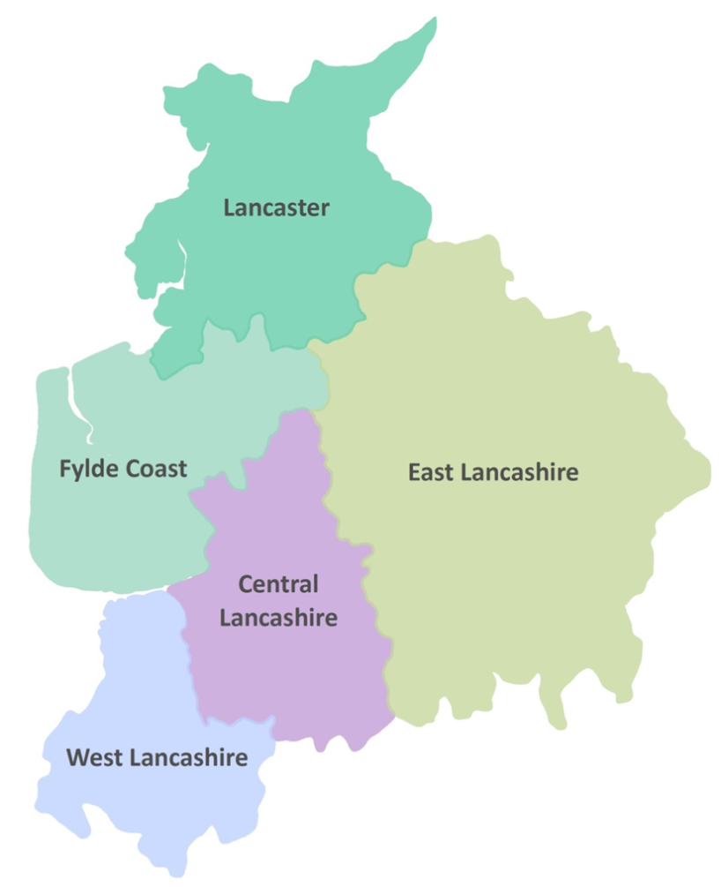

Figure 1: The masterplan areas

Introduction – Lancaster's Masterplan
This document sets out the Highways and Transport Masterplan for the district of Lancaster. Together with the technical evidence and public consultation underpinning it, it represents the County Council's considered position on the transport infrastructure required to support the delivery of development and growth in the district of Lancaster over the life of the City Council's Local Plan and beyond.

The fundamental purpose of transport is to enable economic and social activity. It allows people to get to work, to access services, to keep in touch with friends and family and visit places for leisure. It also allows businesses, suppliers and customers to come together. However, transport also impacts on people, places and the environment. Traffic congestion brings delays and disrupts communities; road accidents cause injury and suffering; vehicle emissions affect people's health and contribute to global environmental problems.

Balancing the positive and negative impacts of transport is vital in providing sustainable highways and transport networks for the future. We can only do this if we consider the consequences that changing these networks will have on the users, the people, the environment and the economy of the district of Lancashire, both now and in the future.

To do this we must take full account of other strategies that shape the county:

- The Local Plan for Lancaster District 2011 – 2031 aims to ensure that sufficient opportunities are available to meet the district’s needs for housing, economic growth, education, recreation and transport priorities whilst ensuring that local communities can flourish and the environment is protected and enhanced. Elements of Lancaster's emerging Local Plan that have been essential in the development of this masterplan are the Morecambe Area Action Plan, which was adopted in 2014, and the Land Allocations document, which will be Part A of the new Local Plan. Part A will identify the sites and opportunities needed to meet development needs up to 2031 and also protect areas of environmental, economic and social value.

- The Lancashire Enterprise Partnership is a government endorsed partnership between the private and public sectors established to provide leadership for the county's economy and be a catalyst for job creation and economic growth. The Partnership has its own agreed priorities and programmes as set out in the Lancashire Strategic Economic Plan – A Growth Deal for the Arc of Prosperity submitted to the Government in March 2014.

A significant factor in the development of this masterplan is the completion of the Heysham to M6 Link Road (Bay Gateway), which will directly connect the Heysham and Morecambe peninsula to a reconfigured Junction 34 of the M6. The link road is expected to open to traffic in autumn 2016 and will fundamentally change traffic patterns across the district, with huge implications for how we can realise our ambitions for transport and travel.

A number of complementary traffic measures are required as part of the development consent order to build the link road (see Appendix 1). These are intended to ensure that benefits of the completed link road are felt across the wider Lancaster area.

This masterplan therefore:

- Considers patterns of land use and transport use in the district of Lancaster;
- Considers the impact of future plans and priorities on our existing transport networks;
- Puts forward a vision for the district of Lancaster's highways and transport networks that supports the City Council's future aspirations; and
- Sets out the highway and transport measures that will be needed to support this vision and outlines funding mechanisms and a delivery programme.

How consultation shaped this masterplan
The consultation on the draft District of Lancaster Highways and Transport Masterplan took place in spring 2015. Views were sought from District Councils, Members, Stakeholders, District and Parish Councils and members of the public.

We received 100 written responses to the consultation and although these cannot be taken as necessarily representative of the views of the people of Lancaster district as a whole, many of the comments and concerns raised have provided detailed information as well as suggesting solutions to the transport problems of the area.

We have taken on board many of the views and ideas we have received and revised the masterplan to reflect this. As progress is made towards projects and strategies, there will be opportunities for public engagement to discuss the best way to make sure the actions that come forward from this masterplan are as effective as we can make them.

The consultation draft of this document outlined three options for how we could approach the transport problems and opportunities of the district over the next 15 years:

Option 1 – Do only what we need to
Option 2 – Improve what we have
Option 3 – Improve and extend

From the responses we received, people were most likely to agree with Option 3 – Improve and extend (74% agreed) and most likely to disagree with Option 1 – Do only what we need to (78% disagreed). Overall there was a clear message about the need for change. The masterplan takes forward elements of the two options for change; to extend our network but also to improve what already exists.

The points raised by the consultation responses fall into the following topic areas:

Lancaster City Centre
There was general agreement that a solution needs to be found to the congestion of the gyratory system which contributes to poor air quality, delayed journey times and an unattractive environment around the city for pedestrians and cyclists, visitors and residents.

There was concern, however, that too much restriction of traffic in the city centre would cause difficulties for businesses and residents. This was felt to be a particular problem for the area west of the centre around Luneside, but also for residents whose daily journeys to employment or education takes them between Morecambe/Heysham and the Universities/South Lancaster or vice versa. Some respondents were concerned that drivers would seek unsuitable alternative routes to avoid longer journeys using the M6. Several respondents suggested that an additional bridge over the River Lune would help to keep traffic moving.

South Lancaster
There was call for changes to transport networks in South Lancaster to ensure capacity is provided to cater for both increased road traffic and demand for safe, sustainable travel options generated by current and potential development of land at Lancaster University and to the south of the city.

Around two-thirds of respondents agreed with our proposals to make changes to Junction 33 of the M6, which would remove significant levels of traffic from the centre of Galgate. There was concern, however, that relocation of the junction would disadvantage residents of the area south of Galgate. A number of respondents acknowledged this issue and offered potential solutions.

Heysham to Lancaster Corridor
Measures to improve journey times into Lancaster were welcomed by respondents. There was support for a rapid transit service, but some concern about how this would impact on congestion on Morecambe Road.

Most respondents agreed on the need for better public transport connectivity around Morecambe Bay, with calls for electrification of the Morecambe line, as well as for improved passenger services and facilities for both rail and bus passengers. The need for safe cycling routes between Heysham and Lancaster was highlighted.

Morecambe
There was support for proposals to integrate the promenade with Morecambe town centre, as well removing traffic from the promenade, providing access for deliveries and servicing of businesses would be maintained.

In addition to the bus and rail issues mentioned above, parking for cars and coaches in Morecambe was a concern raised by some respondents.

Caton Road Gateway
Around two-thirds of respondents agreed with our intention to make Caton Road the principal gateway into the city for traffic from the M6, from both north and south.
Whilst a Park and Ride at Junction 34 was welcomed, it was emphasised that this must be priced realistically, offer regular services and incorporate bus priority measures along Caton Road.

Carnforth
Improvements to rail services to enhance links to Cumbria and Yorkshire were a major theme of responses, with calls for integration of bus, train and cycle facilities. There was also support for relief of congestion on the A6 and changes to the town centre to make the environment safer and more attractive to pedestrians. There were suggestions that the value of Carnforth's railway and canal heritage should be recognised, with greater emphasis on the Lancaster Canal as a traffic free route for pedestrians and cyclists.

Rural access
There was concern about the provision of bus services and connectivity with rail services in the rural areas. Sustainable travel within the Areas of Outstanding Natural Beauty and to visitor attractions was highlighted, together with concern about traffic using narrow rural roads. Support was given for improving links beyond the county boundaries, including promotion of the Bentham rail line.

Lancaster Now
The name 'Lancaster' is one of the most significant in British history. The Duchy of Lancaster (a title held by the reigning monarch) dates from the 14th century. Names such as John O'Gaunt, the second Duke, are still famous today, as are the Wars of the Roses, fought by the houses of Lancaster and York for the throne.

Lancaster today is both the district within Lancashire and the city at its heart. The remarkable history of the city, combined with the district's location on the edge of Morecambe Bay (a RAMSAR site, internationally significant for wildfowl) and the outstanding countryside of the Lune Valley and the Forest of Bowland, helped the district's economy grow rapidly in the years before 2008.

With a population of over 141,000 in 2014, the local economy now employs around 56,000. Key employment sectors include the service and knowledge-based industries, education, energy and health, with growth sectors in the low carbon economy, environmental technologies, creative and digital industries, and tourism.

The district is effectively split by the M6 with the population mostly to the west of the motorway, in the City of Lancaster, the towns of Morecambe and Carnforth and villages such as Heysham, Bolton-le-Sands and Galgate.

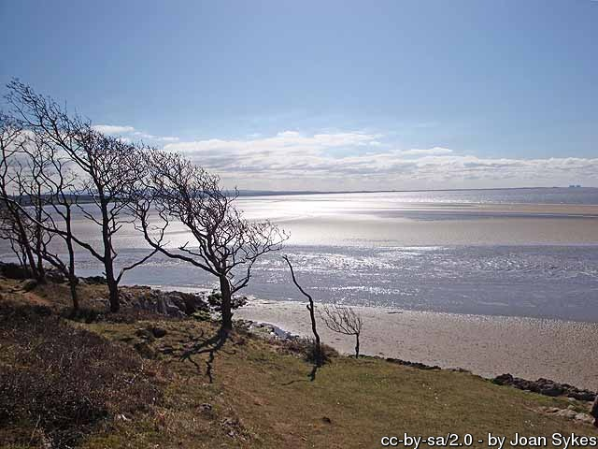

Figure 2: Lancaster's masterplan area
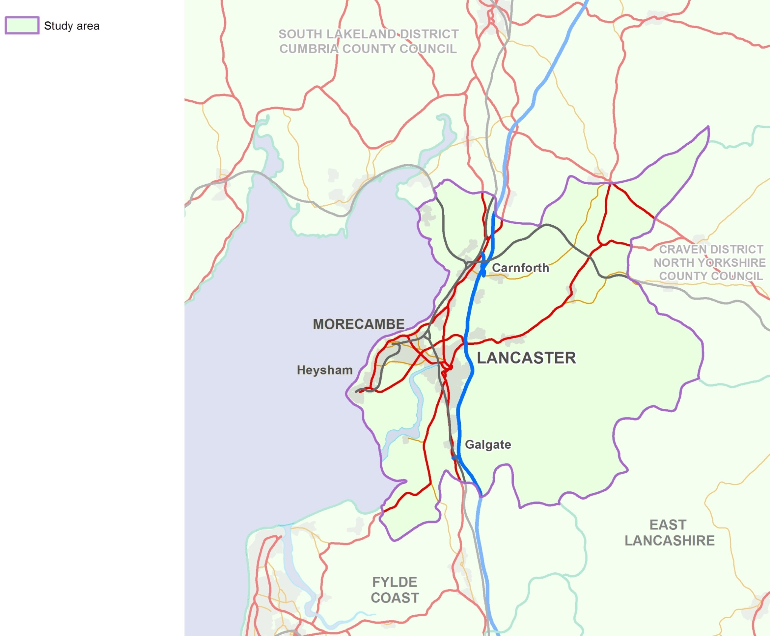
City of Lancaster
Lancaster is one of the country's most important heritage cities. Its outstanding historic environment results from its strategic location on England's north west coast.

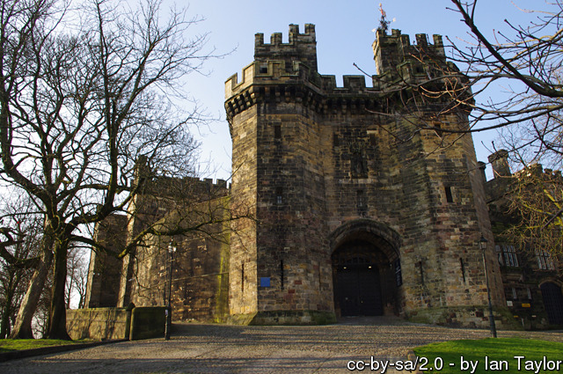
Once a Roman fort, Lancaster was an important medieval town, with a castle and priory. The Georgian era saw the success of the port on the Lune at St Georges Quay. As the third most important port in the country, it generated the wealth to build the old Custom House and the dwellings and warehouses that survive on the quayside and throughout the city today.

The Lancaster Canal skirts the city centre, then crosses the Lune on a magnificent aqueduct. Lancaster in the 19th century was a centre for architectural and decorative arts and this is reflected in its buildings.

Lancaster is home to a wide variety of businesses, although the public and service sectors dominate. The city is the administrative centre of the district and is home to the Royal Lancaster Infirmary, the Morecambe Bay area's main hospital and to the Lancaster campus of the University of Cumbria.

Lancaster University and the University of Cumbria's Lancaster Campus are young institutions – both were 50 years old in 2014. Whilst the University of Cumbria's Lancaster Campus is a leader in the training of education and health professionals, Lancaster University is now one of the country's top teaching and research institutes. In the top 1% of global universities, the purpose-built campus occupies Bailrigg, a 360-acre site donated by Lancaster City Council in 1963.
Morecambe
Morecambe sits on the shores of the bay from which the town takes its name. Unlike Lancaster, the town of Morecambe only officially came into being in the late nineteenth century.

Morecambe has had a long association with entertainment. It was a thriving seaside resort in the mid-20th century, attracting visitors from Yorkshire in particular thanks to historical connections through the railway that brought Morecambe into being. However, by the late 1970s the resort was declining and in the following 20 years the resort's main attractions all closed. Morecambe's tourism offer now is very much focussed on day trips.
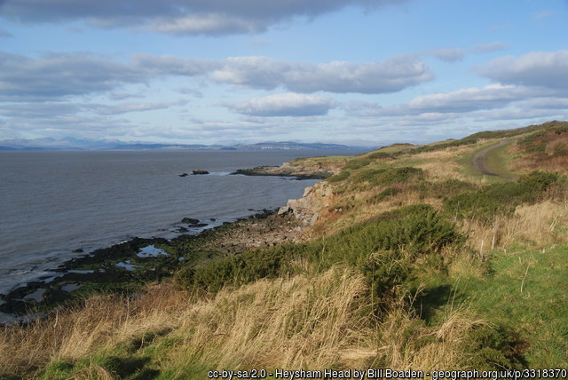

Since the 1990s, Morecambe has been the focus of concerted efforts to regenerate the area. Perhaps the best known of these projects is the iconic Midland Hotel, a spectacular example of Art Deco architecture, which after years of decline was restored at a cost of £7million and reopened in 2008 to international acclaim. However, the town centre has lost much of its function.

Employment in Morecambe is based on a limited service sector and there are relatively high numbers of economically inactive people, a low wage economy and many households facing hardship.

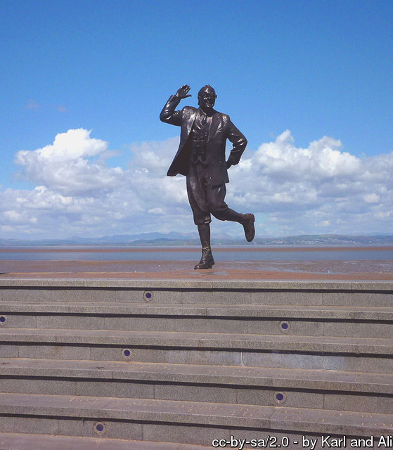
Heysham
The village of Heysham is an ancient settlement and still has many stone-built cottages dating back to the 17th century. The National Trust property at Heysham Head includes the only sea cliffs between Cumbria and North Wales, and on it are the ruins of St. Patrick’s Chapel, dating from about the 8th century, and two sets of rock cut tombs. The open space of the headland contrasts with the narrow streets of the historic centre of Heysham, and to the south are the distinctive buildings of two nuclear power stations.
The Port of Heysham, part of the Peel Ports Group, is a key gateway for trade between Great Britain and Ireland. It supports the UK, Irish & Isle of Man economies by enabling trade within the Irish Sea with a growing number of ferry services to Dublin, Belfast, Warrenpoint and the Isle of Man.

The port handles all kinds of cargo and services, from renewable energy to Ro-Ro (roll on – roll off) and has a growing number of daily freight ferry services to Ireland and the Isle of Man. Whilst tonnage has declined slightly during the recession, completion of the Heysham to M6 Link Road (Bay Gateway) will make the port's connections to the strategic road network all the more attractive.

The port also forms a major offshore supply base for one of the largest gas fields in British waters and is ideally located as a support base for the future offshore wind farm development in the Irish Sea.

Carnforth
The small market town of Carnforth serves the north of Lancaster district and south Cumbria. Although now at the heart of a largely rural area, the town owes its size to the railways and to iron and steel working. It still provides an essential role as a local service centre.
Carnforth attracts visitors by its location close to the coast and limestone country, but it is the railway that gives Carnforth its biggest claim to fame. In 1945, Carnforth railway station was used as a set for the David Lean film 'Brief Encounter', starring Celia Johnson and Trevor Howard. Fans of this film were one of the major factors in the refurbishment of the railway station, including the refreshment room run by the Carnforth Station Trust which was constructed to match the studio set used in the film. The railway infrastructure concentrated around the station is also of important heritage interest.

The Lancaster Canal links Carnforth to Lancaster through Bolton-le-Sands and Hest Bank and leads north towards Kendal.

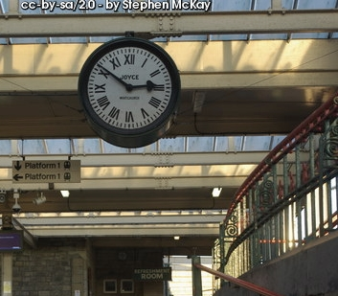
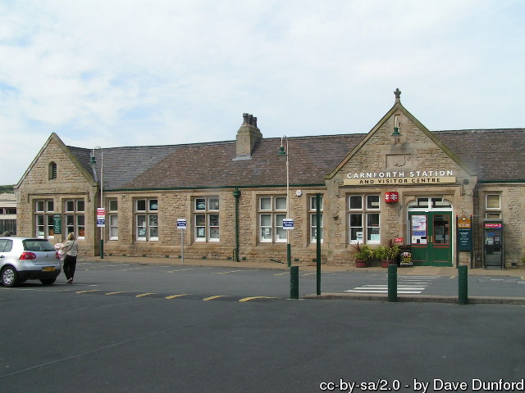
Rural Lancaster
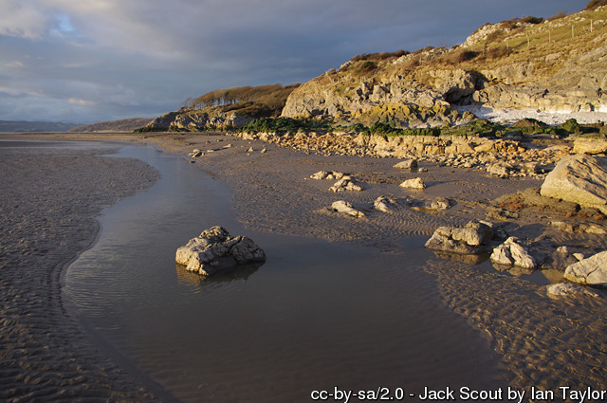
The district of Lancaster is largely rural, with the most spectacular and varied landscape in Lancashire wrapped around the urban core of the district.

In the north west of the district, the Arnside and Silverdale Area of Outstanding Natural Beauty (AONB) is a limestone landscape with ancient woodlands and a rich and dramatic coastline.

The Forest of Bowland AONB to the south east of the district is a landscape of deeply incised upland fells of gritstone with vast sweeping peat covered moorlands. 'Cloughs', steep sided, wooded valleys, link these upland landscapes to the richer farmed foothills.
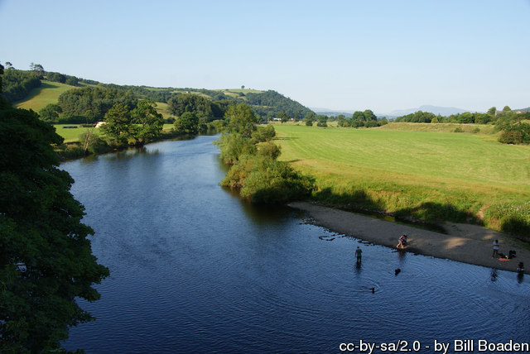
Between the two, lies the Lune Valley, with rich pastures and old stone villages such as Hornby, Arkholme and Wennington, whilst to the south west are the coastal plains and mosslands of Cockerham and Glasson Dock.

This rural area provides a significant input towards the local economy through tourism and farming and is home to some significant industries such as minerals working.

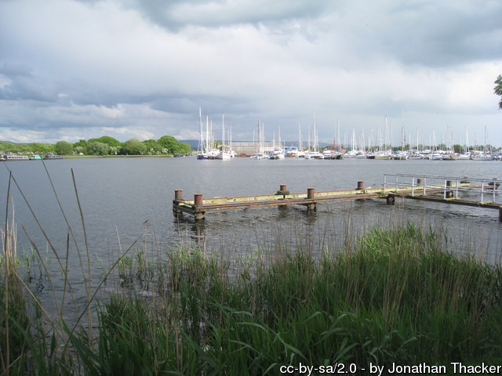

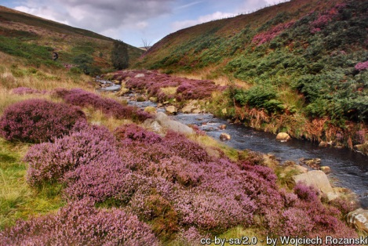

Lancaster Now – People and Places

People
As would be expected, the two universities are a dominant influence on the district. But this influence on district wide numbers conceals significant social issues in parts of the area.

Looking at statistics for the district as a whole, in 2011 almost 10% of residents were aged between 18 and 22, over 40% higher than the proportion for Lancashire as a whole and also the North West. The almost 16,000 young people in this age group, including students, therefore bias information presented on a district level.

Compared to the average for England and Wales, the district of Lancaster has a lower than expected proportion of the population without qualifications. However, although large numbers of undergraduates arrive, they don't necessarily stay once they have gained their degrees.

Economic activity figures indicate that the district has a lower proportion of the working age population economically active than other districts; however, student numbers again distort the true picture, accounting for over 10% of economically inactive residents.

Employment in the district is mostly in public administration, health and education, with over 38% (in 2014) working in the sector compared to just under 28% in the North West. The service sector, particularly accommodation/ food and transport/logistics, also accounts for more jobs than typical, whilst manufacturing has fewer than half the jobs of Lancashire as a whole.

For those residents who work, median earnings are lower than in Lancashire as a whole, with gross pay in 2015 averaging £383.30 per week in the district compared to £391.50 across the county and a UK wide figure of over £425.

Deprivation across the district is lower than average, although around 4,100 children live in poverty. The district contains small areas with some of the worst deprivation in the country, including three in the worst 1% and a further six in the worst 5%. These areas are in the north of the City of Lancaster and the centre of Morecambe. In these areas, life expectancy is around 9.9 years less for men and 8.8 years less for women than in the most affluent parts of the district.

Figure 3 shows how the population is spread across the area, as recorded in 2011 Census, with the M6 marking a clear boundary between the mainly urban west of the district and the rural east.

What is not shown on the map are the small settlements that are scattered across the rural areas. These communities have only a very limited impact on overall travel patterns because, individually, the numbers of journeys are small. However, their needs are still an essential consideration for this masterplan.
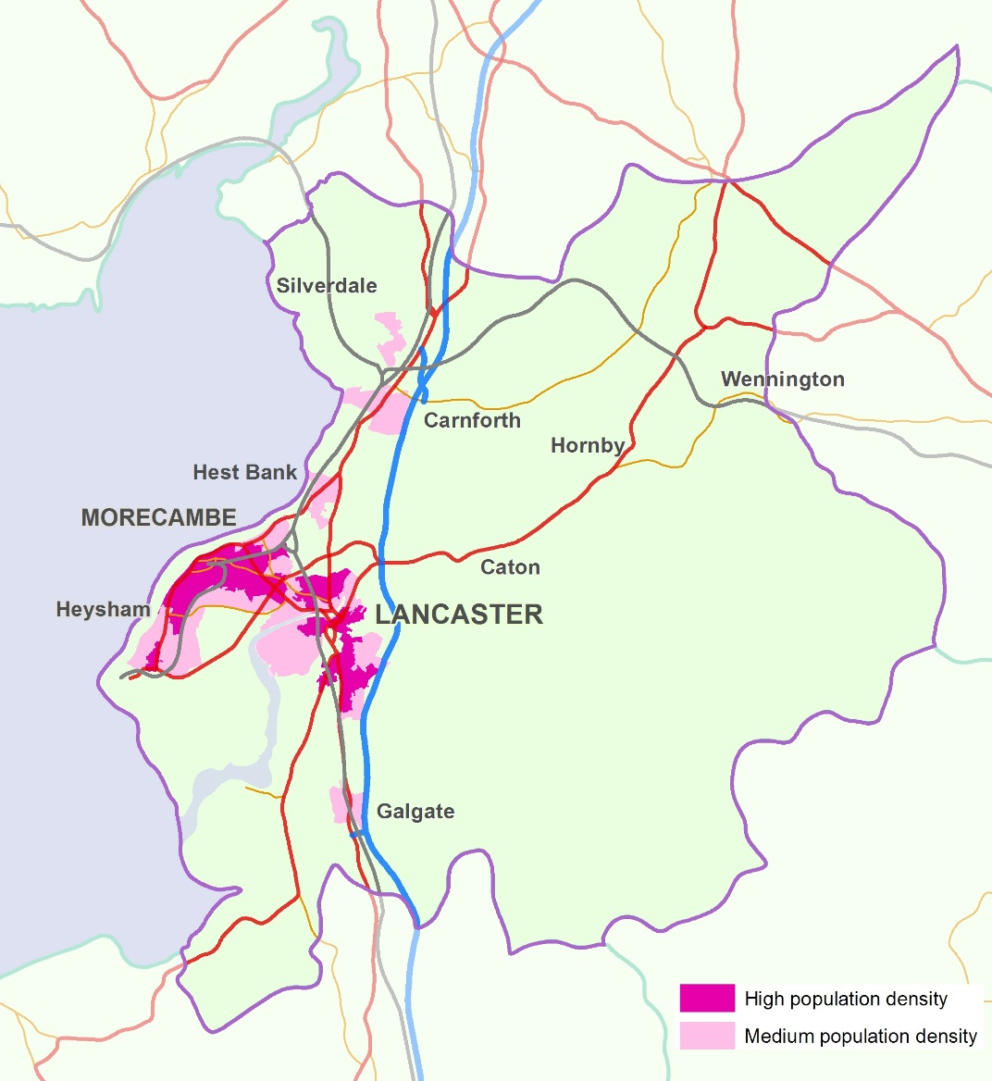

Figure 3: Lancaster's people

Places
Where people live determines where many journeys start and end, so the more people in an area, the greater the demand on the network. This is particularly true of commuting, which currently places by far the biggest strain on our transport systems as many workers try to travel in a relatively short period of a few hours in the morning and early evening.

The next major influence on our transport systems is the places that people want to travel to.

Certain destinations attract a lot of people, whether through choice, such as for leisure and shopping or through necessity, such as for health or education. As well as acting as destinations for visitors, these locations often have large numbers of workers and therefore have a major impact on commuting.

Town and city centres are traditionally a focus for employment and shopping. Lancaster though has a significant heritage offer and therefore is particularly attractive to visitors. The city centre is also home to one of the universities and to the hospital, meaning that large numbers of people travel in and out on a daily basis. Lancaster University to the south of the city again draws in significant numbers of students, staff and visitors.

Major employment areas include White Lund, White Cross and around the power station at Heysham. Heysham also sees significant traffic to and from the port, much of that being heavy vehicles.

Figure 4 shows the places that large numbers of people and vehicles travel to and from. Together, people and places shape the demand for travel in, to and from the district of Lancaster.

Figure 4: Lancaster's places

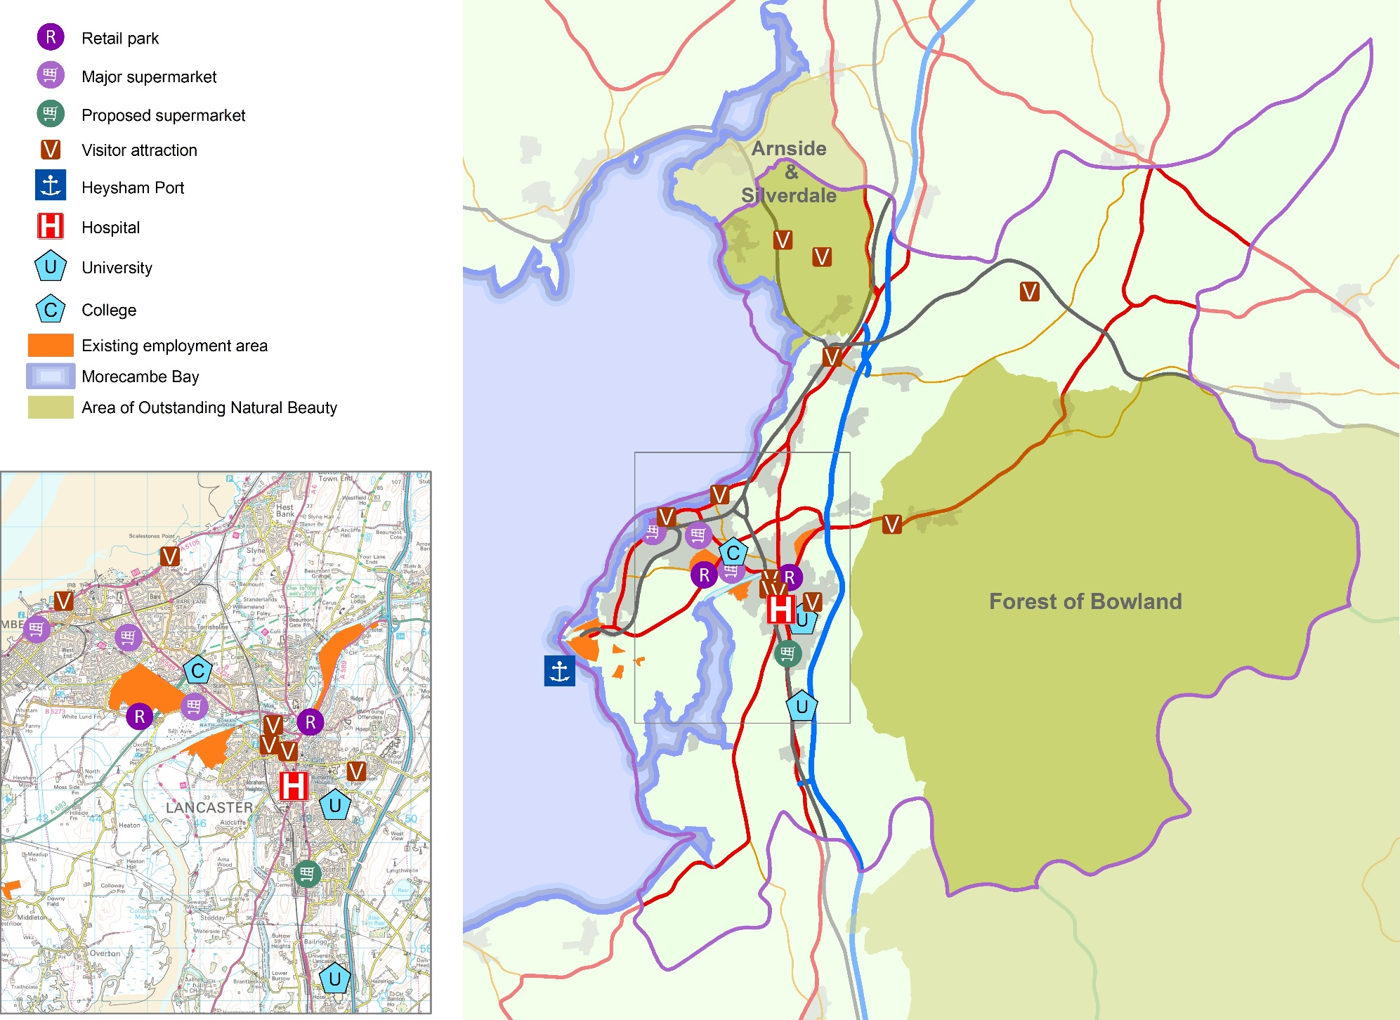

Lancaster Now – Transport and Travel

Travel Patterns - Longer distances
The district of Lancaster lies within the nationally significant north-south transport corridor that includes the West Coast Main Line railway and the M6. This provides excellent connectivity with other parts of the UK, including London, the West Midlands and Scotland.

By train…

The district already benefits from fast and frequent train services to London, Birmingham, Manchester, Manchester Airport, Glasgow and Edinburgh, and the impending electrification of the lines between Manchester and Preston via Wigan and Bolton will improve this strategic connectivity further.

Other lines link the district to Barrow, the South Lakes and to North Yorkshire and Leeds.

By road…

The M6 runs from north to south through the district and has three junctions, one to the south of the city, one to the east and one near Carnforth. The A6 parallels the motorway whilst the A682 runs through the Lune Valley to provide connections to North Yorkshire and the A65.

By ferry…

The Port of Heysham provides a significant link, particularly for freight, to Northern Ireland, the Republic of Ireland and the Isle of Man, with daily ferry services.

Figure 5: Longer distance journeys
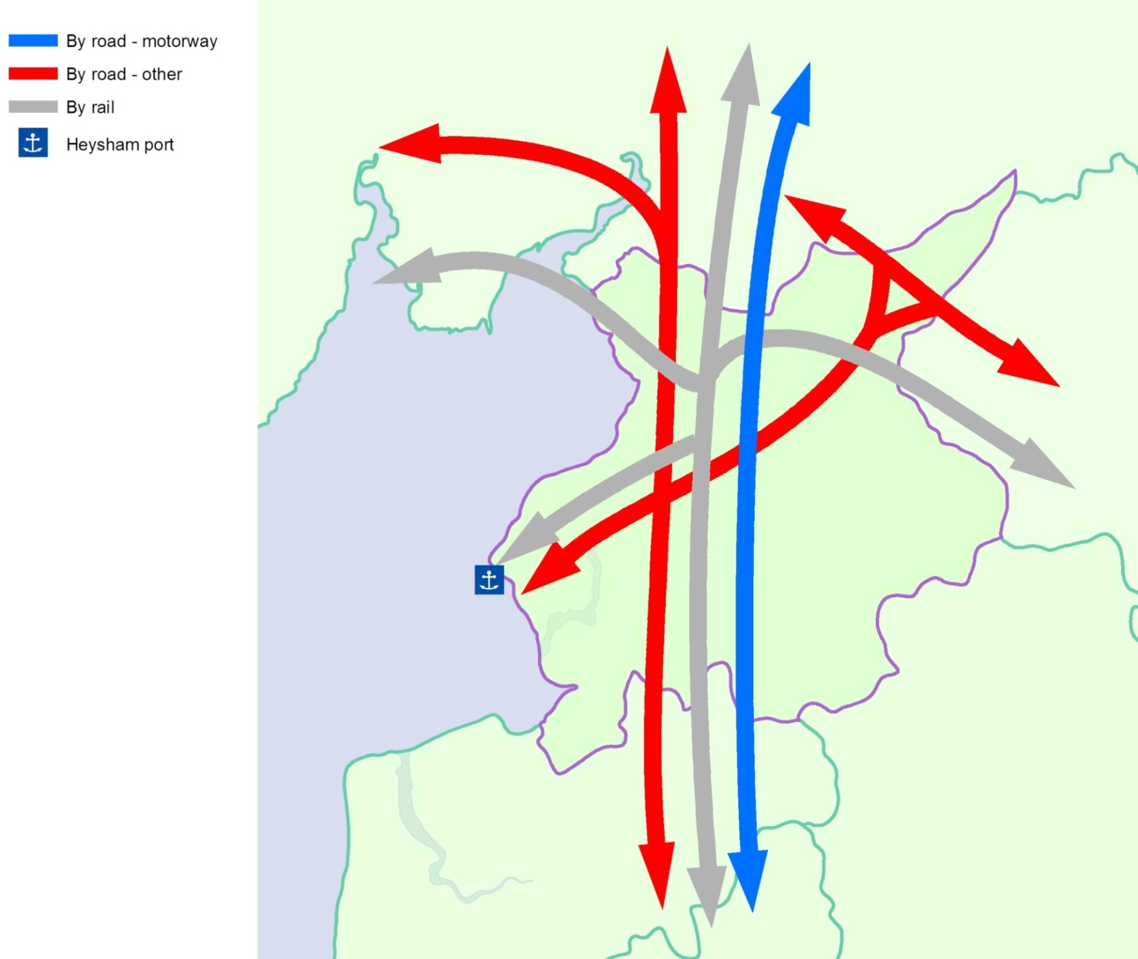

Travel Patterns – Daily journeys
Information on where people live and need to travel to, together with an understanding of the longer distance journeys in the area, provides a basis to understanding the main journey patterns in the district.

Journeys are made for many purposes, but the purpose that dominates the busiest times of the working week is the journey from home to work. This is also the journey type about which most information exists as questions about travel to work were asked in the 2011 National Census.

The major journey to work movements by Lancaster's residents and workers are shown in Figure 6.

The biggest external flows are between the district and South Lakeland, which has always been the case historically. However, the districts to the south, especially Preston and Wyre are becoming more important. Lancaster is a net exporter of labour, with almost 4,000 residents leaving the district to work elsewhere every day, making these longer distance connections particularly important.

The majority of residents still choose to work in the district however. Lancaster is Lancashire's most self-contained labour market with nearly 80% of locally employed residents living and working in the area.

These commuter movements take place in the context of a highway network that has reached or is reaching capacity in a number of places but where sustainable modes are becoming an ever more viable option for some journeys.

Figure 6: Commuting in the district of Lancaster

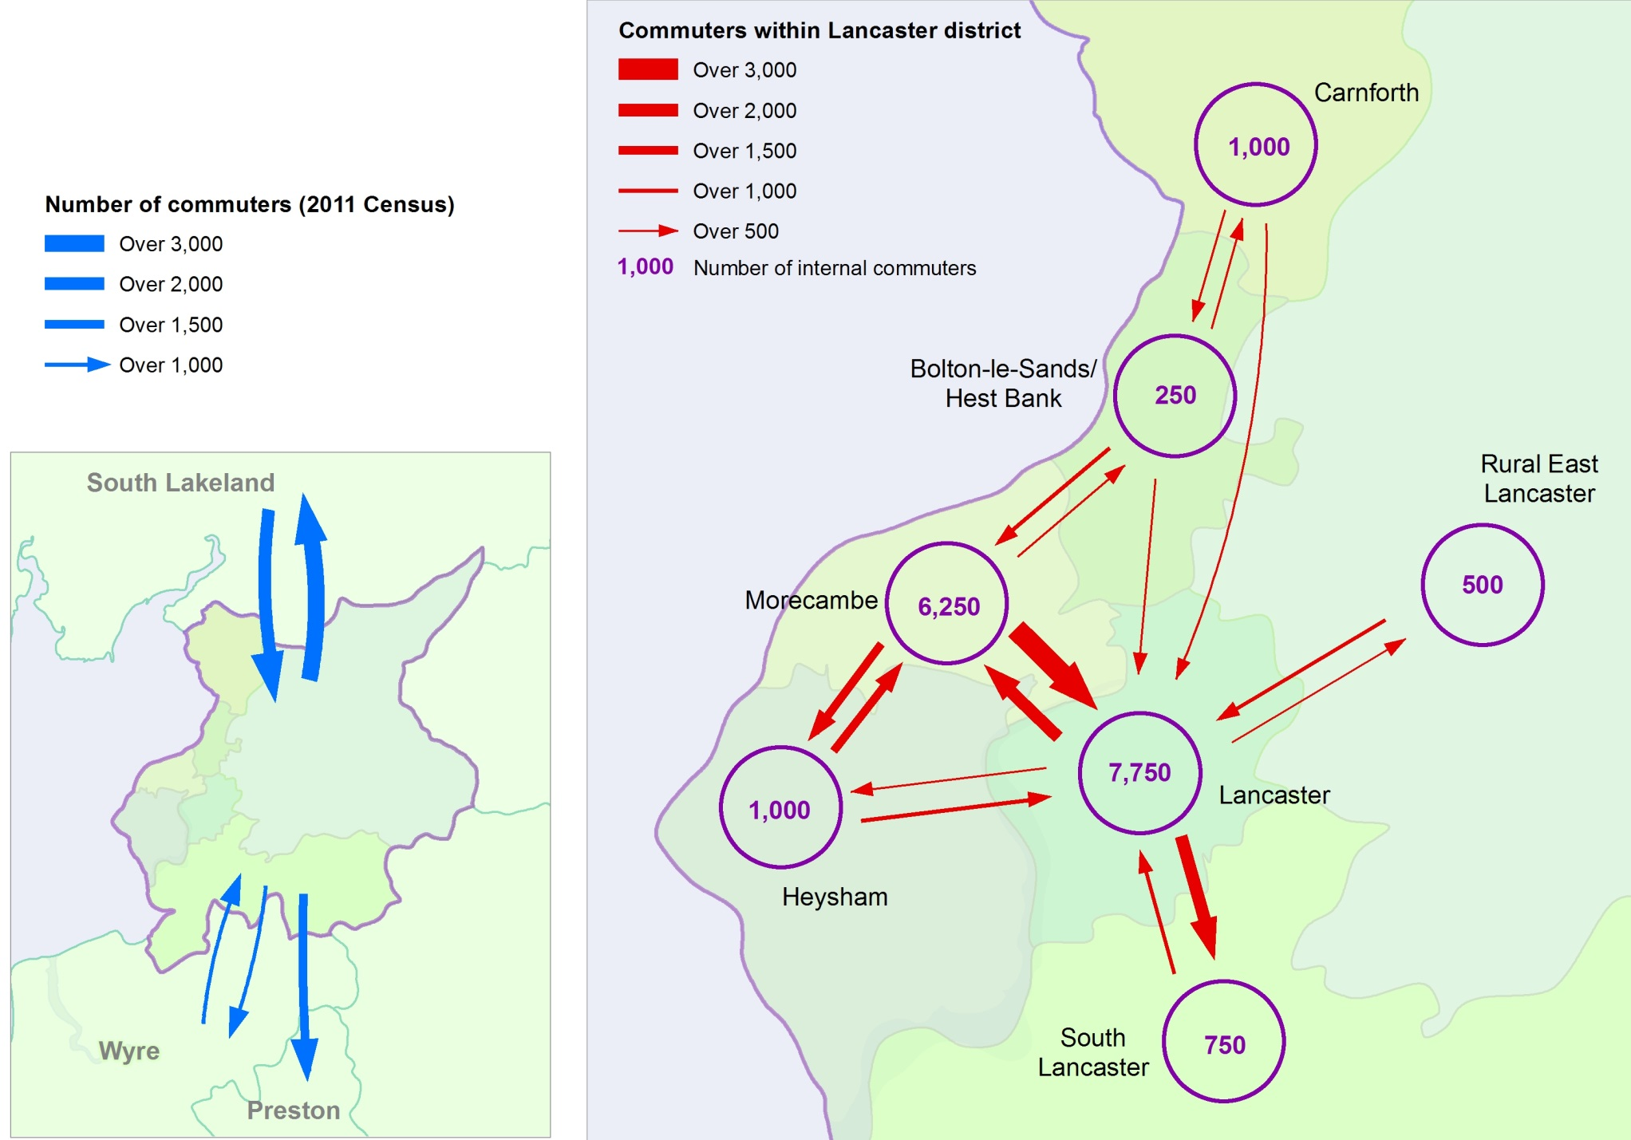

How we travel today
Having looked at where people are travelling to and from, what impact do these journeys have?

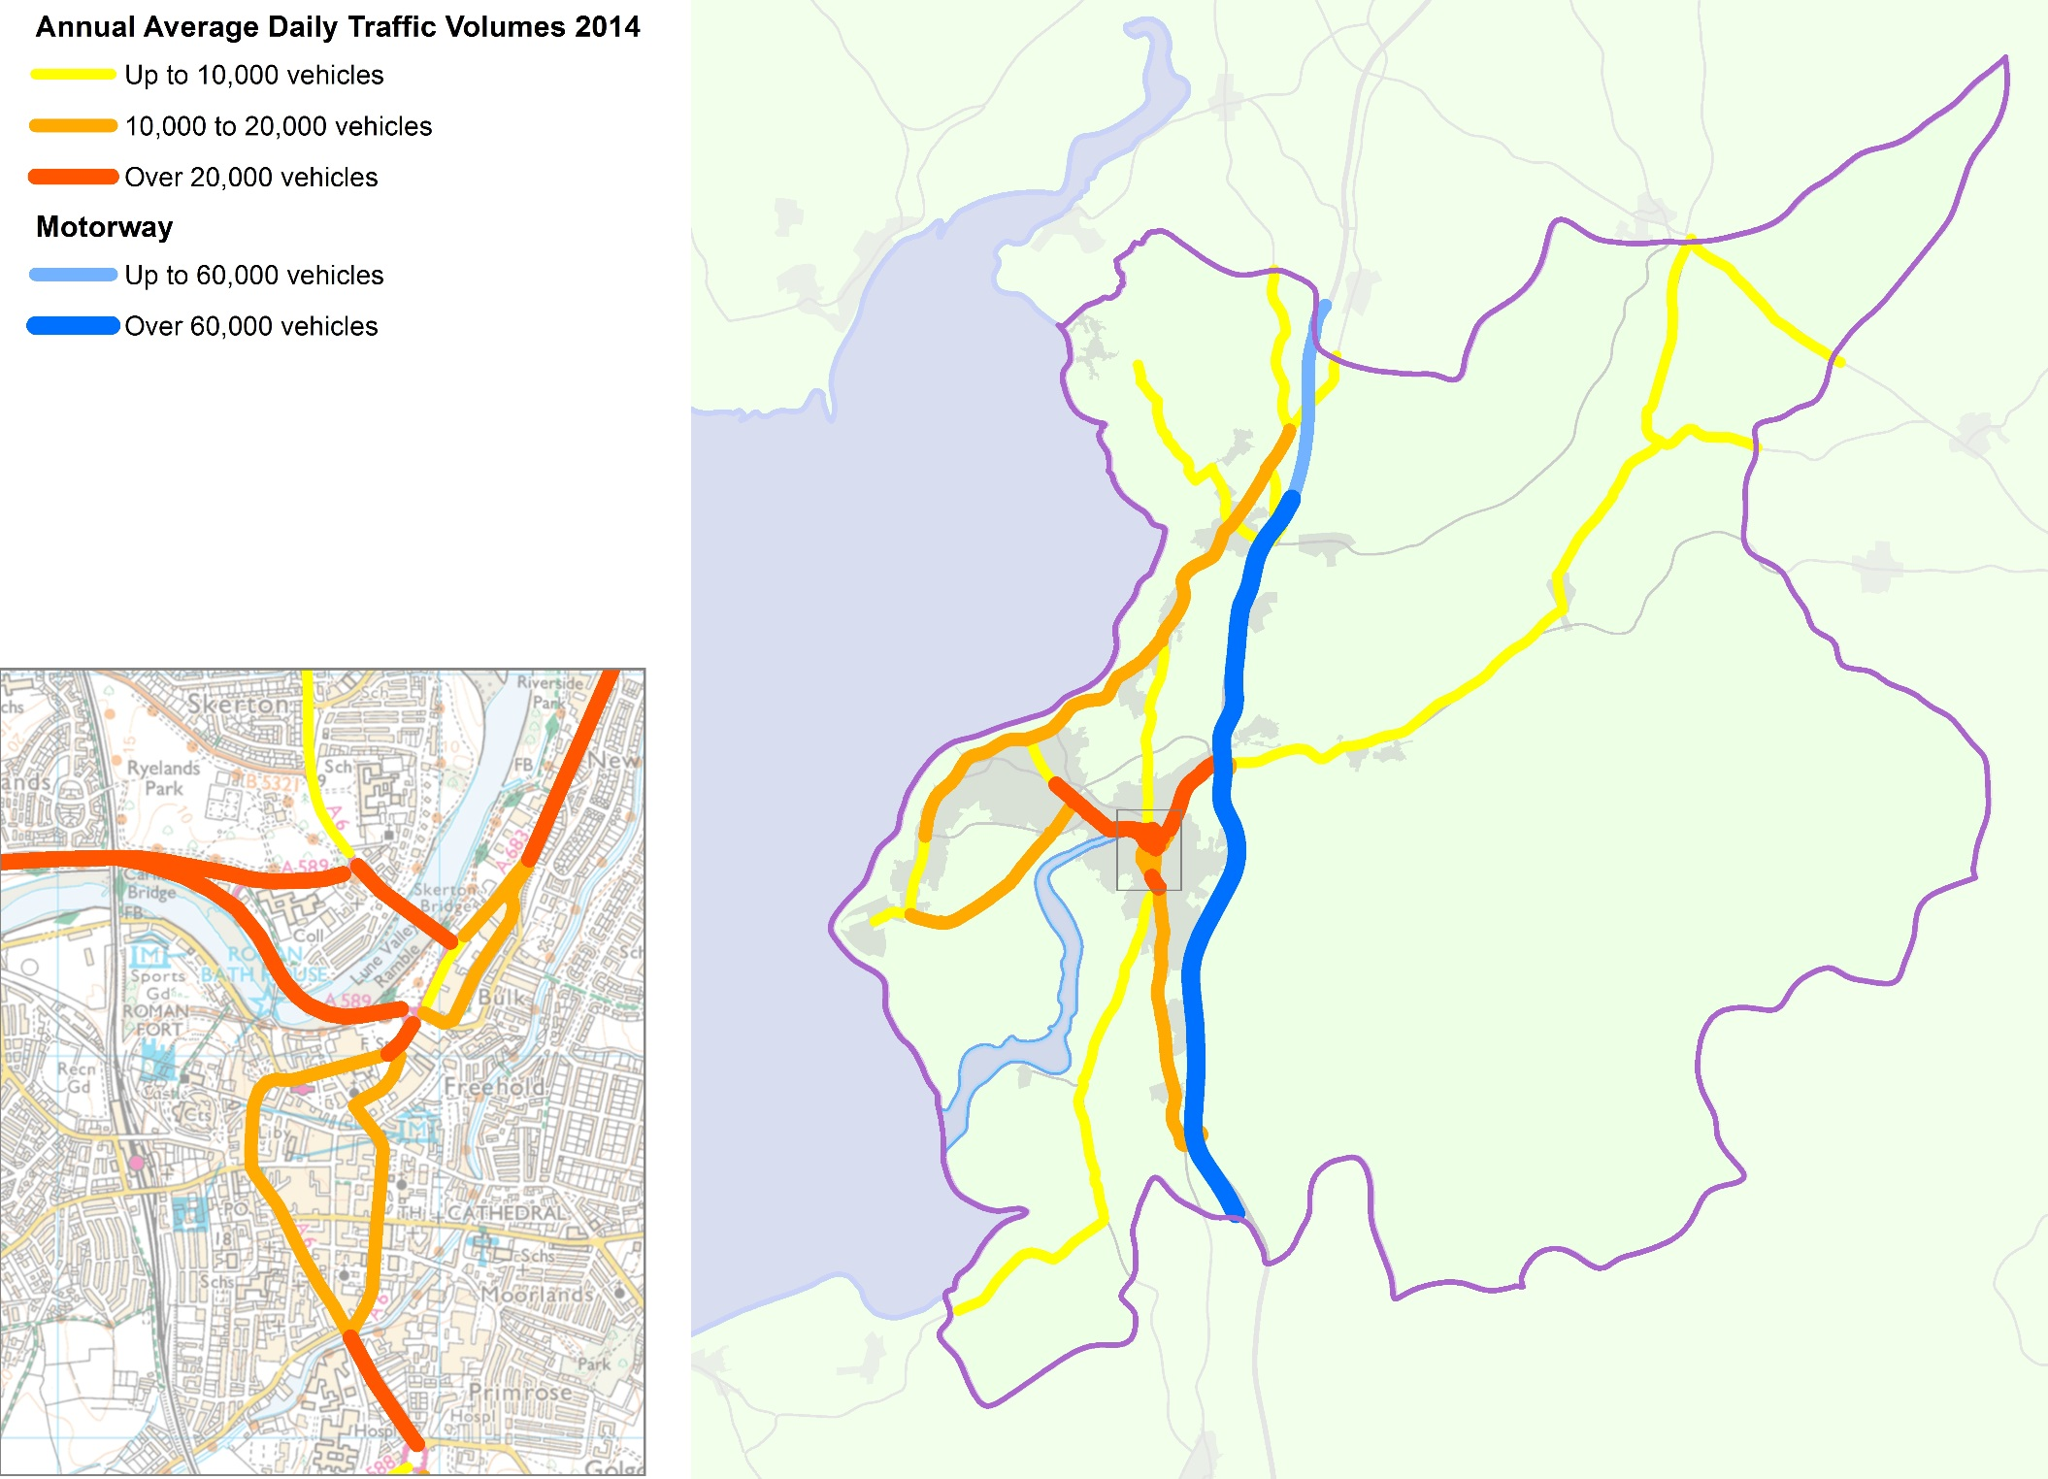
The car is the dominant travel choice for most people for most journeys for many reasons. Across the district as a whole, 75% of households have a car or van available, although this masks areas of particularly low car ownership in Morecambe and parts of the City of Lancaster.

The most obvious effect of these choices on our roads is the amount of traffic those roads carry, not just in the peak hours but through the whole day. Figure 7 shows the number of motorised vehicles that use our major roads during a typical day.

The Port of Heysham also affects traffic. With an increasing amount of freight shipping across the Irish Sea, as well as movements associated with the port's role as an offshore supply base for the energy sector, the number of lorries going to and from the port each day is increasing. With the nature of 'just in time' logistics, the arrival and departure of these vehicles tends to coincide with ship movements, meaning that there are distinct peaks through the day and night.

Figure 7: Our current road network

The previous map shows the volume of traffic on our major roads. This traffic of course includes buses, which suffer the same delays as other road users unless there are bus priority measures in place, such as dedicated bus lanes etc. Bicycles may not be counted in the traffic totals, but cyclists also have to share this road space unless they have dedicated cycle provision.

Figure 8 shows the main sustainable transport provision in Lancaster.

Not surprisingly, the busiest rail station is Lancaster, providing as it does the only station served by the West Coast Main Line. Looking at 2014/15 figures, Lancaster saw over 2 million people travelling from or to the station, up by over 50% in the last 10 years, with an additional 340,000 passengers using the station as an interchange. Other stations in the district saw far smaller numbers of travellers. Morecambe, Carnforth and Bare Lane had around 10% of the users of Lancaster. Wennington saw the lowest passengers with fewer than 3,500 and Heysham Harbour saw 9,600 travellers in the year. Usage of all stations in the district has grown over the last 10 years, with Silverdale seeing an increase in travellers of over 75%. Carnforth was the only station to see a small decrease in passengers between 2013/14 and 2014/15, of 1.2%.

Bus services within the urban areas are extensive, with a single operator responsible for the majority of services (Stagecoach Northwest). Services link the four primary locations of Lancaster, Morecambe, Heysham and South Lancaster (including Lancaster University). There are also frequent services from Lancaster to Preston and Blackpool, and to Carnforth and onward into Cumbria and the Lake District.

Lancaster district has seen a significant increase in cycling over the last 10 years, the main driver being the City of Lancaster and Morecambe's status as a Cycling Demonstration Town (CDT) between 2005 and 2011. During this period, cycle use across the district rose by 25% whilst accidents to cyclists declined by 25%. Although this raised cycling levels above the national average, due to the high proportion of the population who both work and live within the district, there is potential to increase cycle use further.

Figure 8: Our current sustainable transport network

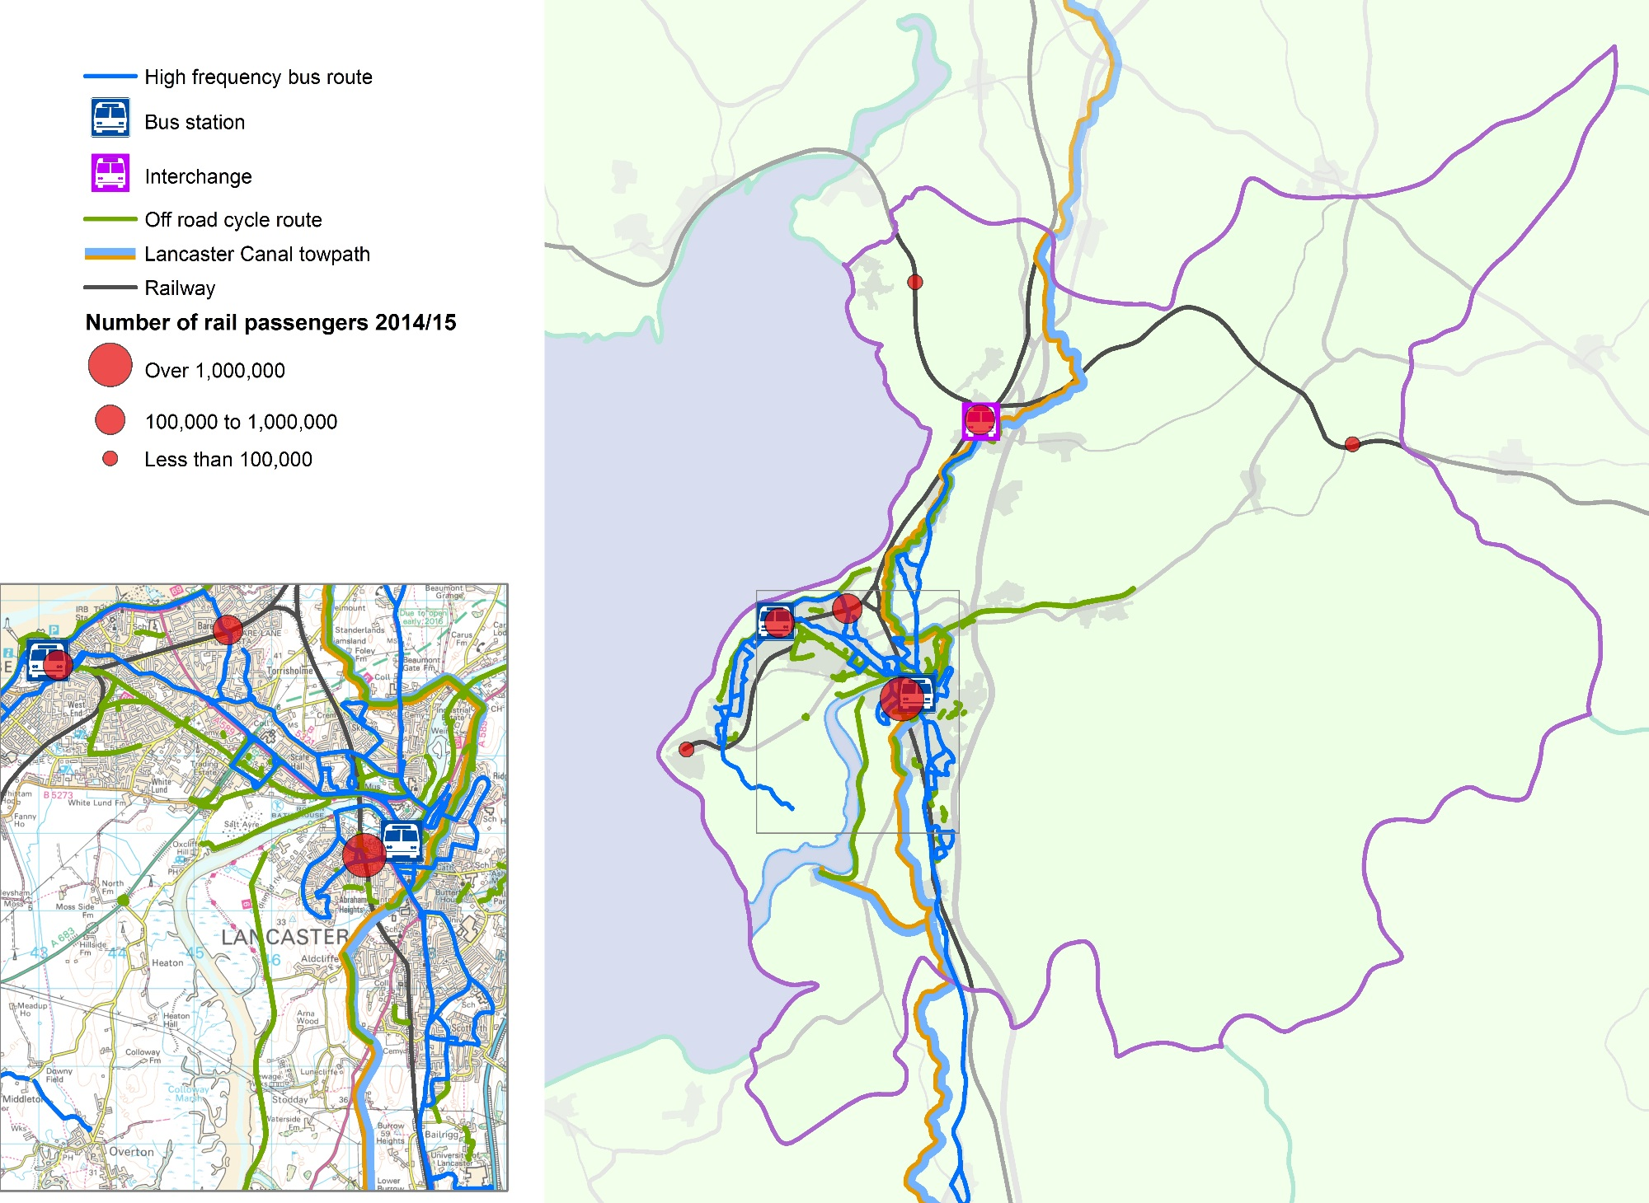

Travel problems today
The previous sections looked at the demands on the network from where people live, where they want to travel to and how they choose to travel.

We now want to look at the impact these journeys have on daily travel, because no one who travels in the district of Lancaster can be in any doubt that there are significant, serious issues that need to be addressed. These fall into four overarching strands that are interrelated.

Congestion
The three interconnected gyratory systems that form the heart of the City of Lancaster's road network are notorious for congestion. The sheer volume of traffic that needs to travel in and out of the city centre or cross the city to reach Morecambe and Heysham makes congestion almost inevitable, but gyratory systems compound the issues from this congestion.

These one-way systems were typically a 1960s and 1970s solution to the increasing numbers of cars on the roads then. Designed to transport what then seemed like large volumes of motor traffic around urban areas at the greatest possible speed, the systems had limited regard for the impact on people on foot or on bikes.
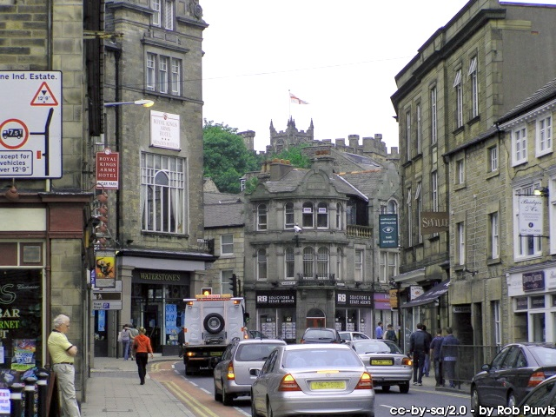

These gyratories are noisy, polluted and unpleasant places and create a vicious circle where people feel compelled to drive because cycling and walking are perceived to be too dangerous and unpleasant; this compounds the problem as traffic volumes then reach levels the system was never designed to cope with and so congestion spirals. Buses, too, become less attractive if they are also caught up in the congestion and their timetables are no longer reliable.

Lancaster's gyratory system is effectively throttling the city centre. The A6 rings the main shopping area, making access difficult for everyone and difficult and potentially dangerous for pedestrians and cyclists. Natural connections between the railway station and the castle to the west and the canal and public buildings to the east have been severed; there is no longer any clear way to navigate the city, particularly for visitors, which is a major drawback in a city with such a wealth of historic interest.

There are clear consequences for the economy of the city and of the wider district. The congestion, and the time delays associated with it, costs businesses significant sums of money, both in terms of fleet operation and working hours lost, but also in terms of lost business as customers go somewhere easier to get to. That in turn makes it more difficult for businesses to operate in and around the city and also makes it significantly less likely that businesses will choose to locate there.

However, such issues are not confined to the city centre. The A6 corridor in particular is very busy, with significant congestion at the A6/A588 Pointer Roundabout and at the A6/Hala Road junctions. This limits the potential for growth to the south of the city and makes connections to Lancaster University slow and difficult, particularly for cyclists. Like so many urban arteries, the A6 serves many purposes, with homes, businesses and shops along its length. The on street parking reduces capacity in places and can add to the hazards along the road.

The village of Galgate, to the south of Lancaster on the A6, bears the brunt of Lancaster's traffic to and from points south of the city. Almost 1,300 vehicles in the morning and over 1,500 in the evening have to negotiate the A6 as it runs through the village. Not surprisingly, the traffic lights in the centre of the village cause queues, which in the morning can reach over one kilometre back to M6 Junction 33, with typical speeds of around just 10mph for northbound traffic.

Traffic on the A6 is also the problem for Carnforth, where, like Galgate, a nearby motorway junction (M6 Junction 35) means that traffic has to travel through the town and its central traffic signal junction. Much of the problem in Carnforth is traffic heading to the M6 to travel north, particularly traffic from Heysham that finds it more convenient to reach the motorway via the coast than struggle through Lancaster's gyratory system.

Morecambe to some extent shares similar issues to Lancaster. Traffic congestion is an issue in the town centre and the roads also form barriers to easy movement in and out of the core of the town. However, unlike Lancaster, Morecambe's problems are compounded by the levels of deprivation in parts of the town, making it all the more important that the town centre works for the many households without access to a car.

Away from the main town centres and villages, traffic levels also present barriers:

- people are far less likely to want to cycle or walk any distance due to fears about safety and pollution
- communities suffer if the roads that run through them are busy and difficult to cross other than at particular places
- local centres cannot become sustainable if busy roads make the area unattractive and potential visitors therefore go elsewhere.

Congestion also has implications for public transport. Rail travellers need to get to and from stations, which often means walking, and in the future will include more cycling, neither attractive when the area around the station is congested. Bus services suffer even more, as the buses that would relieve the congestion if enough people used them are themselves stuck in the traffic and therefore not an attractive alternative to the car.

As well as these local impacts, there are the wider environmental and social impacts that affect our ability to meet our commitments to:

- reduce carbon emissions;
- improve personal health and wellbeing in Lancashire;
- support economic development;
- increase community cohesion; and
- provide affordable travel options in the future.

Road Safety
Road safety is a key priority for the County Council and as such has its own strategies and policies outside the remit of this masterplan. However, there are particular road safety issues in the district of Lancaster that our proposals could impact on and therefore road safety needs to be discussed in more detail than was the case in previous masterplans.

In the five years between 2010 and 2014, there were 433 people killed or seriously injured on the district's roads. This is an average of 90 people killed or seriously injured every year. Latest data for 2014 shows that Lancaster had the highest number of killed or seriously injured casualties at 114, five of whom were children. In addition 409 people (of all ages) were slightly injured in collisions in Lancaster in 2014.

Lancaster is the worst district in Lancashire for pedal cyclist casualties, both killed and seriously injured, overall and ranks joint second for all pedal cyclist casualties in the 20-25 year age range. The other age group at an increased risk in the district were those aged 65 and over with Lancaster having the joint highest rate in Lancashire of killed or seriously injured casualties in the over 65 years age group.

Of particular concern in Lancaster are the relatively high casualty rates for vulnerable road users:

- Lancaster has the highest rate of pedal cyclist and powered two-wheeler casualties killed or seriously injured for all ages in Lancashire;
- Lancaster has the highest casualty rate for 26-64 year old pedestrians in Lancashire; and
- nearly 55% of children injured on the roads in Lancaster were either walking or cycling.

Work towards fully understanding and addressing these issues is ongoing with our partners, but quite clearly the masterplan has a role to play in seeking to provide highways and transport networks that can be negotiated safely by all users.

Air Quality
The impact the quality of the air we breathe has on our health can be enormous.

Generally if you are young and in a good state of health, moderate air pollution levels are unlikely to have any serious short term effects. However, elevated levels and/or long term exposure to air pollution can lead to more serious problems. This mainly affects the respiratory and inflammatory systems, but can also lead to more serious conditions such as heart disease and cancer. People with lung or heart conditions may be more susceptible to the effects of air pollution.

Poor air quality is also unpleasant, even without health problems. Vehicle emissions from traffic sat in congestion make any street look and smell extremely unattractive for everyone, especially those not in a vehicle themselves.

Lancaster City Council has a responsibility under Local Air Quality Management legislation to review air quality and where levels exceed national objectives, declare an Air Quality Management Area (AQMA) and put in place measures to reduce emissions, reported in a local Air Quality Action Plan.
Lancaster
City Centre

In general across the UK, the biggest problems with air quality are linked to vehicle emissions, usually particulates or oxides of nitrogen. The district of Lancaster is no exception to this and three AQMAs have been declared, all for nitrogen dioxide.

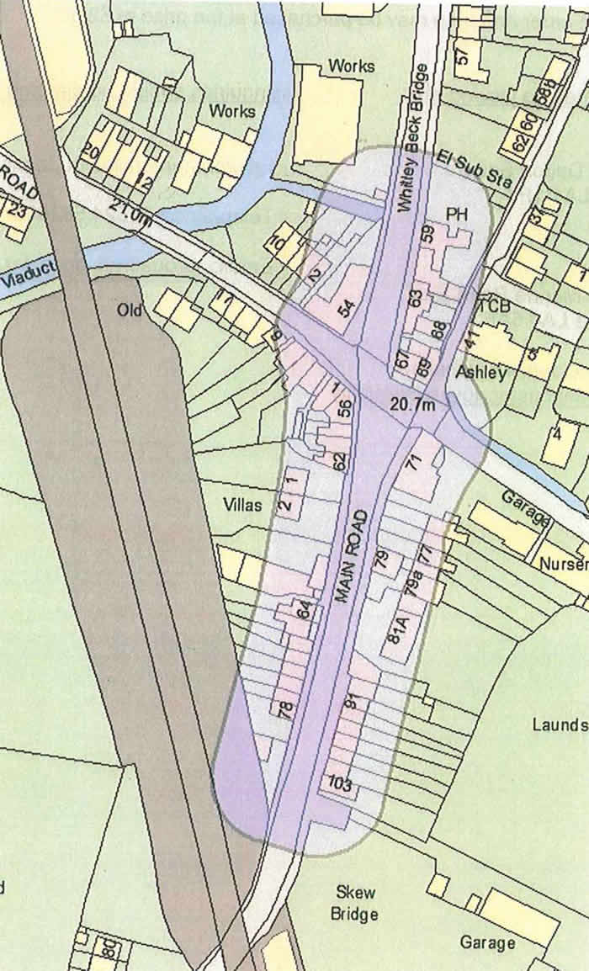
Congestion at three particular places along the A6 has already been discussed and not surprisingly, these coincide with the declared AQMAs:
Galgate

- The City of Lancaster AQMA (declared 2004)
- Carnforth AQMA (declared 2007) and
- Galgate AQMA (declared 2009)

These areas are shown on the following diagrams.

The Lancaster City Council Air Quality Strategy was adopted in 2013 and sets out a timetable of events leading to the production and monitoring of an Air Quality Action Plan. The Plan will contain physical measures which have been identified to measurably improve the air quality within Lancaster. The opening of the Heysham to M6 Link Road (Bay Gateway) in autumn 2016 will have a significant effect on traffic flows on many of the roads covered by the current AQMAs, and baseline conditions will need to be
Carnforth

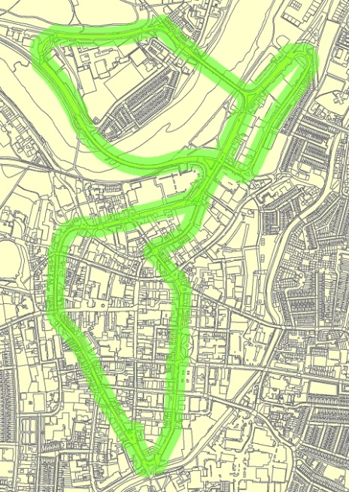
monitored for a full year after opening before the effectiveness of any interventions can be assessed. The Action Plan is to be agreed and formally adopted by 2019/20. The timetable to achieve this is set out in the Indicative Milestones table later in the masterplan.
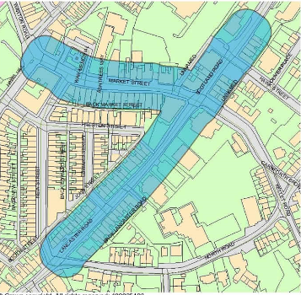
Rail Travel
Lancaster station provides the district with its connection to the West Coast Main Line (WCML) with Virgin Trains West Coast providing regular services to London, Birmingham, Glasgow and Edinburgh. In addition, Trans-Pennine Express operates an inter-city style service between Manchester Airport/Manchester and Glasgow/Edinburgh using modern electric trains.
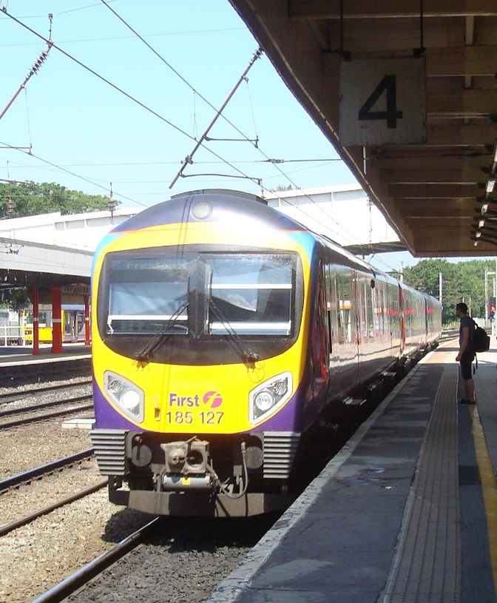

Local services also run from the station, to Carnforth and then on the Furness Line to Silverdale and through to Barrow in Furness, on the Bentham Line between Heysham Port, Morecambe and Bare Lane through Lancaster and Carnforth to Wennington and on to Skipton and Leeds. There are also connections to Windermere via the West Coast Main Line and Oxenholme.

Carnforth station offers a range of services linking the market town to Barrow, Skipton, Leeds, Lancaster, Preston and the south. Rail connectivity to the north requires a change of trains at Lancaster.

The Train Service Requirement for the Northern franchise sets out the trains that need to be operated by Northern between Lancaster and Barrow and Morecambe/Lancaster and Leeds. Trains between Barrow and Manchester and Windermere and Manchester will form part of the Northern Connect brand of inter urban express services and will use either highly refurbished or the new rolling stock. The refurbishment of all retained diesel and electric trains should start

in 2016 and be completed by 2018 and the new diesel and electric trains are due to be phased in between 2018 and 2019.

The Furness Line will become part of the Northern Connect network with 21 trains per day between Barrow and Lancaster and fast trains from Barrow to Manchester Airport at least eight times a day from December 2017 using new or highly refurbished rolling stock.

On the Bentham Line, Northern services run from Morecambe, through Bare Lane and Lancaster, to Carnforth, Wennington and continue to Skipton and Leeds using a variety of diesel multiple units of the types common on Lancashire secondary lines. There are five services a day each way Monday to Saturday (only one of which runs to Heysham Port) and four on Sundays. This will increase to six trains a day by December 2017 then seven per day from December 2019. However, the line in fact offers a quicker and cheaper service to Leeds than travelling via Manchester.

Northern also run a Lancaster to Morecambe service which is much more frequent. However, the schedule is irregular, although at peak times services are roughly half-hourly.

In addition, Northern operates a limited direct service between Lancaster and Windermere (the Lakes Line) using modern diesel rolling stock, with a more frequent service available if passengers change trains at Oxenholme. The Government has announced that the Windermere branch will be electrified between Oxenholme and Windermere. Timescales for this have yet to be confirmed and it is not known in what way electrification will affect the service on this line and its links to Lancaster and the south.

The longstanding issue of poor quality rolling stock is being addressed by the new Northern franchise. All retained rolling stock will be fully refurbished as new; new diesel and electric vehicles will be introduced from 2018 and all Pacers will be withdrawn by 2019.

Most of the stations have received investment. Where facilities are missing or need expanding then there will be funding available through the Station Improvement Fund which forms part of the Northern franchise and is set at £38m to be spent in the first 3 years of the franchise. It will cover issues such as passenger comfort, security and revenue protection.

Both the Furness and Bentham lines are covered by active Community Rail Partnerships (CRPs).

The Furness Line CRP covers the service between Lancaster and Barrow in Furness and the stations between Carnforth and Barrow inclusive. The services have been formally designated by the Department for Transport as a community rail service. The designation covers both services and stations, but not other infrastructure.

The Bentham Line CRP covers the services and stations between Skipton and Heysham Port inclusive, with the exceptions of Lancaster and Carnforth, and has also been formally designated as a community rail service. This designation does not cover the infrastructure of the line other than the stations.

Designation is a formal process which results in an agreed 'Route Prospectus' for the line which is agreed by the Government. Parliament considers designation to be a permanent arrangement although it recognises that changing circumstances may require a review of the Route Prospectus from time to time. Designation allows CRPs and the railway industry greater freedom to implement innovative solutions that stand outside normal rail industry processes.

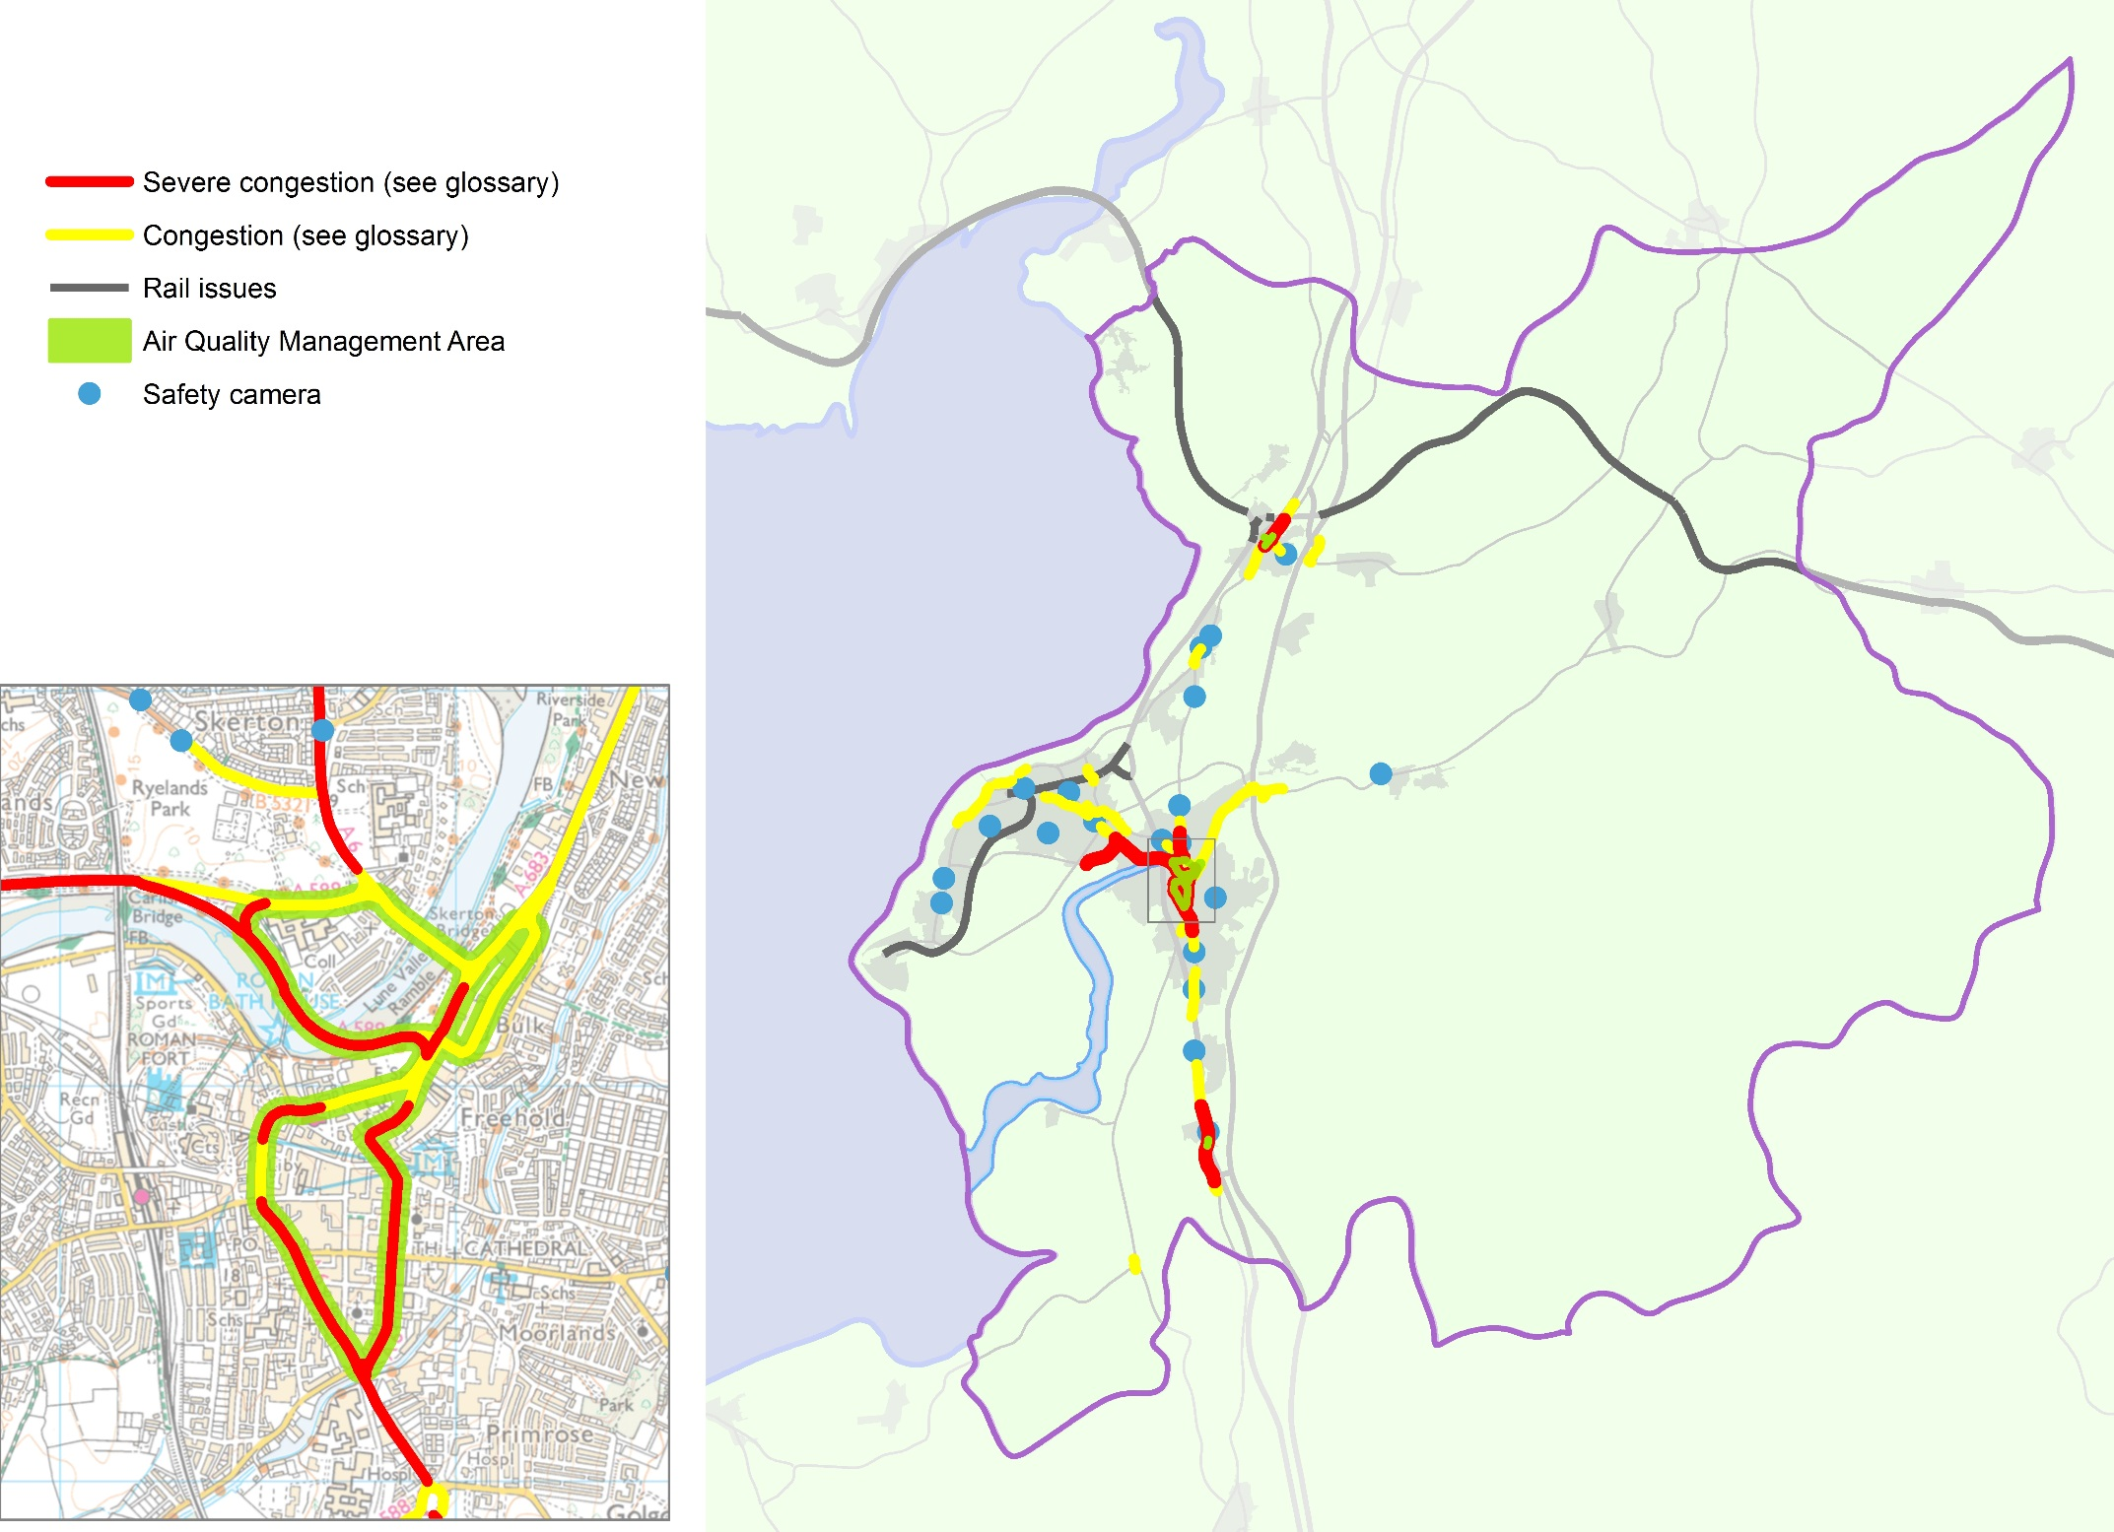
Figure 9 shows where the most urgent and significant problems in the district of Lancaster are, not just the congestion, but also where air quality is being affected and where we know that the sheer amount of traffic causes barriers to movement or limits travel choices. It also indicates where we know there are issues relating to rail transport and locations where safety cameras have been installed due to concerns about road safety.

Figure 9: Travel problems today

The Heysham to M6 Link Road
Completion of the Heysham to M6 Link Road (Bay Gateway) is one of the largest road construction projects currently managed by a local authority in England. At a cost of £128.62 million, it will directly connect the Heysham and Morecambe peninsula to a reconfigured Junction 34 of the M6. The link road is expected to open to traffic in the autumn of 2016, when it will fundamentally change traffic patterns, with huge implications for how we can realise our ambitions for transport and travel in the district.

The primary objectives of the link road are to:
- improve communications between Heysham, Morecambe and the M6 motorway, including improving access to Heysham Port and surrounding areas;
- facilitate industrial and commercial regeneration and provide employment opportunities;
- remove a significant volume of traffic congestion from River Lune bridges in Lancaster city centre; and
- create opportunities for the enhancement of alternative travel modes by relieving the current traffic conditions.

However, these statements hide the real impact of this nationally significant new infrastructure and the area over which it will change both traffic flows and how we can think about our highways and transport networks. Figure 10 below shows the predicted changes in traffic once the link road is opened and the potential of those changes.

The full benefits of a reliable, direct connection between Heysham and Morecambe and the M6 motorway will be dramatic. In economic terms, areas closely linked to motorways do better.

Once the link road is completed:
- Businesses will be closer to consumers and to each other, bringing transport costs down and making businesses more competitive. Businesses will be better connected to the labour market as well.
- Constraints on growth from congestion and unreliable travel times will be removed.
- The peninsula will become more attractive to the transport industry, a major sector of the economy that supports jobs and that across the UK directly contributes billions of pounds to the economy.
- The local economy will be boosted, with an expected £4.40 return on every £1 invested in the road.
These impacts can create agglomeration effects where a range of businesses work closely together to enable higher productivity,

increased innovation and knowledge sharing. This enables specialisation through efficient connections with suppliers and markets, deep and specialised labour markets, knowledge transfer or supporting specialised leisure markets.

These effects will be particularly significant for both Morecambe and Heysham, with economic benefits being seen even before the road is completed.

However, the benefits will also be felt in parts of Lancaster, where the link road will bring improvements in air quality through a reduction in traffic on existing roads, particularly heavy goods vehicle (HGV) traffic. This reduction in traffic, allowing sustainable modes to be encouraged, will benefit those who find the cost of travel prohibitive and will help to open up access to employment and education in the city and across the peninsula.

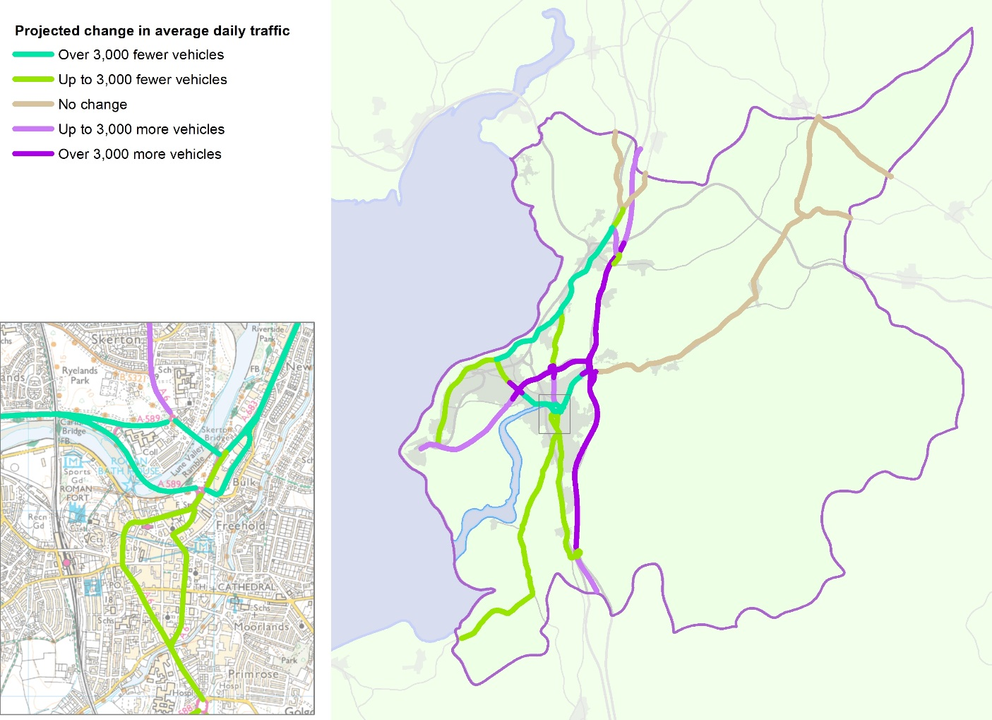
As part of this, a HGV movement strategy for Lancaster is being prepared. The strategy will pave the way for a series of Traffic Regulation Orders that will limit HGV movements. These will ensure that HGVs make full use of the link road and provide wider environmental benefits across the district.

Improvements in the city centre will also reap economic benefits, and a number of complementary traffic measures are required as part of the development consent order to build the road. These measures are set out in full in Appendix 1 and are effectively intended to ensure that at least the minimum benefits of the link road are felt across the wider Lancaster area.

In summary, they require:
- a Park and Ride to be developed at M6 Junction 34 with suitable measures to support it on Caton Road;
- Heavy Goods Vehicle (HGV) restrictions to make HGV traffic use the completed link road;
- a review of the city centre gyratory system; and
- a detailed feasibility study for a rapid transit service between Lancaster city centre and Morecambe and Heysham.

This masterplan shows how the County Council is meeting obligations under the development consent order. However, our philosophy is to go beyond this 'do minimum' approach and instead to make full use of the potential for transformational change within the district that completion of the link road gives.

Figure 10: Traffic changes due to the completion of the Heysham to M6 Link Road (Bay Gateway)

Looking To The Future
We have looked at what we know of our current transport problems, at the wider issues that impact on transport and touched on the impact that the Heysham to M6 Link Road (Bay Gateway) will have. We now need to look at the district of Lancaster in the longer term as both the people and the places of the area change over the next 10 to 15 years.

The future development of the district is being shaped by policies and strategies being put in place now. These plans allow us to understand how economic development will be promoted and how public health will be improved. Whilst there are also changes that are harder to predict, such as how our weather and climate will alter and how technology will advance, we know that we need to do all we can to make sure that what we do now is sustainable in the future.

Growth Deals for the Arc of Prosperity
Key to Lancashire’s economic development is the Lancashire Enterprise Partnership (LEP) and the Growth Deals it negotiates with government.

The overarching purpose of the Lancashire Growth Deal agreed in July 2014 is to re-establish Lancashire as an economic powerhouse and a national centre of excellence in advanced manufacturing by maximising its clear competitive strengths and capabilities in the aerospace, automotive, energy and health science related sectors. The Growth Deal is specifically designed to establish a transport investment programme to match Lancashire's economic and housing growth opportunities and challenges.

A key objective of the Growth Deal is to maximise the value of the 'Arc of Prosperity' that sweeps across Lancashire linking key economic assets, high value business clusters, centres of research and training excellence and new housing growth opportunities. The 'Arc' encapsulates the importance of Lancaster district as a major location for economic and housing growth, underpinned by its world-class, research intensive university, a renewed city centre, and the prospect of further growth as an energy centre and port serving Lancashire and the wider North.

Much of this focus is on Lancaster University and the area around it. The University is bringing forward major developments to strengthen its core science and technology base, which is underpinned by its leading position in physics and computing sciences. This creates the opportunity to innovate and develop new quantum technologies, a key national industrial objective, and the

prospect of leveraging spin-out opportunities in computing and healthcare sciences.

The University is partnering Sheffield University in a Growth Deal project to develop an Advanced Manufacturing Research Centre (AMRC) in the North West. The AMRC will increase the productivity of this sector in Lancashire and the North West region, further refining the established model developed at the AMRC Catapult Centre in Sheffield. The proposal is also at the heart of the Lancashire and Sheffield City Region Local Enterprise Partnerships' successful Science and Innovation Audit submission to the Government: the Northern Powerhouse Advanced Manufacturing Corridor. There will be opportunities to integrate with the University of Central Lancashire's Engineering Innovation Centre in Preston to establish Lancashire as a national centre of excellence.

The Lancaster Health Innovation Campus will be a new knowledge based initiative on an 11ha site immediately adjacent to Lancaster University. The Campus draws on pioneering developments in North America providing an integrated approach to healthcare and services for people as they grow older. It also integrates and delivers an innovative combination of services applicable to urban and rural environments. At the heart of the Campus is the University’s Faculty of Health and Medicine, which will work with international healthcare providers and companies.

The Campus will house innovation buildings providing laboratory and test space for companies carrying out product and service development in collaboration with the University and healthcare bodies, premises for companies working on the Campus and interactive facilities for engagement with the community. This initiative will be the first project of its kind in the North of England.

Adjacent to the Innovation Campus and University in South Lancaster is a location that has previously been identified as having the potential to help meet the future housing and employment needs of the district. This area includes sites, identified in 2012, at Bailrigg and Whinney Carr, which could deliver up to 1,500 new homes.

The University of Cumbria has also seen investment in its Lancaster campus at Bowerham, close to the city centre. The Lancashire Enterprise Partnership (LEP) is investing £2.5m in facilities on the site which will enable people to acquire skills which directly address skills shortages in the Health and Social Care sector.

Heysham is an important component of both the local economy and Lancashire's Energy offer. The Port of Heysham is owned by Peel Ports Limited who support the LEP's growth aspirations and see a strong strategic fit to their ambitions with the Liverpool SuperPort. Following completion of the Heysham to M6 Link Road (Bay Gateway), Peel Ports will invest in underused areas of the existing Port as well as in adjacent land in which they will seek to expand their operation.

Heysham is the only site in the UK that is home to two operating nuclear power stations and is one of 10 sites identified nationally for a new build power station, Heysham 3. Heysham 1 and Heysham 2 are estimated to end electricity generation in 2024 and 2030 respectively. Each of these events will have significant economic impacts upon the local community and broader economy.

The Irish Sea is the location for a significant amount of offshore energy generation. DONG Energy is constructing the 660MW Walney Extension Offshore Wind Farm comprising up to 90 turbines and expected to be fully commissioned in 2018. When inaugurated, it will be the largest offshore wind farm in the world. The electricity generated will feed into the National Grid at a new substation being constructed at Heysham.

Lancaster's Local Plan
Whilst the Lancashire Enterprise Partnership provides the strategic vision for Lancashire’s growth, how land is used is a vital factor in how an area’s economy and people develop. Housing and other forms of development must support economic growth but also ensure that public health and environmental considerations are taken into account and that development plans are sustainable in providing for today's needs without prejudicing those of future generations.

The key document that sets out how land-use and development will be planned for by a local authority is the Local Development Plan. This is made up of a suite of Development Plan Documents (DPD) that set out a range of planning policies and site allocations which cover the development of housing and commercial, either public or private, along with policies which seek to protect environmental and community assets. Since development should always be in accordance with the Local Development Plan, this provides the key background to the development of our highways and public transport networks.

The current Local Development Plan for Lancaster District 2011 – 2031 comprises the saved policies of the Lancaster District Local Plan (2004), the Lancaster District Core Strategy (2008), the Development Management DPD (2014) and the Morecambe Area Action Plan DPD (2014).

The Development Management DPD sets out generic policies which will be used to determine planning applications. The Morecambe Area Action Plan sets out a series of actions for the central commercial area of Morecambe, including investment in the public realm, to enhance the attractiveness of Morecambe for investment and achieve regeneration.

Following the clear direction in the National Planning Policy Framework that local planning authorities must establish their own housing requirement by determining their objectively assessed need for housing, Lancaster City Council commissioned consultants Turley Economics to prepare a Strategic Market Housing Assessment (SHMA) of the district's future housing needs. This work was completed in October 2015 and recommended that there is an objectively assessed need for 13,000 to 14,000 new homes by 2031 (with a base date of 2011). This equates to an average annualised delivery rate of 650-700 new homes. This housing growth is within the context of economic potential to achieve around 9,500 new jobs over the same period.

Given that the recommended objectively assessed need is greatly increased and must be for a much longer period than that addressed by the Core Strategy in 2008, the City Council is advancing a new strategic approach to establish the quantity of development requirements and the principles of the spatial distribution of development. This new strategic approach will supersede that of the Core Strategy and will be progressed through the Land Allocations document of the new emerging Local Plan; this will be Part A of the new Local Plan. Part A will identify the sites and opportunities needed to meet development needs up to 2031 and also protect areas of environmental, social or economic value.

The City Council undertook an in-principle strategic spatial options consultation "Meeting Future Housing Needs" in the summer of 2014, and a further potential strategic sites consultation "People, Homes and Jobs" in the autumn of 2015. This masterplan does not propose where development will occur but does make comment on where development could be best accommodated to provide maximum benefit to our current and future highways and transport networks and enhancing accessibility and transport linkages in accordance with Policy DM20 of the City Council's Development Management DPD.
At the same time as the strategic approach and land allocations element of the Local Plan for Lancaster District is prepared, the Development Management DPD will also be refreshed. This is to ensure that its policies take account of changing circumstances, national guidance, and the implications of the new strategic approach and the Land Allocations document. The updated Development Management DPD will then become Part B of the new Local Plan.

A dedicated DPD for the Arnside and Silverdale Area of Outstanding Natural Beauty (AONB) is also being prepared jointly by Lancaster City Council and South Lakeland District Council. The DPD, once adopted, will form part of both authorities’ local development plans. It will provide bespoke planning policies which seek to protect the Arnside and Silverdale AONB whilst identifying sites that offer opportunities to address local housing needs.

The City Council is also continuing to explore the extent of accommodation needs of Gypsies and Travellers, and additionally Travelling Show People.

It is anticipated that consultation will be carried out on all the local plan documents in early 2017 with formal publication and submission later in 2017.

Clearly, exactly where housing is developed will have major implications for our highways and transport networks. If only travel issues are considered, then it is obviously better if new development can use existing transport networks. New housing that allows residents to travel by means other than the private car places less strain on our highways network than developments which are remote from sustainable transport networks. No highways authority wants to see development which will make existing highways issues worse.

However, identifying land for new development is in reality a much more complex matter in which transport and accessibility is only one of many considerations (although a major one). Enabling extra development whilst keeping our highways operating efficiently will be a challenge. Whilst some new road capacity may be needed, we will do all we can to ensure that sustainable travel options are readily available. We won’t, however, rule out major infrastructure improvements if these are required and the funding can be found (although such funding could require a substantial contribution from developers).

Our Highways and Transport Masterplan is therefore not a response to a final Local Development Plan but is part of the conversation that will assist in its preparation.

A number of specific sites have already been identified by the current development plan or have been identified in earlier stages of the Local Plan process:

- Luneside East is a large brownfield site with planning permission for 160 dwellings, and an application pending for 400 student flats. The site has received £4 million from the Lancashire Enterprise Partnership through the Growing Places Fund for remediation works to unlock the site.
- Development of a number of major brownfield sites is either underway or nearing completion at:

  - Luneside West - 356 dwellings, by Barratt Homes and Redrow Homes;
  - Lancaster Moor Hospital - 405 dwellings are being built by Story Homes, alongside the conversion of the Grade II former hospital building by PJ Livesey;
  - Nightingale Hall Farm - 164 dwellings by Barratt Homes.
- The retail led redevelopment of the Lancaster Canal Corridor North site remains a key element in plans to boost Lancaster’s attractiveness to shoppers, visitors and residents. Working in partnership with British Land and Lancaster University, plans are being advanced for the comprehensive redevelopment of this key area which will provide modern facilities for retailers and food and drink operators currently lacking in the city centre. Building on the site’s existing heritage assets, the scheme will also aim to significantly improve the facilities for arts and culture as part of the overall offer of the area. The opportunity also exists to provide an element of high quality student accommodation which will help bring vitality and life into the area and broaden its round the clock appeal. Integration of the scheme into the existing city centre is a key issue to be addressed as plans develop.
- The City Council's draft Land Allocations document (2012) identified significant new green field development sites in east and south Lancaster. These have no formal development plan status at present.

Health and Wellbeing
Public Health Profiles for 2014, produced by Public Health England, show that there is significant work to do in some areas. In particular, the number of people killed or seriously injured on the district's roads is categorised as 'significantly worse than the national average'. However, within the district there are other issues that have a significant impact on health outcomes, including the levels of deprivation experienced in parts of the district and the poor air quality in others.

Lancashire County Council is now responsible for much of the Public Health work that was previously carried out by the NHS. The Lancashire Health and Wellbeing Board gives public health experts a greater input to many of the different council services that impact on people's health including education, housing, transport and the local environment.

The Boards vision is that every citizen in Lancashire will enjoy a long and healthy life. As part of achieving that vision, three programmes of interventions are set out for delivery by 2016 which will improve health and care services, improve health behaviours and address the wider determinants of health and wellbeing.

Starting well | - To promote healthy pregnancy  - To reduce infant mortality  - To reduce childhood obesity  - To support children with long term conditions  - To support vulnerable families and children
Living Well | - To promote healthy settings, healthy workforce and economic development  - To promote mental wellbeing and healthy lifestyles  - To reduce avoidable deaths  - To improve outcomes for people with learning disabilities
Ageing Well | - To promote independence  - To reduce social isolation  - To manage long term conditions and dementia  - To reduce emergency admissions and direct admissions to residential care settings  - To support carers and families

Scratch below the surface of these priorities, and all have links to travel and transport:

- Active travel is key to tackling obesity and encouraging healthy choices for all ages.
- How our streets and public spaces look and function is not only key to encouraging active travel, but to promoting wellbeing for everyone.
- A lower life expectancy is closely related to deprivation; addressing deprivation requires addressing the social determinants of deprivation and that includes access to employment and to education among other factors.
- Reducing road injuries and deaths and improving access to transport are clear and specific transport issues.
- Safe and effective transport is crucial in helping older people and others at risk of social isolation stay independent and live well.

Providing both real and perceived safety fears about them can be allayed, active travel modes can improve the health of people and reduce their healthcare costs. For example, if 1 in 10 journeys were made by bicycle, the NHS could save £250 million a year. The prevalence of many of the major health issues facing the population, including obesity, diabetes and coronary heart disease, would be reduced if more people of all ages were active. For instance, each additional kilometre walked per day is associated with a 4.8% decrease in the likelihood of obesity.

Sustainability
From the National Planning Policy Framework to the Local Sustainable Transport Fund, sustainability has become a key factor in all plans and policies. For a highways and transport masterplan, it presents several key challenges to what we want to achieve.

- Lancashire's transport infrastructure assets are the most valuable publicly owned asset managed by the County Council, with a combined estimated gross replacement cost of about £9 billion.

Without this infrastructure, Lancashire would not be able to function as a place to live, work or visit. Given the importance that Lancashire's transport infrastructure plays in our everyday lives and in our economic future, it is vital that we maintain and manage this asset as sustainably as possible, maximising benefits and opportunities and reducing negative impacts as far as possible to provide best value for the people of Lancashire.

- As a Highways Authority the County Council has had a duty to manage roads to ensure that flooding does not represent a nuisance to road users. However, under The Flood and Water Management Act 2010 (FWMA) the County Council has now also been designated as a Lead Local Flood Authority (LLFA). The FWMA places a range of new powers, duties and responsibilities on the LLFA and its partner Flood Risk Management Authorities (RMAs). Each LLFA has to produce a Local Flood Risk Management Strategy (a ‘Local Strategy’).

A sizeable proportion of the district of Lancaster is at risk of flooding from a number of sources including tides, rivers, local sources, the Lancaster Canal and the sewer network. There are also two reservoirs in the district which pose a medium risk of flooding. Many of the towns and villages are next to either the coast or the River Lune and its tributaries. The greatest consequences of flooding in the recent past have come from two sources, tidal and then fluvial flooding.

As LLFA, the County Council is therefore working with our RMA partners to develop options for water management in rural areas, with a view to balancing the needs of agricultural productivity, flood risk management and sustainable drainage practices. We will therefore make sure that proposals put forward under this masterplan fit with our Local Strategy and that issues of flooding and drainage that could affect a proposal are taken into account in the development of schemes and business cases.

- There is now little argument that we need lifestyles that generate a smaller carbon footprint. 'Low carbon' transport has the potential to allow individuals to make a genuine difference to the world around them. However, the evidence of travel choices made at the moment shows that what is on offer now is not what people are prepared to switch to. This suggests that we need to do more to provide low carbon options that more people want to use.

- There are many rural areas of the district that are remote from employment and services. These areas have come to rely on the car, making it very difficult for those without their own transport. However, increasing car use is unlikely to be sustainable in the future. Providing alternatives both for residents and for visitors will therefore be vital for economic development.

- The roll out of superfast broadband across the county will have a fundamental impact on how many of us do business on a day to day basis. It will allow many people to reduce the amount they have to travel – we can shop from home, download films and games and, of course, work from home. For businesses, it will offer far greater access to customers and digital media, also with less need to travel.

We need to maximise the benefits of reduced car traffic for our highways and transport networks while also taking account of the negative impacts, such as greater delivery traffic. We also need to ensure that those who cannot or do not adopt superfast broadband are not forgotten.

- The landscape of the district is particularly diverse, ranging from the wooded hills and limestone of the Arnside and Silverdale Area of Outstanding Natural Beauty (AONB), through drumlins and reclaimed mossland, the river valleys of the Lune and its tributaries and then rising up to the Forest of Bowland AONB. As well as supporting the agricultural sector, the landscape provides an important recreational resource supporting the visitor economy. Providing good transport links that do not damage that environment will therefore be crucial to the masterplan.

- Lancaster district's historic environment includes a wealth of historic buildings, archaeological sites, townscapes and landscapes and is a highly significant cultural and economic asset which should be protected and enhanced wherever possible. Public realm and transport improvements can make positive contributions to this environment, with the potential to boost the visitor economy and provide better opportunities for people to access local heritage and participate in cultural and leisure activities.

The city of Lancaster itself is widely recognised as a city with exceptional architectural heritage. The Lancaster Cultural Heritage Strategy (2011) identified how Lancaster could make the most of its heritage for the benefit of local people, visitors and the economy. Lancaster has recently joined the England's Heritage Cities group to promote its culture and heritage to visitors. An attractive and functioning city centre environment with reduced traffic congestion will encourage people to visit Lancaster's historic attractions, shops, cafés and other services, stimulating economic growth, increasing employment opportunities and helping to secure the viability of the city centre.

Historic townscapes could be improved by reducing intrusive traffic, and a reduction in pollution and vibration caused by heavy traffic and congestion may slow down the deterioration of the fabric of historic buildings. However, we must take care not to damage historic buildings and structures (such as the Lancaster Canal), archaeological sites, townscapes and their settings by changes to the public realm. Measures such as road layouts, traffic calming and pedestrianisation could have an adverse impact on the historic environment.

- 'Green' tourism could be a vital component of the district's future visitor offer. By actively seeking ways to reduce the negative impact of business operations on the environment, green tourism aims to ensure that economic development as a result of tourism is a positive experience for everyone; local community, tourism businesses and visitors. Businesses benefit by conserving resources, reducing waste, reducing costs through efficiencies and staff awareness, attracting new customers and improve their public image. The wider benefits are the positive impact on the local community, support for the local economy and reduction of congestion and pollution.

As well as future development, Figure 11 shows how the environment of Lancaster impacts on development:

- the Areas of Outstanding Natural Beauty
- the Green Belt, put in place to prevent the merging of neighbouring towns and to direct investment to the older parts of the urban areas
- features of the historic environment
- the areas at risk of flooding and
- the areas of nature conservation value.

These constraints, together with the people, land and economy of Lancaster today, are shaping both the local plan and this highways and transport masterplan.

Figure 11: Development and constraints
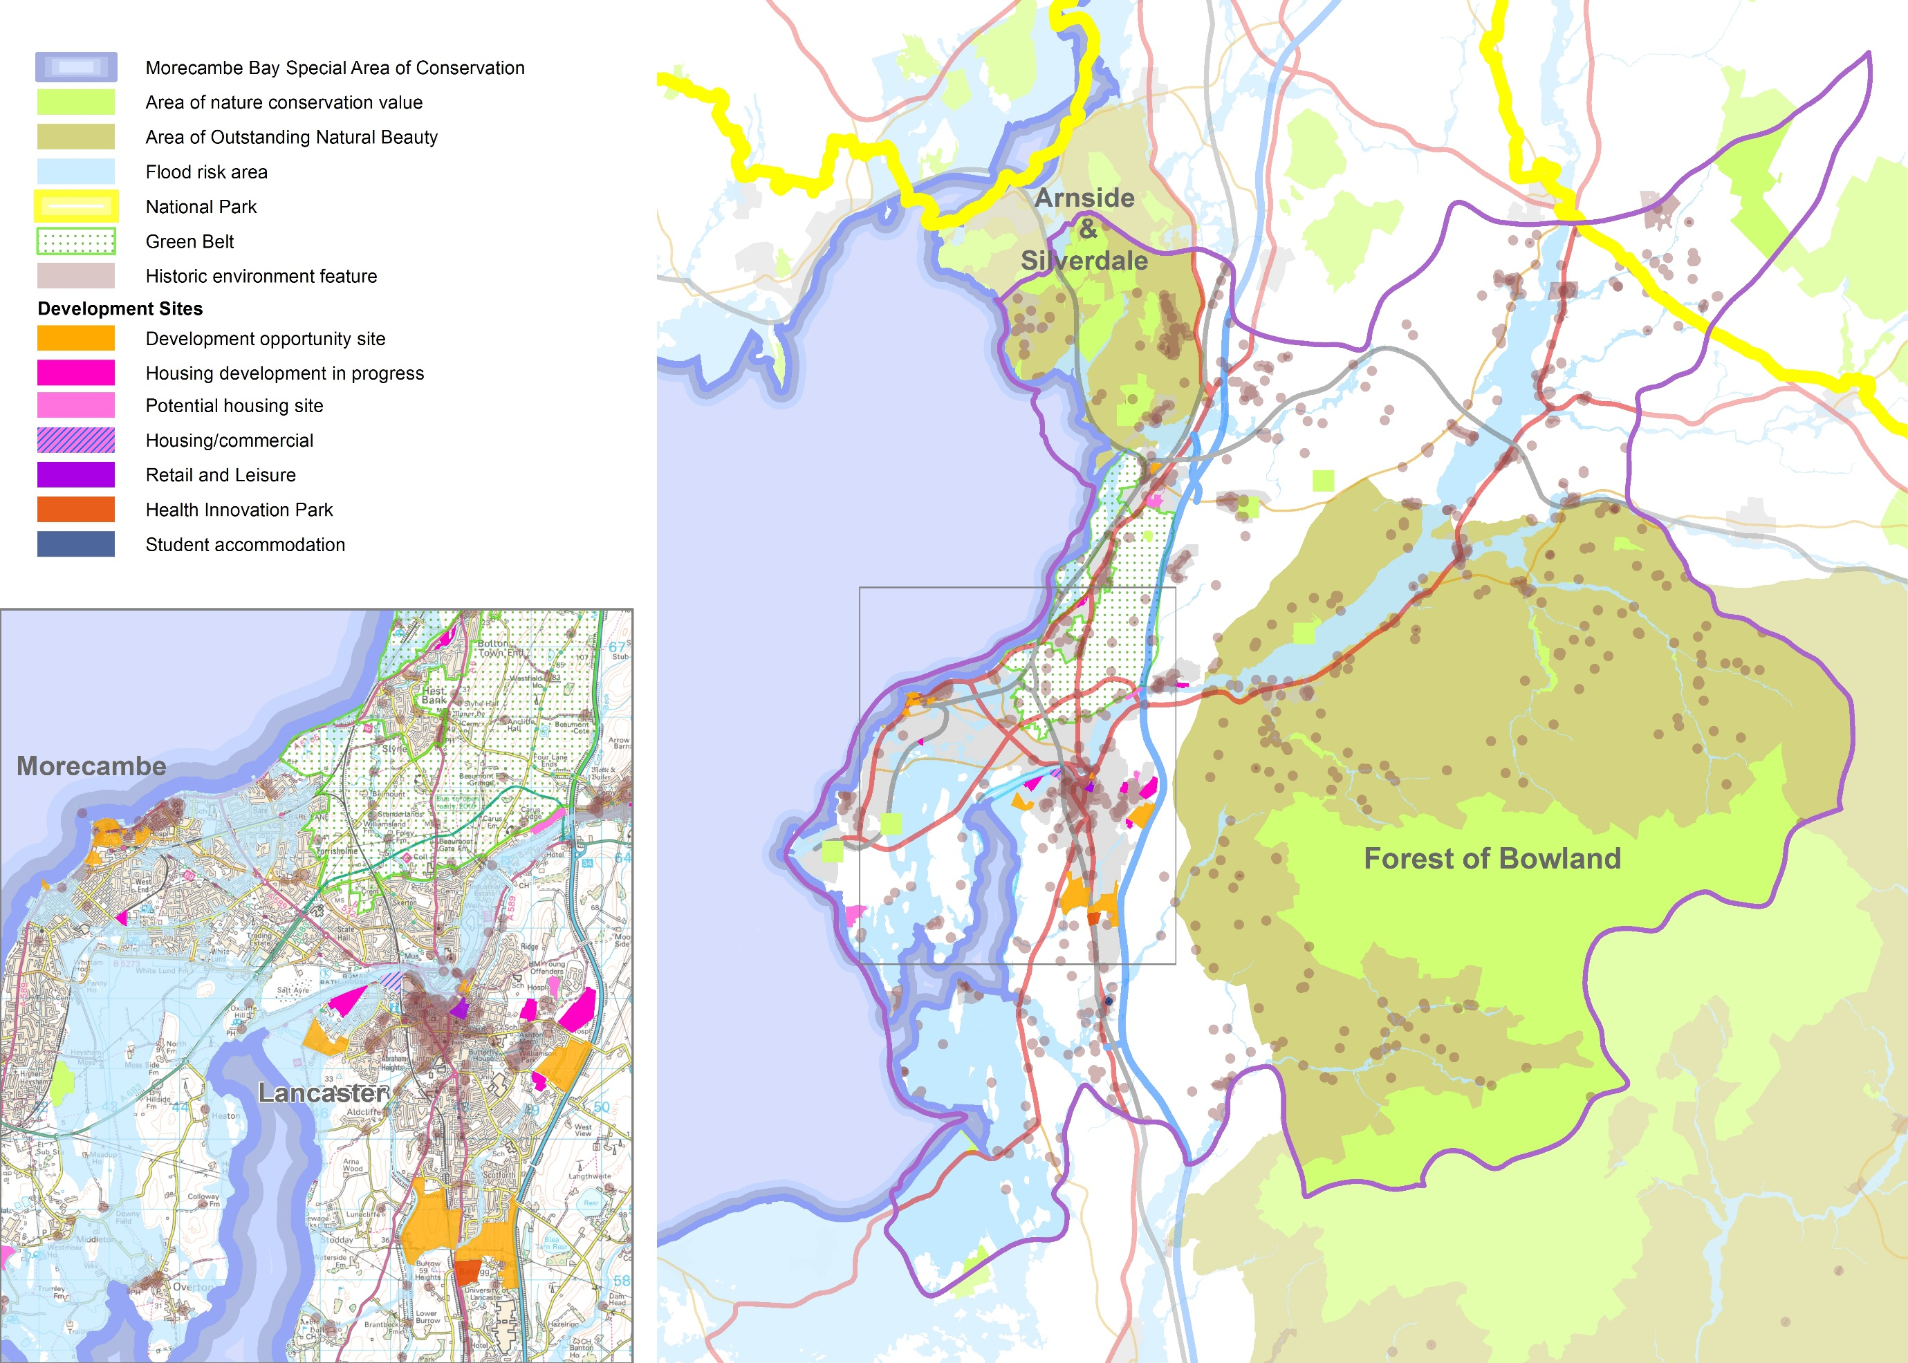

Funding
Government funding
Major changes to the way transport infrastructure is funded came into effect from 2015/16. Local Enterprise Partnerships are now responsible for delivering a £12bn Local Growth Fund (LGF) budget devolved from various Government departments including the Department for Transport. This has for the first time created the opportunity to integrate key economic and transport priorities and plans. Almost £8bn has already been allocated to over 900 projects across England to build vital infrastructure, improve skills and create thousands of jobs. The Lancashire Enterprise Partnership is responsible for the review and approval of individual major scheme business cases and ensuring effective delivery of its programme.

The LGF is a single pot with no internal ring fencing and access to it is through a 'Growth Deal' negotiated between the Government and Local Enterprise Partnerships. The LGF includes a significant amount of local transport funding. In addition to funding for local major transport schemes, from 2015/16 the LGF includes over 40% of the Integrated Transport Block (IT Block) funding previously received directly from the Department for Transport by local transport authorities. This reduction in the amount of IT Block funding received directly by the County Council from 2015/16 means that there will be less direct guaranteed funding for smaller scale local transport schemes going forward.

In the March 2016 Budget, the Government announced the opportunity for LEPs to bid for a share of £1.8bn from the LGF to support projects in their areas that boost economic growth and create jobs. The Lancashire Enterprise Partnership's bid submitted to the Government in July 2016 includes the Advanced Manufacturing Research Centre North West at Lancaster University and South Lancaster supporting infrastructure as priority projects for this round of Growth Deal funding.

Strategic partners
Our strategic partners are also seeing changes that will impact on what we can achieve through this masterplan.

The rail industry is complex, with operation of the infrastructure separate to the operation of passenger and freight train services.

Network Rail is the public sector monopoly owner and operator of the national rail network, including track, signalling, bridges and tunnels. It operates in 5 year 'Control Periods' (CP), for which delivery plans are produced. CP5 started in April 2014, with CP6

starting in April 2019. In order to achieve infrastructure improvements in Lancashire, we need to be in a position to influence the development of the strategies that will determine activity in CP6.

Rail North, a consortium of 29 local authorities across the north of England, is now working in partnership with the Department for Transport to manage the Northern and Trans Pennine Express train franchises. The franchises came into operation on 1 April 2016 and over the next four years will bring 140 new trains onto the network as well as improving facilities at stations.

On the roads, the Highways England is responsible for operating, maintaining and improving the strategic road network in England, which includes major trunk roads and most motorways. Highways England is responsible for delivering the Government's vision for the network. The Company has published its Strategic Business Plan in answer to a clear brief set out in the Government's Road Investment Strategy (RIS) and has committed funding for a five year period to meet the performance expectations set out in that strategy.

Developer contributions
When development is proposed, the developer is often required to make funding contributions towards any infrastructure improvements needed to support the proposals. For development proposals where significant infrastructure is required these contributions can be substantial. These developer contributions are in the form of section 106 and section 278 agreements within the Lancaster district.

Another potential developer contribution is the Community Infrastructure Levy (CIL). Since 2010, local planning authorities have been able to charge a CIL on certain developments. In introducing CIL, local planning authorities need to prepare a ‘charging schedule’ which forms part of the Local Development Plan. This schedule sets out what, if anything, the charge will be per dwelling for residential development or per square metre for all other development. In setting charges, planning authorities need to balance the level of charge with the potential impact on the economic viability of development. To date, Lancaster City Council has yet to introduce a CIL charge.

If the resources are to be available to fund the initiatives set out in this masterplan, the County Council believes that developer

contributions will need to be an essential part of the funding mix and supported through the Local Development Plan.

This in turn will require housing to be located in areas where the economies of the development process can sustain developer contributions.

Across Lancashire, this need for balance between developer contributions and development viability is a key issue. Securing developer contributions through planning obligations as private sector investment will be crucial to delivery of the District of Lancaster's masterplan.

Looking to the Future – What are the challenges?
As the previous pages show, the district of Lancaster faces considerable opportunities and challenges in its future development. These challenges are summarised here showing the strengths, opportunities, weaknesses and threats. Appreciating these provides us with an understanding of what will influence and shape our highways and transport network.

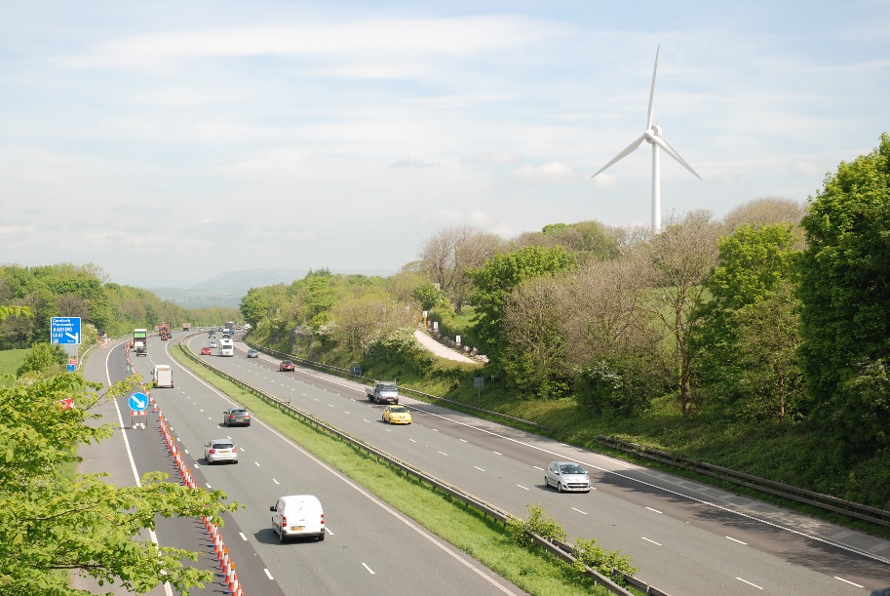

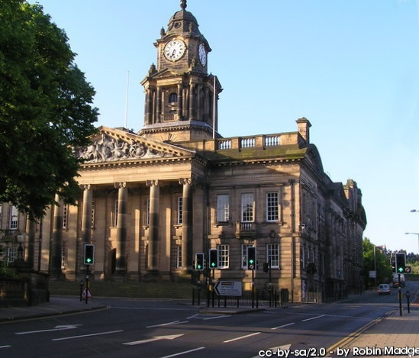

STRENGTHS

- Widely recognised as a city with exceptional heritage
- Two leading UK universities with an emphasis on research and vocational training
- Retail mix in the city attract large numbers of shoppers
- Significant increase in cycling over the last 10 years
- Excellent location on main north-south road and rail corridors
- Outstanding natural landscapes including Morecambe Bay
- Port of Heysham
- Strong energy sector – nuclear and renewable

OPPORTUNITIES

- Heysham to M6 Link Road (Bay Gateway)
- Lancaster Castle and other heritage visitor locations
- Health Innovation Campus and other University led activities
- Morecambe Area Action Plan
- Expanding trade across the Irish Sea
- Demand for renewable energy
- 'Greenest' population in the county
- Locating new housing and commercial development in areas capable of generating Community Infrastructure Levy (CIL) funding

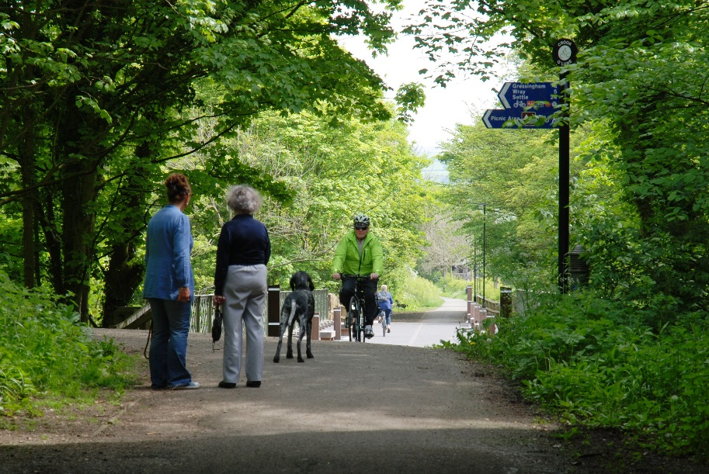

WEAKNESSES

- Traffic congestion particularly around the city's gyratories
- Limited accessibility between Morecambe seafront and the town centre
- Pockets of deprivation in Morecambe and the City of Lancaster
- Three AQMAs declared across the district
- High quality rail connectivity limited to Lancaster
- Serious issues of safety for vulnerable road users
- Large rural area from which access to services is difficult for non-car owners

THREATS

- Increase of pressure on traffic due to significant urban development
- Current financial climate
- Lack of knowledge of the district of Lancaster nationally
- All day congestion on the Lancaster gyratory system

Developing Our Transport Vision
In seeking a solution to the district's future challenges, it is clear that there are four development priorities that must be accommodated:

- The knowledge sector (Lancaster University, University of Cumbria, Innovation Campus);
- Enhancing the role of the city of Lancaster as a key cultural, leisure and service centre;
- Regenerating and reinventing central Morecambe; and
- Developing the energy and logistics sector in and around the Port of Heysham.

However the development required to meet the future needs of the district must take place without making life worse for existing residents and businesses, at a time when critical problems such as congestion and associated poor air quality in the city centre must also be resolved.

We will capitalise on the opportunities the completed Heysham to M6 Link Road (Bay Gateway) will offer and fulfil our obligations with respect to opening the new link. Appendix 1 sets out these requirements for complementary measures as specified in the development consent order for construction of the link road. These measures include:

- Specific local traffic management measures.
- An operational Park and Ride site within 1 month of the link road opening.
- Supporting 'appropriate' bus priority measures for the Park and Ride service within 12 months.
- An action plan timetabling measures to be completed within 10 years which will prevent traffic in the city centre returning to the levels we would have seen in 2030 if the link road had not been built. The action plan must cover:

(a) a review of the city centre gyratory system;
(b) an investigation into further Park and Ride sites
(c) a detailed feasibility study for a rapid transit route from Lancaster city centre, rail station and bus station to Morecambe and Heysham

Once the Park and Ride site is operational, the development consent order acknowledges that further work needs to be done, but does not prescribe in detail what the outcomes of that work should be.

Traffic reduction in the heart of the city centre was never the main aim of the link road. Furthermore, future housing and employment growth in the district will place additional pressures on the local road network. Increasing congestion would again make journey times unreliable, which will in turn would make it difficult for public transport and logistics to operate effectively. Road safety and air quality would also worsen, with traffic levels making walking and cycling increasingly unpleasant on many roads. Where the link road has provided less benefit, these pressures will be greater.
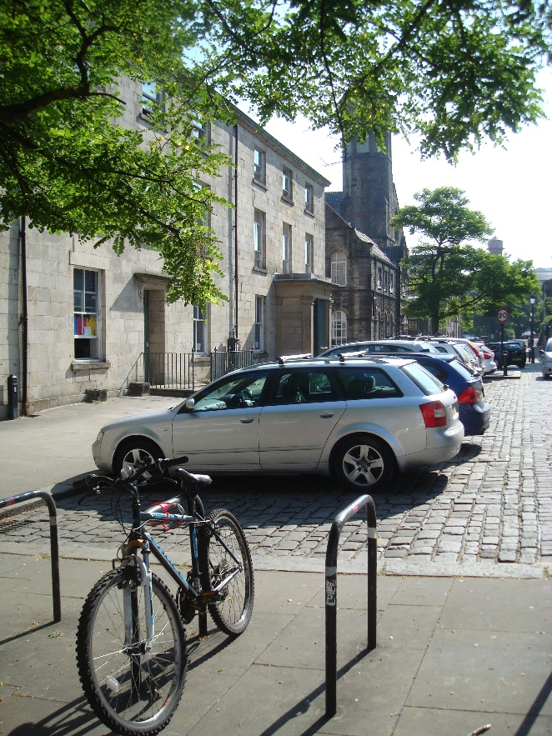

The consultation on the masterplan that took place in 2015 showed most support for Option 3 – Improve and Extend. In line with this option, we will deliver the projects that are already programmed, fulfil our obligations under the link road development consent order and continue to manage the network to make it as effective as possible. But we will also develop and implement a radical programme of measures that will deliver a fundamental and permanent transformation of sustainable transport across the district.

Experience from elsewhere shows that even major programmes of sustainable transport improvements are unlikely to have a significant impact, so we face a major challenge. Nevertheless, through this masterplan we will make changes to the city centre road network to favour walking, cycling and public transport, creating a vibrant, healthy city centre but ensuring that local traffic can still get to where it needs to go. Elsewhere, our transport measures will support development at South Lancaster and Heysham and the regeneration of Morecambe, and will relieve Carnforth and Galgate of unnecessary traffic.

Our proposals support the County and City Councils' strategic vision of a sustainable future where transport is fully integrated and where walking, cycling and public transport are an effective and obvious alternative to the private car.

It is an accepted part of the legal framework that governs new development that developers are asked to contribute to the new public infrastructure, of any type, that their development may require. This will most certainly be the case in the District of Lancaster.

Our Transport Vision

The district of Lancaster is a unique place and is at what could be a pivotal point in its history, with significant decisions required about the scale and location of new development, particularly housing.

The combination of heritage, environment, academic excellence, research innovation and outstanding connectivity that the city has is shared by only a few places in the country. The City of Lancaster is now building even greater strength in its retail, leisure and employment offer, with major developments planned in both the city centre and around Lancaster University.

With a rich and varied retail offer and diverse employment opportunities, the city will become even more attractive. But this attraction will need to be matched by the right infrastructure, both in terms of housing and transport.

National, and indeed global, evidence shows that areas such as Lancaster need the highest levels of sustainable transport provision to match the aspirations of an advanced heritage/retail/leisure and business offer. The need for this provision sets the scene for future infrastructure provision.

Away from the city, there is the same need for sustainable transport.

- In Morecambe both the visitor economy and local residents and businesses would benefit from much better sustainable connections and from the regeneration opportunities those connections would bring. Heysham, as a gateway to the port and to the energy sector, needs not only good links for people, but also for freight. Across the peninsula, it is vital that the full potential of the new link road is developed.

- Carnforth and Galgate both need long term solutions to the congestion at their centres, whilst rural areas need to be assured that access to services will not depend on owning a car. Given the district's heritage and countryside, the increase in green tourism could also benefit the district's economy.

We are at a point in time that gives us all the opportunity to make Lancaster an exemplar of how an unashamedly 'green' district can also be an outstanding and sustainable success for everyone. In essence, the question is: For how many of our journeys are we prepared to leave the car at home?

Our Vision for the district is one where the answer to that question is 'as many as possible'.

In 2031:

Lancaster city centre is a vibrant and successful core to the district, where earlier issues of poor air quality and congestion have been tackled. Pedestrians and cyclists can move around easily and freely, through safe and attractive public spaces. This is because the centre is largely free of traffic. There is much less through traffic and most of the vehicles that do need to be there are ultra-low emission. The city has become an attractive destination for visitors from near and far.

Away from the city centre, the residential roads, old and new, are quiet as traffic no longer rat runs trying to escape the gyratory system. Walking and cycling are now the norm for many local journeys and car clubs mean that there is far less need to own a car. Ultra-low emission cars are now commonplace as charging is straightforward wherever the car is kept, on or off road.

Public transport is also far more reliable and new links to South Lancaster mean that Lancaster University has been able to expand and maintain its prestigious reputation. Those who work in the area almost all commute by sustainable modes: on foot, cycle or using the 'Lancaster Reach' bus rapid transit services.

Morecambe is thriving again: a revitalised town where everyone can get to where they want to go easily on foot or by bike and where the amazing promenade gives way seamlessly to an attractive and strong commercial centre. The town is now a 'must visit' attraction on the Lancashire Coast and Morecambe Bay tourist trails.

In Heysham, the old village is an attractive tourist destination now readily accessible without a car. South Heysham and the Port are a thriving focal point for industry, with the link road providing superb access to the motorway network, complemented by improved access by public transport and by cycle.

Carnforth is a hub for the north of the district, with redesigned public spaces making the centre a much more attractive place to visit. The station is now integral to the town centre and improved rail links provide easy access to jobs around Morecambe Bay and

across into Yorkshire. The town is also a gateway for visitors coming to enjoy the countryside and wildlife of the area, as well as its railway heritage.

Galgate is a quiet village, no longer straddling the city's main link to the motorway.

The rail network provides high quality, fast services to and from Morecambe and rail travel around the Bay is straightforward. Many more passengers use the Bentham line as well. Public spaces around stations are now attractive and it is easy to walk and cycle to stations or to leave an electric car on charge.

Buses aren't held up in Lancaster city centre, so they are used extensively for travel between South Lancaster, the city centre and the other main urban areas. The 'Lancaster Reach' bus rapid transit services linking Heysham and Morecambe to South Lancaster and Lancaster University to M6 Junction 34 via the city centre are particularly popular, not least because they use ultra-low emission vehicles, which are quieter and smoother than conventional buses.

The 'Lancaster Links' network for non-motorised users is now comprehensive. For those who want direct routes, the roads are much quieter and safer for cyclists on the main radial routes in the district. For those who don't want to ride on the roads, there are dedicated links for all users between the main urban centres with quiet routes linking to them.

The 'Links' network also connects the district to its neighbours to north and south through the long distance trails that bring a significant number of visitors to the district to explore the coast, the Lancaster Canal and the valley of the River Lune.

Figure 12: Our Transport Vision
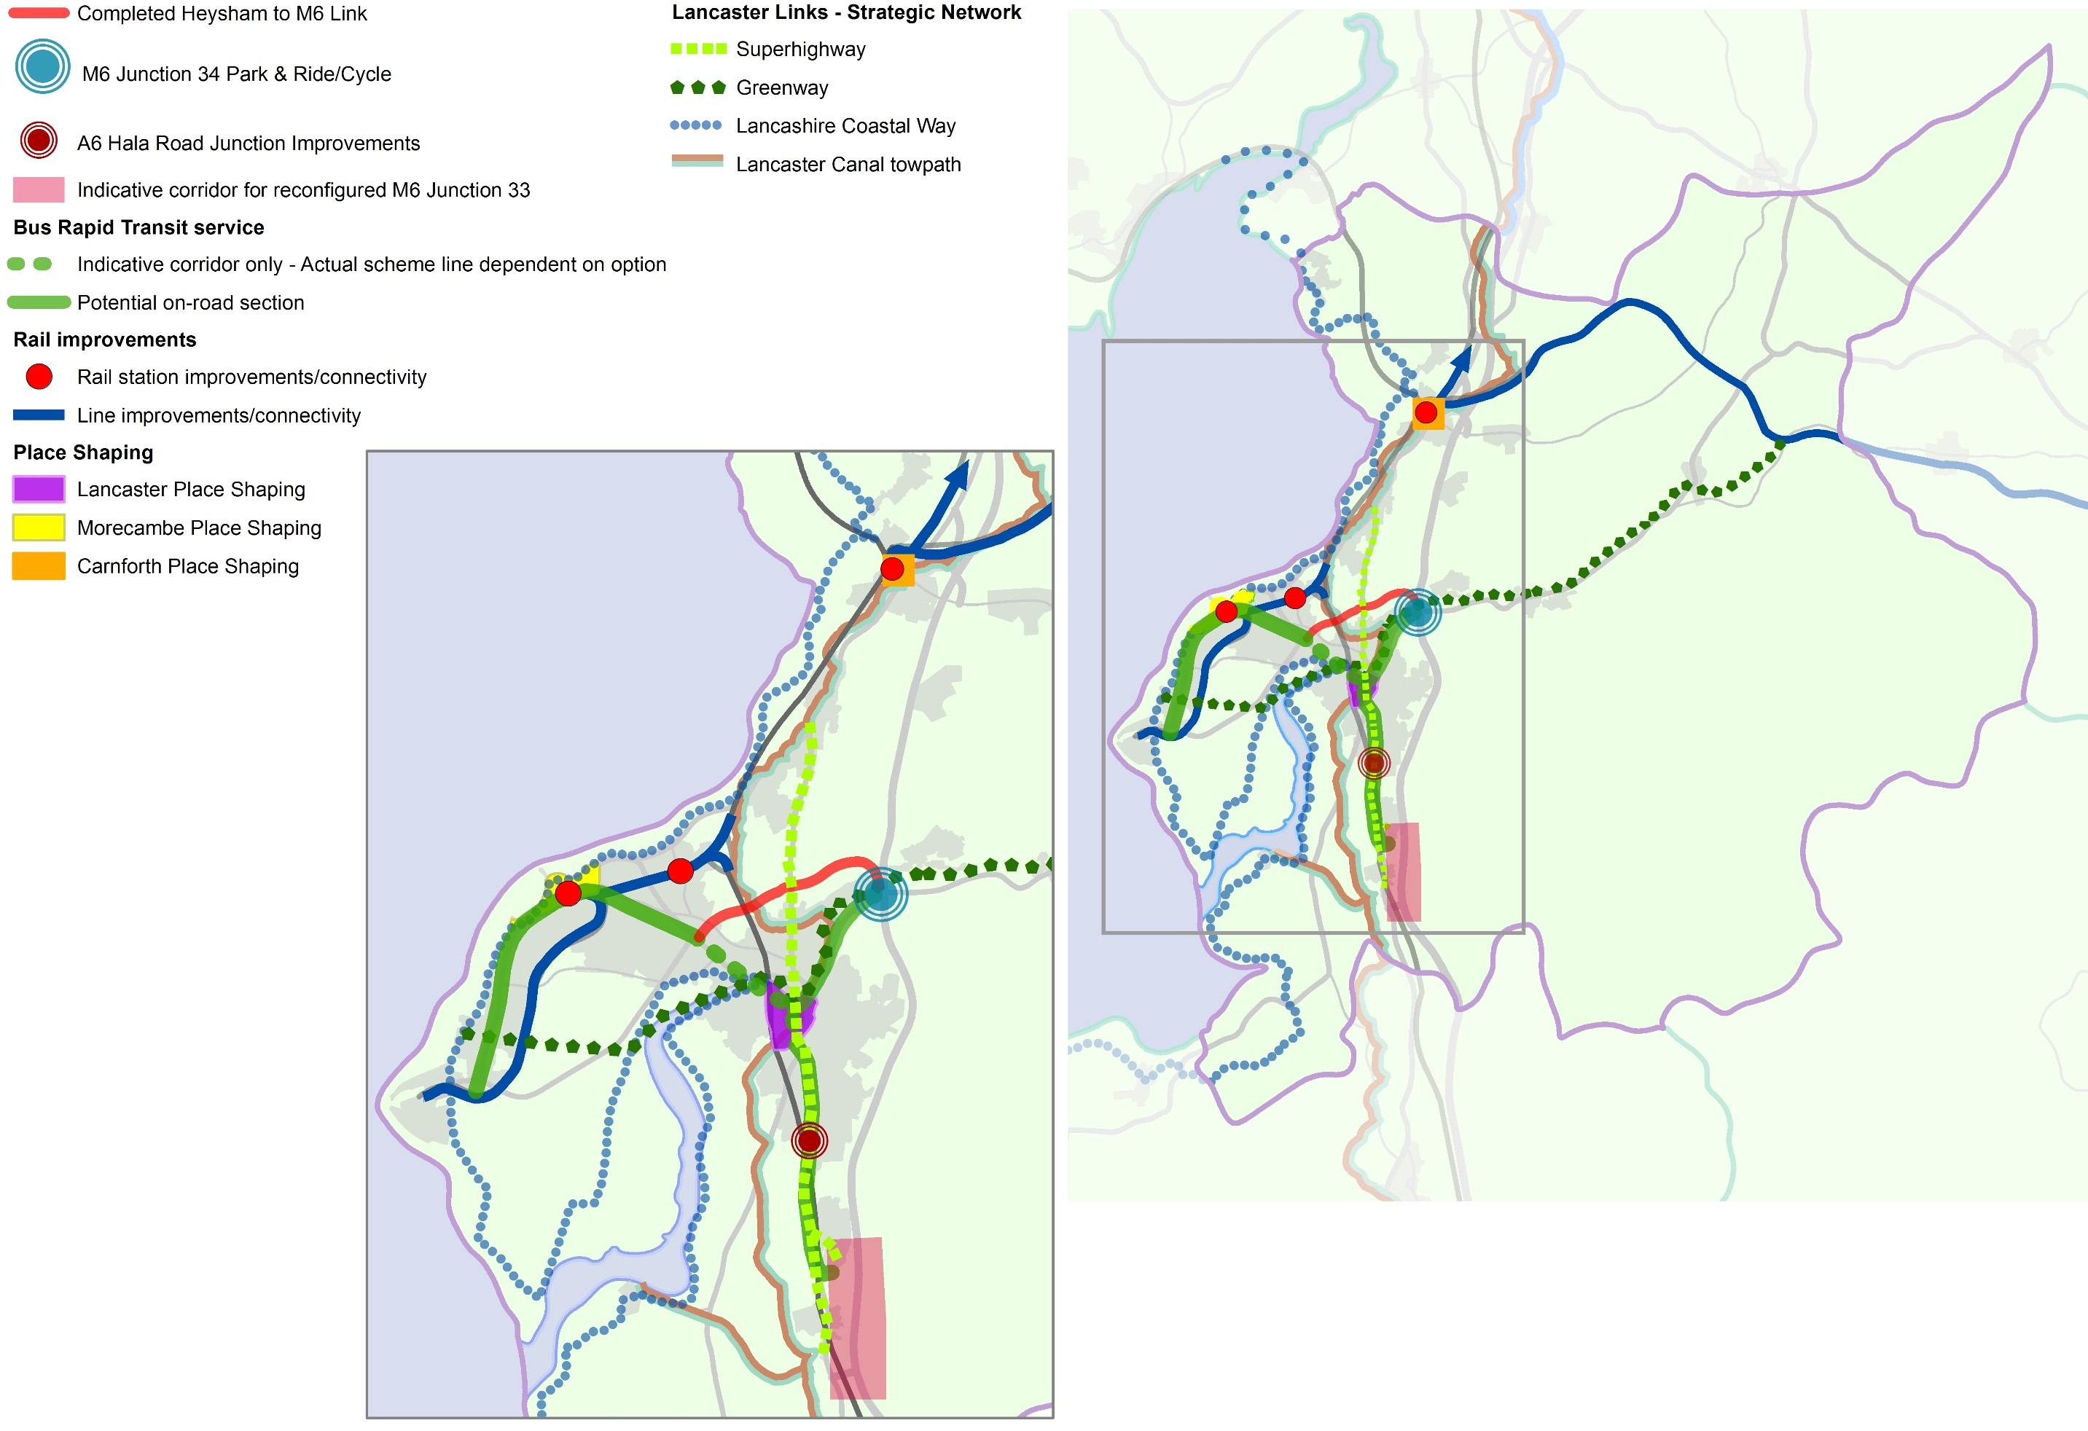

Lancaster City Centre
The City of Lancaster should be one of the jewels in the North's crown and has recently joined the England's Heritage Cities group, working with the tourist authorities of 10 other historic cities to promote its culture and heritage to visitors.

With outstanding heritage, and with a developing retail and leisure offer, Lancaster city centre has all the components to be an outstanding success. Combine this with its universities' pedigrees, the nationally significant Health Innovation Campus planned for South Lancaster and the potential for further growth through the allocation of land to meet future housing requirements and the city's future looks bright.

To achieve all this, though, there are two significant problems to be overcome. The city's existing transport networks are struggling now, so they cannot possibly be expected to cope with the future demand that would be put upon them. Then there are the health implications of the city centre's air quality problems, caused by transport, which are unlikely to improve without intervention.

At the heart of both problems is the city centre gyratory system, both the traffic that currently has to negotiate it and the way it operates. Solve this and Lancaster has the breathing space to develop and grow as a 'green' city where everyone's travel needs can be accommodated as sustainably as possible.

Without a congested gyratory system, all sorts of things become possible:

- Air quality stops being a problem and it is pleasant and healthy to be in the city centre. This is a key requirement for the increasing number of city centre residents, for all those who use the city centre, and for the businesses that rely on both to create a vibrant commercial and social environment.

- The physical environment changes for the better, with roads and public spaces becoming pedestrian focussed, high quality spaces where people want to linger.

- Walking around and across the city becomes a pleasure, and the history and architectural heritage of the city can be enjoyed by everyone as part of their journey as well as a series of destinations linked in a coherent way.

- Cycling becomes the normal way to travel around the area and no one thinks twice about whether cycling is convenient or safe as there are dedicated facilities and the roads are quieter.

- Public transport can be fast and reliable, with services running from South Lancaster through the city centre to Morecambe and Heysham and M6 Junction 34 using smooth running, quiet low emission vehicles.

- Wider aspirations for improving the cultural offer in Lancaster and expanding the city centre physically via the Lancaster Canal Corridor North site become easier, with major attractions linked within a pleasant, traffic free, environment.

To achieve this we need to remove as much traffic as we can from the city centre. Completion of the Heysham to M6 Link Road (Bay Gateway) will reduce through traffic on the northern, river crossing loops of the gyratory system by up to 40%, however it will have limited impact on the city centre.

Through traffic isn't the only problem, though. There are large numbers of cars coming into the city each day, many from local areas. We also need to remove as many of these as we can by providing alternatives that really work for people, offering genuine convenience beyond that of the car. Then those cars that still head for Lancaster need, where possible, to be intercepted before they reach the city centre.

By making more space available for buses, cyclists and pedestrians on the existing network, the city centre will become more attractive. Users of public transport will find their journeys become quicker and more reliable, and the city will be able to achieve its potential as a visitor destination.

The city centre can never be vehicle free. Businesses need vehicles for transport and there are plenty of people for whom the car, whether privately owned or a taxi, is their only option for mobility. However, making as many of these vehicles as possible low emission as quickly as possible will start the process of improving air quality however.

South Lancaster
Lancaster City Council needs to plan for around 13,000 to 14,000 new homes in the district over the 20 year period from 2011 to 2031. One of the options suggested to meet this requirement would involve an urban extension of Lancaster to the south of the city, including land already identified at Whinney Carr. Around 3,000 new homes could be built over the next fifteen years on a very large site that, in addition to the Whinney Carr site, would comprise land to the west of the A6 opposite Lancaster University. Land would also be identified for further development beyond 2031. A further 750 homes are also planned off Bailrigg Lane between Scotforth and the University.

In addition to its potential as a strategic housing location, South Lancaster is also home to Lancaster University, a world renowned academic institution consistently ranked amongst the top 10 UK universities for research and teaching. The University continues to grow and now has over 11,000 students, with an international profile that will see the University establish industrial links with key international markets. Through the Lancashire Growth Deal, the University has an ambition to develop a £170m world class Health Innovation Campus on an 11 hectare site adjacent to the main University campus, the first project of its kind in the North of England. The University is in the process of refreshing its Campus Masterplan to accommodate the Health Innovation Campus and potential development to the east of the M6. Development at the University is currently restricted due to the congested nature of the surrounding road network.

Lancaster City Council is also exploring the possibility of developing a 'Garden Village' as an alternative to a traditional urban extension. This would incorporate the existing University campus, along with the land referred to above, to create a high quality residential environment integrated with the University. The Bailrigg Garden Village is expected to be included in the deposit draft Land Allocations Development Plan Document as part of the Council's new draft Local Plan to be consulted on in early 2017.

The potential scale of development in South Lancaster will see a significant increase in the number of journeys, both local and longer distance, generated by the new housing and University expansion. To enable and support these transformational proposals, we have concluded that major improvements to the existing transport infrastructure that serves South Lancaster will be necessary. However, we also consider that they present an opportunity to support delivery of our proposed 'once in a generation' improvements to Lancaster's transport network, for example through a Community Infrastructure Levy. Furthermore, providing attractive alternatives to the car for local journeys could make the traffic generated by the new houses and jobs in the area potentially far less than would otherwise be the case.

How do we make it happen?
Before the Heysham to M6 Link Road (Bay Gateway) is fully open, we are required to publish a Lancaster City Action Plan setting out how we will manage traffic in the city centre. The Action Plan, which is a requirement of the development consent order for construction of the link road, must set out the short, medium and long term interventions that will need to be put in place to deliver our final vision for Lancaster city centre.

This masterplan presents our ideas for making the city centre work more effectively for public transport users, pedestrians and cyclists in the longer term. We will consider how these sustainable transport measures can be developed in stages that align with funding opportunities.

The point has been made already that no one element of the district's future highways and transport network can be appraised without consideration of the rest, in particular, the roads that make up the current city centre gyratory system, which is the key that unlocks Lancaster. However, until we have accurate information on how traffic patterns have changed following the opening of the link road, we cannot say with certainty that our plans will be viable or cost effective.

The masterplan therefore set out an indicative timetable for the further work needed to finalise all our options and to consult on detailed plans. This consultation is likely to take place in late 2018 or early 2019.

However, the opening of the link road does allow us to start the process of changing how traffic is routed around the district.

Caton Road Gateway
Key to this will be the positioning of Caton Road as the principal Gateway into the city centre for traffic from the M6, from both north and south. This will allow us to capitalise on the benefits of the link road and introduce a heavily managed environment for traffic in the city centre.

At Junction 34, we are building a Park and Ride/Cycle facility. Catering for just over 600 cars, the Park and Ride will intercept traffic coming from the motorway and from both sides of the Lune Valley. This site will open shortly after the link road. As well as catching a bus into the city centre, users will also be able to park and either walk or cycle, with a new link to the Lune Valley Ramble and Lune Millennium Park giving a direct and pleasant walking or cycling route into the city centre.

Initially, the site will concentrate on providing parking. However, we expect to gradually increase facilities at the site as more cyclists use it and there is sufficient demand for extra provision.

To fulfil our long term vision for the city, we need to make sure that the Park and Ride operates as effectively as possible. That will mean making the bus the quickest and most convenient way to get into the city centre. We will therefore put in place appropriate bus priority measures where we can as soon as we can, including on Caton Road. These measures will need to be tied to and inform our work on the city centre gyratory system.

Heavy Goods Vehicle Movement Strategy
Heavy Goods Vehicles (HGVs) are a major cause of poor air quality and add to congestion. The management of HGVs forms part of the complementary measures required for the opening of the Heysham to M6 Link Road. The opening of the link road will mean that HGVs no longer need to travel through the city centre or along Caton Road and across the Lune bridges, except for those that require access to locations in the immediate area. A Movement Strategy for HGVs across Lancaster District is being prepared and this will pave the way for a series of Traffic Regulation Orders that will limit HGV movements. These will ensure that HGVs make full use of the new link road and provide wider environmental benefits across the district. Consultation on the strategy took place in summer 2016.

Lancaster Reach – Bus Rapid Transit Network
The development consent order for construction of the Heysham to M6 Link Road required "a detailed feasibility study for a rapid transit route from Lancaster city centre, rail station and bus station to Morecambe and Heysham". We now consider this geography is in reality too limited.

The core corridor of the district, both in terms of residents and jobs, stretches from Heysham, through Morecambe to Lancaster city centre and on to South Lancaster. At each end of the corridor are large numbers of jobs, with the key retail and visitor destinations in Lancaster city centre and Morecambe. With current and potential development, both jobs and housing are likely to increase significantly along this corridor, especially in South Lancaster.
However, the reality of travel along the Heysham to South Lancaster corridor is that, despite every choice being available, there is no one option that allows for a fast and convenient journey its length. Rail doesn't serve South Lancaster and barely serves Heysham.

Buses run on many routes, with frequent services in places along the corridor but experience lengthy delays at a number of locations. Cars likewise get stuck in the city centre or crossing the river, and cyclists currently have limited direct routes that are safe to use.

Improvements to travel between South Lancaster, the city centre, Morecambe and Heysham are therefore urgently needed and whilst we wish to encourage cycling as much as possible, not everyone can cycle or wants to cycle all the time, particularly over longer distances. Lancaster therefore needs a high speed, direct public transport link along this core corridor once traffic in the city centre is reduced.

Improved public transport connections between Lancaster railway station, the Royal Lancaster Infirmary and the city's universities would also make travel to these sites much more convenient for people travelling from outside the district.

We therefore commissioned a detailed feasibility study for a rapid transit route between Heysham, Morecambe, the city centre and South Lancaster via Lancaster University; a much wider scope than the requirements of the development consent order. The study has taken into account the findings of the July 2008 Lancaster District Transport Vision and Strategy report, though no detailed feasibility or appraisal work was done at that time and a number of the options proposed clearly required significant and costly new infrastructure.

Things have changed significantly since 2008, however, and we can now make a much clearer assessment of the transport challenges and opportunities in the area across all modes of travel, linked to the wider economic and planning issues summarised elsewhere in this masterplan.

The study looked at several methods of providing a rapid transit route and clearly identified two options, Bus Rapid Transit and Tram/Train, which both scored significantly higher than the other four. Whilst Tram/Train performed well against most objectives, there are significant feasibility, deliverability and cost issues. In conclusion, it was agreed that the Bus Rapid Transit option would be taken forward for further investigation.

This has helped us to develop the 'Lancaster Reach' bus rapid transit concept further, incorporating the Park and Ride service from M6 Junction 34 to Lancaster city centre to create a 'Y'-shaped network of two routes, one linking Heysham and Morecambe to South Lancaster via the city centre, the other linking M6 Junction 34 to Lancaster University. Both routes will operate between the city centre and Lancaster University via the Royal Lancaster Infirmary, presenting us with a genuine opportunity to create a sustainable transport corridor linking the city centre and the Bailrigg Garden Village.

The next stage is to analyse the options that would allow improved public transport services that offer a competitive journey time compared to the private car. This would significantly increase the attractiveness of public transport, which would contribute to meeting our objective of reducing through traffic in Lancaster city centre as much as we can. Once we have completed this further work, we will be in a position to consult on detailed proposals.

The development of the bus rapid transit concept will also inform, and be informed by, the Lancaster City Movement Study outlined below, as how bus rapid transit services negotiate the city centre will be critical to its success.

One particular option we wish to pursue is the potential use of Ultra Low Emission Vehicles (ULEVs) on these routes, given that the corridor runs through urban areas and includes the city centre gyratory system, which is currently an Air Quality Management Area.

Lancaster City Centre Place Shaping
Lancaster City Council is developing a City Centre Masterplan and Investment Framework, which will evaluate Lancaster's key strengths and highlight opportunities to raise the city's profile and improve its attractiveness to residents, visitor and investors. We will work with the City Council to ensure that the masterplans complement each other and provide a unified direction for development and improvement of the city centre.

Completion of the Heysham to M6 Link Road (Bay Gateway) is expected to reduce traffic around the main city centre gyratory system by up to 10%. Whilst this is not a huge reduction, when coupled with managing Lancaster's approaches, it does offer the opportunity to begin the process of Place Shaping the city centre, which will ultimately include reconfiguring the city centre.

It must be remembered however, that at this early stage, the city centre will still need to accommodate some through traffic, including bus services, and this must be allowed for in any proposals brought forward in the short term. For this reason, we propose to look at options for changes to how the city centre gyratory system works but we do not propose any major, expensive changes to the roads and public spaces until we are sure these will still be needed.

A number of alternative ways the gyratory system could work were suggested in the 2008 Lancaster District Transport Vision and Strategy document, together with a very basic appraisal of how well they might work. We also received a number of responses to the consultation document that offer suggestions for practical ways to manage the existing network more effectively.

The River Lune is fundamental to Lancaster's history and its sense of place, but also affects how people and vehicles move into and out of the city centre today. Assessing the influence and potential of the river crossings will be an essential consideration in our plans for the future. We will also need to address urgently major maintenance issues relating to Greyhound Bridge.

Before we make any substantial or long term changes to the gyratory system or to city centre parking, we will need to be sure that those changes will work and not lead to rat-running of through traffic. We therefore need to do a more detailed appraisal of our options. Since the link road will fundamentally change the distribution of traffic in Lancaster, we can only do this work after the link road is open and our approach to managing Caton Road has been established.

Whilst this work will focus on the city centre, it will need to address issues in the wider area. As well as a core area in which we propose to make changes, there will be a much wider buffer area where the impact of changes will be assessed and where we will also look to resolve local access/safety issues that have arisen over the years. The influence of a number of critical destinations, including the hospital, universities and industrial areas close to the city centre, will be considered as part of this work.

Some problems arise directly as a result of the city centre gyratory and the road network that feeds it:

- There are safety concerns on streets that are used as rat-runs
- Cross-city movements are difficult without a car
- There are problems with severance that make access to local employment more difficult than it should be and
- Access to and from areas further from the centre can be difficult.

Changing how the gyratory system works cannot be done without detailed consideration of a number of other factors. How public transport, including the proposed 'Lancaster Reach' bus rapid transit services, will operate through the city centre is one. How the city centre supports walking and cycling is another.

If we are to encourage people to choose cycling or walking as their preferred way of travelling to and around the city centre, we must make sure that the facilities are in place to allow them to do so conveniently and safely. We intend to put in place a district wide network of strategic and local routes through the 'Lancaster Links' project, which is described in detail later in this masterplan. The city centre will be the hub for many of these routes.

We therefore need to improve routes for pedestrians and cyclists across the city centre, including from the Canal Corridor in the east to the castle, the railway station and St George's Quay in the west. We will build on the 'Square Routes' project, initiated by Lancaster City Council in 2008 and running since then. This project aims to rejuvenate the city centre's public realm in order to make it a more attractive location to visit and in which to do business. In particular, we will look to improve pedestrian provision at specific points on the gyratory system to link the Square Routes.

How parking operates is also critical. As well as needing to ensure that parking is available, reconfiguring the gyratory system gives us the opportunity to reduce traffic going into the city centre by

making it more attractive to park further away and then catch the bus, walk or cycle.

Without removing through traffic, the city centre will remain dominated by the car, although to a lesser extent than now. There will also be little prospect of providing truly world class public transport as the city centre roads will not have sufficient spare capacity to enable the introduction of public transport priority measures that such systems need.

Clearly this could mean changing where people are able to park; in doing so, we will make sure that those people who need to drive into the city centre and park can still do so. We will also be able to use these changes to make it easier for ultra-low emission vehicles to park in or close to the city centre, encouraging up take of these cars and also reducing city centre pollution.

With the increasing promotion of Lancaster as a tourist destination, there must also be provision for coach parking and convenient drop-off points for visitors.

We will bring all these elements together and look at them in detail in a Lancaster City Movement Study, which will give us a clear understanding of our options for transforming the city centre.

Running in parallel to the Lancaster City Centre Place Shaping work are two further programmes: 'Lancaster Links' and Ultra Low Lancaster. These are described later in this masterplan and will both inform and benefit from our place shaping work in the city centre.
Reconfiguration of M6 Junction 33
Our vision includes the reconfiguration of M6 Junction 33 to support the significant growth potential of South Lancaster including developments such as the proposed Health Innovation Campus at Lancaster University and housing at Whinney Carr and Bailrigg.

The existing road network providing access to South Lancaster is constrained; in particular, the A6 where it passes through the village of Galgate. Here the traffic lights at the junction with Salford Road and Stoney Lane in the village centre lack the capacity to accommodate existing traffic flows, with long queues forming frequently on both A6 approaches. Consequently, the area around the junction is a declared Air Quality Management Area. Without any significant improvement, the additional traffic generated by the new developments in South Lancaster will only exacerbate these problems.

A completely new motorway junction so close to the existing M6 Junction 33 would not be acceptable to Highways England, so we are investigating options to reconfigure the existing junction by relocating part of it further to the north. Such an arrangement would enable residents and businesses in South Lancaster to access the motorway network without having to travel through either the city centre or Galgate. A significant amount of traffic will also be removed from Galgate, resolving the issue of poor air quality in the village centre.

The slip roads on the south side of the existing junction would remain where they currently are, meaning that traffic travelling between the north of Wyre district and the M6 south would not need to pass through Galgate.

However reconfiguring the junction will be expensive. It will not be affordable by either the County or City Council without Government support. The Lancashire Enterprise Partnership has included the reconfiguration of Junction 33 as a priority project in its bid for Growth Deal funding submitted to the Government in July 2016. A substantial private sector contribution from developers will also be necessary to secure its delivery.
A6 South Lancaster to City Centre Corridor
The A6 corridor linking South Lancaster with Lancaster city centre will become increasingly important as housing developments and the expansion of Lancaster University begin to take effect. Delivery of housing growth in South Lancaster will be more acceptable if we can demonstrate that a reconfigured M6 Junction 33 will be accompanied by significant investment in developing attractive, sustainable alternatives to the car, particularly for local journeys and for trips between South Lancaster and Lancaster city centre.

There will be some reduction in traffic on the A6 through South Lancaster as a result of the opening of the Heysham to M6 Link (Bay Gateway) and the establishment of the Caton Road Gateway as the key access route to the city centre from the M6. This will facilitate the introduction of better provision for cyclists and public transport in the corridor, including the proposed bus rapid transit services. This will be critical to the development of South Lancaster, whether to the University's Innovation Campus with its need for better links to the Royal Lancaster Infirmary and other health facilities in and around the city centre, or to future housing growth and the development of the Bailrigg Garden Village.

We will produce and consult on a Route Management Plan for the A6 corridor between the city centre and South Lancaster, linked to further work on developing the bus rapid transit services outlined earlier, to create a genuine sustainable transport corridor.

The A6/Hala Road junction in Scotforth, south of the city centre, is already a significant problem to negotiate for cyclists and pedestrians as well as for motorised vehicles. By encouraging traffic accessing the city centre from the M6 onto the Caton Road Gateway, we will free up some road space on the A6, which allows us to begin the process of changing the A6 to a local distributor road.

As a first stage, we intend to reconfigure the Hala Road junction to work better for vulnerable road users and provide dedicated cycling provision for the direct Lancaster to University/South Lancaster route along the A6, as well as giving crossing options for current off-road routes such as the official signed route from Lancaster promoted by Lancaster University to its staff and students. The redesigned junction will also provide opportunities to incorporate bus priority measures in support of our proposed 'Lancaster Reach' bus rapid transit services.

Once a route management plan for the A6 through South Lancaster is in place, we will consider whether renumbering the A6 between Junction 33 and the Pine Lake roundabout north of Carnforth would

be helpful in further discouraging through traffic. The classification and number of a road gives a powerful message about what traffic is expected on it and how that traffic will be accommodated. Anyone looking at a map of an unknown area expects 'A' roads to be more important and better to use than 'B' roads, with lower numbered roads more important than higher numbered ones.

Figure 13: What we need to do - Lancaster
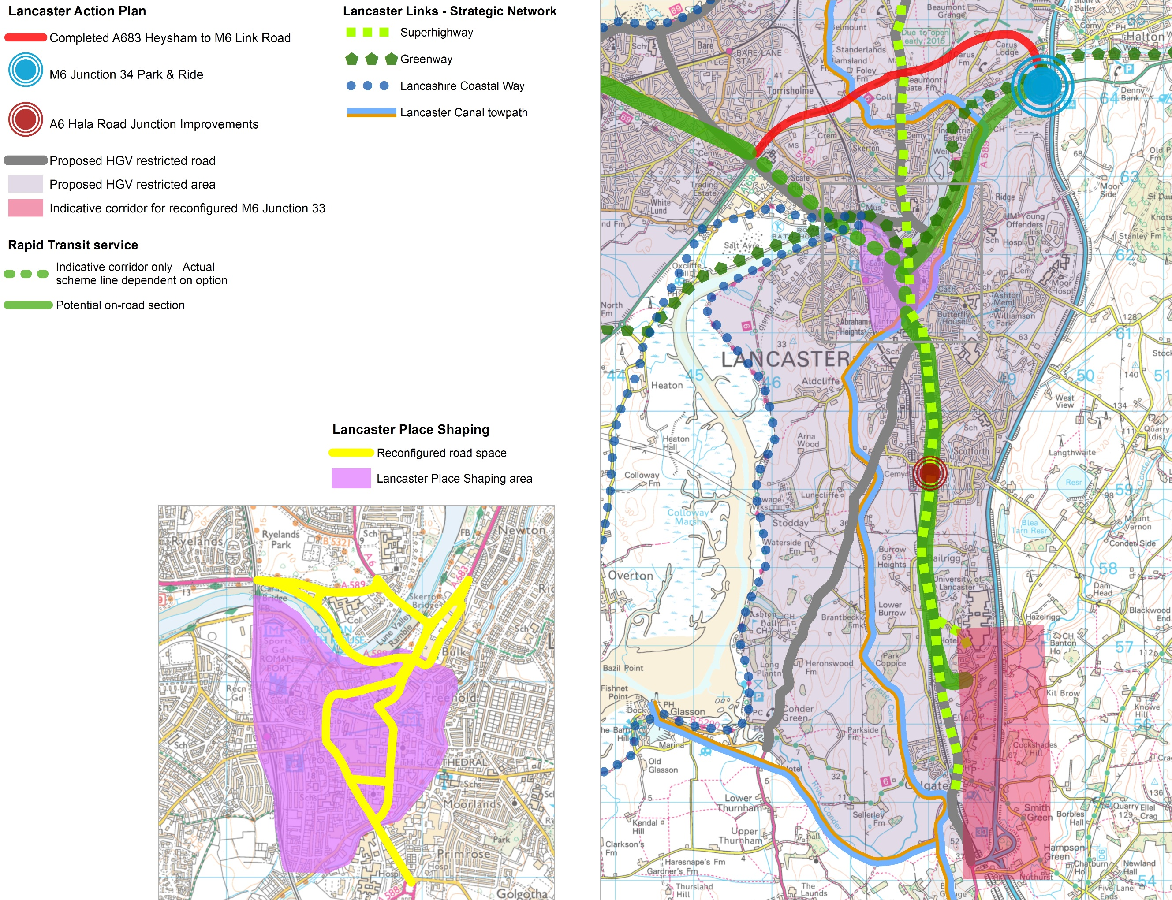

Morecambe
Morecambe has possibly the most spectacular coastal view in the country, which should make the town a key visitor destination. However, the reality is far from this and although day visitor numbers are increasing, far more could and should be done to make Morecambe the successful and lively town it should be, for both residents and visitors.

At the moment, though the seafront and some of the shopping areas are often busy, this footfall doesn't actually benefit the town centre as much as it might, because many people who come to Morecambe don't spend much time actually in the centre.

Creating an environment where people want to spend time will therefore be critical to Morecambe's rejuvenation. More time spent in the town centre will generate more demand for Morecambe's businesses, which will lead to more investment, making still more people want to come to Morecambe and so on. This is the focus of Lancaster City Council's Morecambe Area Action Plan (MAAP), which sets out what needs to be done to make central Morecambe flourish.

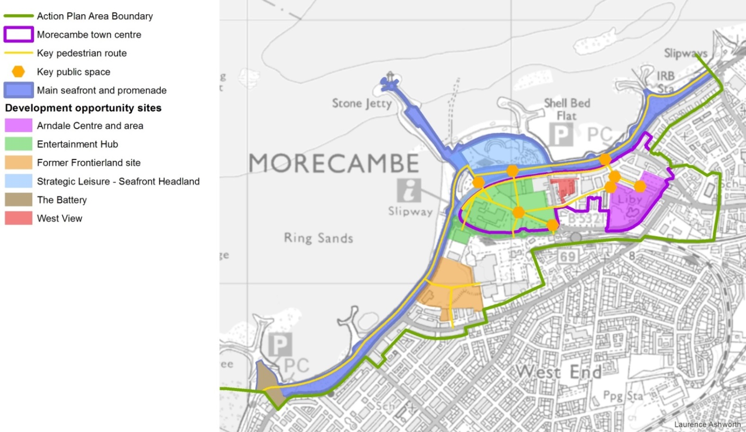
Key to the MAAP is connectivity. The seafront needs to be better connected to the town centre. The town centre needs to be less fragmented. Poulton is too separated from the West End. The whole town needs to be better connected to the rest of the district and to the rest of the country.

Producing this transformation in connectivity for Morecambe will mean that changes, some of them major, need to be made to the travelling experience of both residents and visitors. The Morecambe of the future will see:

- A welcoming arrival (and pleasant departure) for everyone whether they arrive on foot or by cycle, or by car, train, bus or coach;
- Pleasant, easy to follow connections for pedestrians helping concentrate footfall and activity in the heart of the town centre;
- Clear signing of vehicle routes to and from Morecambe and well located long and short stay parking options in central Morecambe;
- A modern rail station which is easy to get to by all modes, and which has regular, high quality services to Lancaster and beyond;
- High quality, rapid public transport links to Heysham and to Lancaster, with proper facilities for passengers;

- Well integrated coach facilities, with passenger facilities integrated into the town centre and well placed layover facilities;
- A seamless join between the town centre and the seafront which makes it much easier, more pleasant and inviting for people to walk between the two;
- A town centre that is well structured and connected, that is easy to understand and navigate, with high quality roads and public spaces that people enjoy spending time in;
- Better connections for pedestrians to and from adjacent residential areas (including the West End) so these increase numbers of people and activity into the centre; and
- Easy access to employment and education.

Whilst the MAAP focuses on central Morecambe, the scope of our highways and transport masterplan is wider. Changes to the town centre, particularly changes to how traffic is routed, will have implications across a much wider area. Improving access to education and to employment will need improvements outside the MAAP area.

Transforming the internal and external connectivity of a town is not a quick process. The MAAP, which sets the stage for this

Figure 14: The Morecambe Area Action Plan

transformation, has a plan period of the six years until 2021, but the actual programme set out in this masterplan is longer. However, with the opening of the Heysham to M6 Link Road (Bay Gateway) in autumn 2016, the first step in Morecambe's regeneration will have been taken.

For the first time, the link road will provide a direct connection between the M6 and Morecambe and Heysham, with no need for traffic to fight congestion on the Lancaster gyratory system. This direct, reliable route will make journeys to the peninsula much quicker and easier, making it much more attractive for businesses to locate there, for residents to live and work and for visitors to come for the day or longer.

With this direct connection in place, traffic that currently uses the coastal route (A589/A5105/A6) between the peninsula and the M6 at Junction 35 (Carnforth) and vice versa will be redirected via the link road, removing HGVs and other traffic from Marine Road and making it easier to integrate the town centre and the seafront. Removing HGV traffic in particular from inappropriate roads will enable a new approach to traffic management that is more fitting for what we want Morecambe to become.

Figure 15: What we need to do - Morecambe
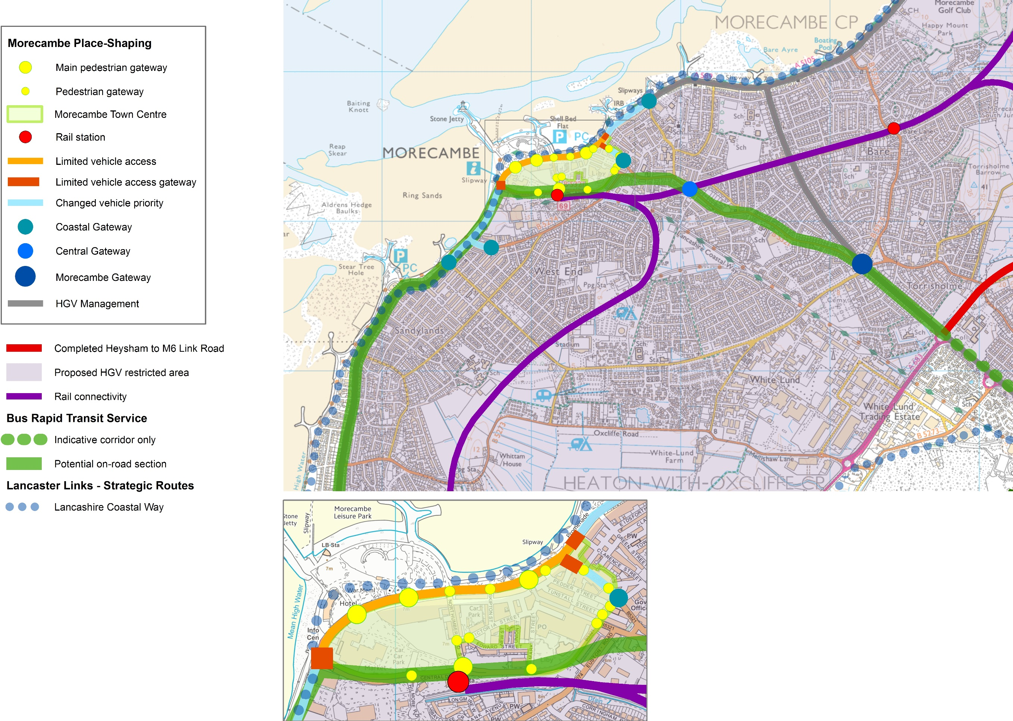

How do we make it happen?
As in the City of Lancaster, the opening of the Heysham to M6 Link Road (Bay Gateway) in autumn 2016 will be the point at which we can start to make significant changes to how travel and transport work in Morecambe. However, we haven't been waiting until then to begin the process of changing Morecambe's roads and public spaces to fit their future role.

'Place shaping' is about linking all aspects of a community; social and cultural, economic, environmental, services, housing and the built environment and most importantly travel and transport, to build sustainable places where people want to live and work, now and in the future. Our Morecambe Place Shaping programme will focus on the highways and transport elements to put in place the fundamental changes needed to make the vision of the Morecambe Area Action Plan (MAAP) a reality.

The first strand of the programme is the seafront. The seafront is Morecambe's unique selling point and how the seafront works must reflect that. It must first and foremost be a place to enjoy the views, a place predominantly for people not vehicles. We will therefore work with the City Council and other stakeholders to put in place definite proposals for how the promenade will be developed as a shared space.

This work will need to include the role the seafront plays in wider networks such as the Lancashire Coastal Way, the Bay Cycle Way (launched in June 2015) and as the starting point for the Way of the Roses coast to coast cycle route. The Silverdale to Cleveleys section of the new England Coast Path passes through Morecambe and is expected to be ready in 2018. The programme will also need to consider the future role of the seafront as a place for events.

The potential redevelopment of the old Frontierland site offers the first opportunity to start the transition from through route to leisure space and we are working with the developer both to improve how Marine Road West looks and also how it functions for pedestrians, including lowering the speed limit to 20mph.

Once the link road is open, we will be able to consult on and then put in place restrictions on vehicles, to prevent through traffic using the seafront as a route between Heysham and the A6. Use of the promenade by heavy vehicles will also be addressed as part of the HGV Movement Strategy mentioned above.

How the seafront links to the town centre and how the town centre can be reinvigorated to be at the heart of a reinvented Morecambe is the second strand of the place shaping programme.

The MAAP vision is for a town centre with, at its eastern end, traditional streets with a distinctive offer, including many independent retailers, and anchored by the Arndale Centre. This is complemented by areas to the west across Northumberland Street that are more contemporary in character but with heritage assets incorporated. Woven into this is a range of town centre uses, including offices, to give a thriving service centre.

Marine Road Central and Victoria Street respectively will be the axes that bind this town centre together for pedestrians, with Marine Road Central being the seafront experience and Victoria Street, one block back, offering an alternative more sheltered route and a quality experience more akin to that of a traditional high street.

Critical issues to be addressed in this vision cover all aspects of travel and transport in Morecambe; it is not possible to make significant improvements to the look and feel of the town centre without making changes to how vehicles use it.

We will therefore work with the City Council and other partners to develop a comprehensive town centre place-shaping programme that supports and links to the development of the seafront and which will include:

- Enhancing the town's natural gateways to give a fitting sense of arrival for all modes, including Central Drive as the main vehicle approach, the rail station and key points of approach for pedestrians and cyclists. Other arrival points for public transport or for a future bus rapid transit service would also be vital gateways.
- Managing how vehicles reach the town centre, including how they are signed and where they park. This will not only mean that we can keep traffic away from central pedestrian areas but that, where appropriate, current car parks can be used for other purposes. Fundamental to this will be maximising the benefits of traffic reductions from the new link road and ensuring that extra traffic that results from the economic benefits of the new road is catered for.
- Making sure parking provision is fit for purpose, so that it is easy to park quickly on arrival, with high quality pedestrian and cycle links into the town centre and on to the seafront. This will reduce the number of vehicles that currently circulate to find preferred parking locations and ultimately can be used to encourage more sustainable modes of arrival.

- Ensuring that coaches have high quality drop off/pick up points that are well integrated to Morecambe's leisure offer, with appropriate, well located layover facilities. Goods servicing also needs to be managed to ensure that it is efficient for business without compromising pedestrian routes and areas.
- Connecting the seafront and neighbouring areas to the town centre by clearly signed, attractive direct routes that will encourage people into the town centre and when there, to spend time in attractive roads and public spaces. In particular, there needs to be a clear pedestrian gateway from the seafront into Euston Road as the main approach to the town centre from the east.
- Key routes for pedestrians and cyclists through high quality public spaces which look attractive and feel safe to be in, both during the day and in the evenings, with well maintained and lit roads and footways that tie in to wider pedestrian and cycle routes.
- Better facilities for public transport, both bus and rail, with proper interchange between the two and good links into the town centre and the seafront. Readily available information and safe, well-lit waiting areas will need to be part of this; the rail station in particular does not offer an attractive arrival experience.

Morecambe Bay Connectivity
Morecambe is Lancashire's major gateway to Morecambe Bay and should be at the heart of connections around the Bay. The town's external connectivity is therefore vital to our place shaping programme.

Whilst access by road will be transformed with the opening of the Heysham to M6 Link Road (Bay Gateway), other connections by rail, bus and cycle will not be. In particular we need to understand what benefits improving connectivity around the Bay would bring for Morecambe and the coastal towns and villages between the Heysham peninsula and Silverdale, including links into the Lake District National Park.

We will therefore undertake a Morecambe Bay Connectivity Study which will explore whether there is a strategic case for improvements to be made across all modes of sustainable transport around the coast of Morecambe Bay. Working with our partners, including Cumbria County Council, Lancaster City Council, Wyre Borough Council, South Lakeland District Council and Barrow Borough Council, we will seek to establish what evidence there is for improving connections around the Bay so that the whole Bay area benefits. The study will look at what enhanced connectivity could achieve as well as options for delivering it.

Rail
We need to address the issue of poor rail connectivity around the Morecambe Bay area. The Morecambe Bay Connectivity Study will therefore examine the issue of Morecambe's rail connectivity. We believe that, given the increasing demand for travel on the Lancaster to Morecambe line even at its current standard of operation, there is the potential to make much more of the line if it could be improved. This will be particularly important to ensure that job opportunities further afield are accessible and that Morecambe can capitalise on increasing tourism in the North West as a result of the increasing popularity of Manchester Airport and potentially the High Speed 2 rail route.

This study will quantify just how enhanced rail connectivity can support Morecambe's regeneration and therefore how the Morecambe line needs to improve. Options for improvements to the service between Morecambe and Lancaster could include making it easier to get to stations, better station facilities, better rolling stock and service frequency and electrification of the line.
Electrification would potentially make it easier for the resort to benefit from the wider electrification of routes across the North

West in future rail service franchises with direct services to places such as Manchester and Liverpool.

Once we have evidence of the benefits of improving the line will deliver, we will be in a better position to influence future rail industry plans and programmes.

Bus services
Access to and from Morecambe by bus will be enhanced significantly through the development of the 'Lancaster Reach' bus rapid transit services discussed earlier. This is particularly important given that Morecambe does not have high car ownership, particularly in more deprived areas where, in the absence of a car, access to education, employment and healthcare can be an issue.

There may also be potential for better connections by bus around Morecambe Bay and into the Lake District National Park. We will explore whether a case can be made for improvements through the Morecambe Bay Connectivity Study.

Cycling and walking
The potential for improvements to active travel facilities in the Morecambe Bay area will also be explored through the Morecambe Bay Connectivity Study. The 'Lancaster Links' network outlined later in the masterplan will be integral to this and will form part of the Cycling and Walking Delivery Plan for Lancashire. For the whole of the Bay area, there may be opportunities to improve public access to the coast with links to the Lancashire Coastal Way and the new England Coast Path.

The launch of the Bay Cycle Way provides enhanced leisure links around the bay, but no real increase in connectivity around the bay. With no crossing of the River Kent below Levens, cyclists have a long detour between Arnside and Grange-over-Sands; what is 5km for the train, is over 20km for cyclists.

Whilst this might appear to be a Cumbrian issue, providing a cycle crossing of the River Kent alongside the Arnside railway viaduct could have significant benefits for the whole of Lancaster district. For Morecambe, it would dramatically increase the attractiveness of the Bay Cycle Way and bring visitors to the town. For Carnforth and the north of the district, it would also increase visitor numbers, but could also open up further commuting options for at least part of the year.

Heysham
South of Morecambe lies Heysham, which is the third largest settlement in the district after Lancaster and Morecambe. It is a local service centre, with an historic village core located close to the sea. The old village is picturesque and has a number of notable historic features such as St Patrick's Chapel and the rock hewn graves located on the headland.

However, away from the historic core, the main features of Heysham are economic, in particular the Port of Heysham, Heysham nuclear power stations with their associated National Grid infrastructure and large tracts of brownfield land. The port is Lancashire’s key link for traffic across the Irish Sea to Ireland, Northern Ireland and the Isle of Man, handling bulk cargo and Ro-Ro (roll on roll off) traffic. There is also a regular passenger service to the Isle of Man. Historically, growth at the port has been constrained by access problems but this will be addressed with completion of the Heysham to M6 Link Road (Bay Gateway).

Heysham 1 and Heysham 2 Power Stations have been supplying electricity to the National Grid since the 1970s and 1980s respectively. Decommissioning of both reactors is due to take place by 2030, however, Heysham remains a nominated site for a new nuclear reactor via the National Planning Policy Statement on Energy. Beyond nuclear energy, the South Heysham area is increasingly providing opportunities for a wide range of renewable energy projects and ancillary businesses. This includes servicing Irish Sea offshore wind farms.

Away from the port and the power stations, the wider South Heysham area is a key location for business and employment and a number of sites have been identified within the City Council’s development plan for economic development and growth. The improved access to the South Heysham area on the opening of the link road gives potential for significant economic growth to be achieved.

As part of the local development plan, the City Council will be looking at further locations for economic growth within the district. With improved accessibility and the existing mix of uses, it is likely that the further growth required will be delivered in the South Heysham area through the ‘Heysham Gateway’ project, which seeks to regenerate and where appropriate expand existing employment areas to make them more attractive to the market.

There are also a number of allocated and proposed residential developments. In particular, given its isolated location, development of the former Pontins Holiday Camp at Heysham Towers will need to consider how sustainable transport can be provided. Further to this expected development, the Strategic Options consultation of 2014 identified a series of options to meet future development needs in the district, which included an option of delivering development across all rural settlements within the district (such as Overton and Middleton) to meet future housing requirements.

The development of Heysham as a whole will therefore require a number of transport solutions to be in place:

- Significant volumes of freight traffic must be able to move easily to and from the link road without adversely affecting residential areas. The opening of the link road will ensure excellent, direct, reliable connections by road to the motorway network, but we must ensure that freight vehicles can readily access the link road from the local network.
- Sustainable commuting to Morecambe and Lancaster will need to be supported, particularly in the light of this masterplan's proposals to reduce car traffic. Rail travel could be part of this picture and will be considered in the Morecambe Bay Connectivity Study.
- New employment in Heysham must be able to be accessed readily by sustainable modes where possible, without reliance on car ownership. The proposed 'Lancaster Reach' bus rapid transit services and the 'Lancaster Links' cycle programme will provide much of this access, but we will need to ensure that local public transport supports development.
- Leisure traffic to Heysham will likewise need to complement other masterplan proposals. In particular, the 'Lancaster Links' and Lancaster Ultra Low programmes described later offer opportunities to capitalise on Morecambe Bay's unique geography and the district's potential green tourism offer.

How do we make it happen?
Much of what we need to do to support Heysham's future is already set out in this masterplan. However, we also need to ensure that the local road network fully supports the Heysham to M6 Link (The Bay Gateway) and allows vehicles, especially HGVs, to, where possible, access the link road without travelling through our communities. To this end, we will undertake a review of the highway network around the South Heysham area and put in place a programme of measures to ensure that HGV traffic is using the network appropriately and can access the link road quickly and conveniently in order to reach the M6 regardless of whether intending to travel north or south.

This could include connecting Imperial Road with Middleton Road and Main Avenue, thereby improving access to Heysham Business Park. Imperial Road currently only serves the Middleton Waste Transfer Station, but opening up this road would provide direct access to the M6 link road for a number of other businesses, removing the need for HGVs to access this area via Middleton Road and the Trumacar Roundabout and supporting delivery of the Heysham Gateway project.

We will then continue to monitor development proposals to ensure that any increase in HGV traffic does not cause future issues in the local area. As part of this, we will continue to review sustainable transport to and from Heysham, Middleton, Overton and local employment areas. We will, if and when appropriate, work with rail industry partners and relevant businesses to look at the potential to transfer freight onto the rail network.

These measures will complement the HGV Movement Strategy for Lancaster described above.

Heysham to Lancaster Greenway
There is already evidence of significant demand for a cycle link between Heysham and Lancaster. The completion of the Heysham to Lancaster Greenway will be the first of the new 'Lancaster Links' strategic cycle routes, described below.

Carnforth
Carnforth is the key small town serving the north of the district. It developed as a railway town and although the station is still served by the Furness and Bentham lines, West Coast Main Line trains no longer stop there. Congestion in the town centre is currently made worse by traffic to and from the north travelling between the M6 and Morecambe and Heysham. This has led to issues with poor air quality at the centre of the town.

Lancaster City Council needs to plan for around 13,000 to 14,000 new homes in the district over the 20 year period from 2011 to 2031. One of the options suggested to meet this requirement would involve a large extension of Carnforth southwards into the Green Belt that could provide for more than 1,250 new homes and employment land.

Should development on this scale take place, the town’s role as a key service centre would become all the more important to both new and existing residents.

Our vision for Carnforth is therefore that it will become a hub for the north of Lancashire, with more pleasant public spaces and improved air quality making the town centre a much more attractive place to live and visit. The railway station will be integral to the town centre with improved rail links providing convenient access for commuters to jobs around Morecambe Bay and across into Yorkshire. The town will have become a gateway for visitors coming to enjoy the countryside and wildlife of the area, as well as Carnforth's important railway heritage, with easy access for walkers and cyclists using the Lancaster Canal towpath, the new England Coast Path and the proposed 'Lancaster Links' network.

Figure 16: What we need to do - Carnforth

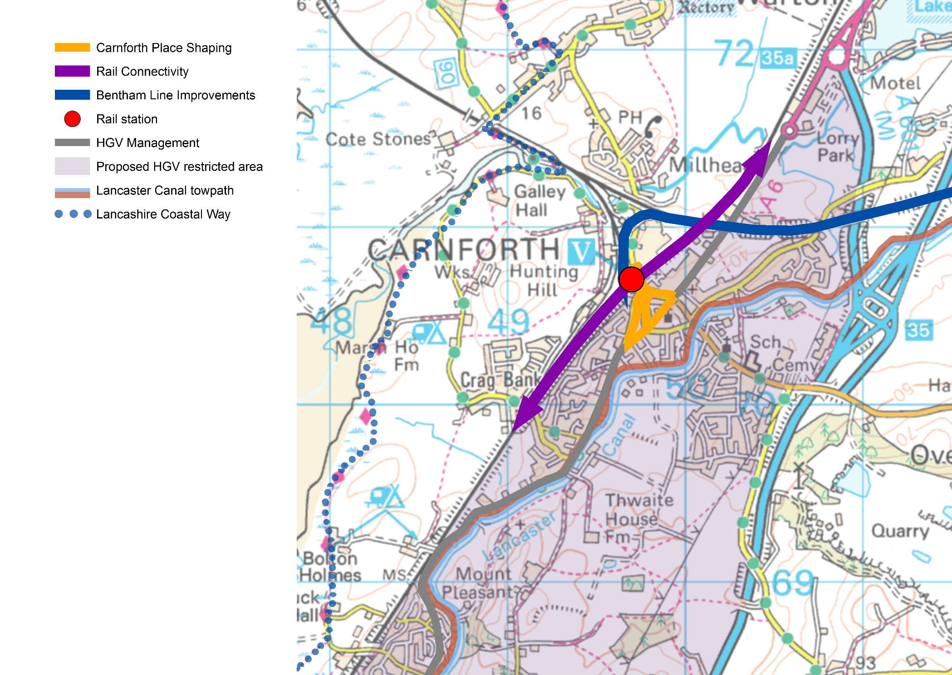

How do we make it happen?
Carnforth Place Shaping
Like so many small rural towns, Carnforth is becoming more reliant on the visitor economy, particularly given its proximity to so many outstanding natural landscapes. With its focus on the touring market, which by its nature tends to be car dependent, it is ever more vital that the town provides an attractive and welcoming centre to encourage visitors to shop locally rather than drive to the large superstores in Lancaster or Kendal.

However, the centre of the town around the signalised A6/B6254 junction sees very heavy traffic. It has been declared an Air Quality Management Area and is not a pleasant environment for pedestrians or cyclists, although with the completion of the Heysham to M6 Link Road (Bay Gateway), much of the heavy goods vehicle traffic currently on the A6 should be removed. Market Street, the main shopping street that runs between the A6 and the station, will see no direct benefit though.

We therefore propose to pursue a programme of pedestrian and traffic improvements to the centre of Carnforth, focusing on Market Street, with a view to creating a space which, whilst allowing traffic to flow, is far more user friendly for those on foot or on cycle. As well as making the shopping area itself more attractive, it will help to ensure that people feel comfortable travelling by more sustainable modes.

When we know how traffic volumes have changed once the link road is open, and we have greater certainty as to what development will happen in the area, we will consult further on options for the town centre's roads and public spaces. These options will set out alternative ways that traffic will be routed in the town centre, including HGV traffic from Warton Road, and how much extra provision there will be for cyclists and pedestrians.

However, we would want to complement the work done in Lancaster city centre and so our preferred option is likely to be a managed space where pedestrians are able to cross the road where they want to and traffic travels slowly through the area, in a manner similar to Fishergate in Preston.

These changes will complement both the cycle and electric vehicle strategies for the district and help improve Carnforth as a hub for interchange with the rail network.

Carnforth rail connectivity
The main line platforms at Carnforth railway station were largely removed in 1970, prior to the electrification of the West Coast Main Line (WCML) leaving the station with working platforms for the Furness and Bentham lines only. Despite this, 204,000 passengers used the station in 2014-15 to start or end their journeys, and although this was a decrease of 2,000 on the previous year but 27,000 higher than in 2009-10. Some of this patronage is due to the popularity of the station's 'Brief Encounter' café and visitor centre, and also the railway heritage infrastructure around the station. However, with an attractive market town and walks into the outstanding countryside around it, Carnforth could be far more of a visitor destination, to the economic benefit of the town.

Carnforth offers good services to Lancaster and the south with connections into London and Birmingham services possible at either Lancaster or Preston. Whilst the WCML passes through Carnforth station, passengers have to travel to Lancaster first for services to Kendal, Windermere and Scotland.

There is local support for the reinstatement of the main line platforms to improve connectivity to the north. Whilst it is currently extremely unlikely that trains bound for Scotland would stop at the station, the key service would be that linking Manchester with Kendal and Windermere. There is already a strong commuting movement between the Carnforth area and the South Lakes and this could increase if Carnforth or the surrounding area sees significant housing growth.

Given the limited parking at Carnforth and the undesirability of drawing more car traffic into the town, Carnforth would not necessarily function as a Park and Ride for the wider area, but the ability to change to northbound services from both the Bentham and Furness lines could be attractive.

However, the decision to stop trains at the platforms if they were reinstated is one that the rail industry would take and which would require operational trade-offs; the journey time of a service that called at reinstated platforms would be increased and there could also be implications for other services using the WCML, which is already a very busy track and will become busier on the opening of the HS2 high-speed railway.

There are a number of changes affecting the routes through Carnforth over the next few years:

- New Northern and Trans Pennine Express franchises started in April 2016.
- Electrification of the Oxenholme to Windermere line is planned but there is no fixed date for completion.
- Northern Hub Phase 1 completion, due to be completed by December 2017, will result in changes to service patterns across the North West. Northern Hub Phase 2 completion is expected by December 2019 and will result in further changes.
- The Furness Line will become part of the Northern Connect network with fast trains from Barrow to Manchester and Manchester Airport at least 8 times a day from Dec 2017 using new or highly refurbished rolling stock.

What the impact of all these changes will be on the potential for WCML trains to call at Carnforth in the future is not currently clear, and will not be so for several years. Furthermore the future pattern of new housing development could also have a significant impact on the potential viability.

Whilst work has been done on the viability of reopening the main line platforms in the past, such work would need to be refreshed in order to put forward a case for reinstatement to Network Rail. There is also a potential alternative to reinstating the main line platforms which would allow services to stop at the current platforms before rejoining the WCML. Whichever solution was pursued, there would be substantial capital and revenue costs involved and so a strong economic case would need to be demonstrated to secure funding.

At a time when the County Council's resources are tightly stretched, we do not feel it would be appropriate to produce a business case for northwards connectivity at this moment in time, given there are so many unknowns affecting what could be expected of the station.

However, we do feel that improved northbound connectivity is worthy of further investigation and we will take the lead on this.

There have also been long standing aspirations to develop better linkages between Carnforth and both Barrow and Ulverston to benefit from the economic growth potential at the proposed Sellafield (Moorside) Nuclear Power Station and at the GlaxoSmithKline site in Ulverston. The north of Lancaster district could provide a residential base to some of the workers employed on these sites and so could add further impetus to enhancing connectivity at and services through Carnforth.

We will therefore look at both these issues as part of the Morecambe Bay Connectivity Study described earlier, which will consider the evidence and potential for improvements across all sustainable transport modes around Morecambe Bay, including at Carnforth.

Rural Lancaster
By their nature, the rural areas of Lancaster tend to be very dependent on the car, which can not only lead to local problems on the highways network, but makes life very difficult for those who, for whatever reason, do not have their own transport:

- Rural isolation and an ageing population both present health and wellbeing issues for the health sector, so there is a real opportunity to work together to maximise the benefits of reducing social isolation for organisations as well as individuals.

- Young people who don't have access to a car can find it very challenging to reach education and employment, to the point that they may be forced to leave their own community to find suitable work and housing.

- Car dependence is unlikely to be sustainable in the longer term, both on cost grounds and through the need for carbon reduction. Car ownership in rural areas is likely to become increasingly unsustainable, so alternatives need to be in place sooner rather than later.

- More than in any other area of the county, visitors need to be able to travel without a car and there is a definite need to support a sustainable visitor economy to ensure that the natural environment is protected while its economic benefit is maximised.

These problems could be compounded in the future if consideration is not given to sustainable access when considering the scale and location of future housing and employment needs within existing rural communities.

We therefore need to do what we can to make more sustainable modes available where possible, both for those who don't have the choice of a car and for those who would want other options, whether through age or cost. However, the car will remain a vital part of rural transport and we therefore need to do what we can to make car ownership itself as sustainable as possible.

How do we make it happen?

Maintaining rural connections will require an integrated approach across all modes of transport to make rural travel as sustainable as possible in the future.

Both walking and cycling have a definite role to play in supporting rural travel. Both have the potential to provide the start and finish of longer journeys if there is a truly convenient option for longer distance travel that doesn't involve the private car. The 'Lancaster Links' programme outlined later in the masterplan is not intended to be purely urban, but to provide both links into the rural area and support for interchange to other modes.

However, those other modes are currently limited, whether bus or community based transport or, for those close enough to a station, rail. Furthermore, funding for conventional subsidised bus services is difficult in the current economic climate, which adds further urgency to our need to find the most cost effective solutions to ensure access to and from the rural area.

Work set out in other masterplan areas will provide evidence on where the need for intervention is greatest and we will extend this work to include the district of Lancaster. In line with likely future funding requirements, the study will focus on where the greatest benefits can be achieved by using public money to maintain access to services.

One of the most important questions this work will inform is what genuine long term alternatives to conventional public transport, that will be sustainable into the future, might look like. Providing public transport to sparse rural areas is a problem in many other areas of the UK and in many other countries worldwide; we need to understand whether their solutions could be applicable in Lancashire and in particular in the rural areas of Lancaster District.

The demands placed on a transport network by the economy of the rural area, its residents, businesses and visitors are complex; there are a wide range of starts and destinations, of times and days of travel and of demand for travel. Any rural transport system therefore needs components that can deliver a wide mix of journey types, both regular trips on fixed days (e.g. students going to college 5 days a week in term time from one rural community) and also sudden demand for transport from any number of people, from one person needing to reach a job interview, to visitors coming into the area because it is the school holidays and the weather is good.

There are models for how community transport could evolve to meet at least some of this demand. This could include Parish bus services or social enterprises such as The Little Green Bus in the Ribble Valley. Little Green Bus is a vital transportation service in the

Ribble Valley and surrounding areas providing sustainable community services to elderly, isolated and often vulnerable members of the community.

Other options include not for profit car clubs that operate from communities. As an example, a vehicle and parking/charging point is provided to a community not for profit group. Members can hire the vehicle for those trips the group decide are important, e.g. four people needing to travel to work who have no alternative transport and can car share. Car clubs could contribute to reducing emissions if set up with an ultra-low emissions vehicle, a definite consideration where trips could be into Lancaster city centre.

The concept of car clubs could also be tied in to the development of rural transport hubs in places such as Silverdale, Over Kellet, Hornby, Wennington and Cockerham, to name but a few possible locations. With other transport modes available such as rail and/or cycle, the addition of car share clubs at these points could offer a great deal of flexibility. Parking and charging provision in small local park and ride areas at the same location and facilities for secure cycle storage could also start to provide the numbers of passengers making a regular journey that conventional public transport is good at supporting.

Rail stations are another potential local transport hub. However, that presupposes that the rail service itself is adequate to support regular use, particularly by commuters. The Bentham Line between Carnforth and North Yorkshire currently has low passenger numbers, but it also has the potential for significantly improved patronage.

From Carnforth, the Bentham Line runs eastwards to join the Settle-Carlisle line just south of Settle. Of the four stations on this part of the line, only one is in Lancashire, at Wennington, with a station at High Bentham just outside the county.

Services on the line have been discussed, and it is not surprising that patronage is low, with fewer than 3,500 journeys to and from Wennington station in 2014/15. Whilst current use would suggest that the line serves little purpose other than as a scenic leisure route for those who know of it, even now the line offers a faster, cheaper route to Leeds from Carnforth station than travelling via Preston and Manchester. This gives the line the potential to play a bigger role in both Lancashire and North Yorkshire than it currently does:

- There is a clear leisure market that could be reinforced by both increasing the attractiveness of Carnforth as a destination in its own right and by easy onward connections to Cumbria and the Southern Lake District as well as the Yorkshire Dales.

- The line might also be able to play a bigger role in local travel, particularly if more housing were to be located in the Carnforth area.

We will engage with our rail industry partners, the Community Rail Partnership and North Yorkshire County Council to consider the implications of new development on the line and therefore how the line and the services on it can be improved in the future.

For areas around Morecambe Bay, we will look at the rural transport issues as part of the Morecambe Bay Connectivity Study. This will consider the evidence and potential for improvements across all modes of sustainable transport around Morecambe Bay, including the Arnside and Silverdale Area of Outstanding Natural Beauty.

Lancaster Links

An integrated multi-use/cycling network for the district
As well as reducing traffic and therefore improving air quality, the economic and health case for cycling and walking is now well established:

- An active population is a healthier one, leading to significant reductions in cost for the public sector, particularly the NHS, and also for businesses, which lose fewer staff days to ill health.
- The community also benefits as more people are out and about so perceptions of wellbeing and personal safety improve.
- The economy benefits as footfall is increased; shoppers on foot tend to spend more in town centres than those who come by car and
- Evidence now shows that more and more inward investors are attracted to those areas where high quality sustainable travel options exist, particularly among high tech firms.

However, if we want to see more people cycling and walking, then making everyday journeys by cycling and walking has to be as ordinary and normal as going by car, and we need to treat them as such when we plan for them.

Car drivers expect to go door to door or if they interchange to have convenient parking. They expect direct connections that are well maintained. They expect to be able to leave the car conveniently at their destination and find it there when they get back. They expect to make the journey in safety.

Why should cyclists and pedestrians expect less? Cycling in particular shouldn't be a minority pursuit or something just for a family day out. Like walking, it should be part and parcel of everyday life, so if we want it to be seen that way, we need to plan it that way, regardless of current levels of use.

We need to plan our active travel (predominantly cycling and walking) network around and with the people who use it - the dedicated cyclists who want a direct on road route, the less confident who want quiet roads or off road facilities and the families who need a wholly safe environment for leisure.

But in the planning we need to acknowledge that we work with limited resources, so we need to prioritise what we deliver on the

ground, making the best use of funding as and when it becomes available.

All active travel offers health benefits, so we need to focus on where we will get the biggest return on funding beyond just health:

- Improving road safety
- Improving air quality and, in some ways the most important,
- Supporting access to economic activity, including urban centres, employment and education and the leisure economy.

Lancashire Cycling and Walking Strategy
The Lancashire Cycling and Walking Strategy is being developed by a partnership of local authorities, public health, recreation, cycling and walking organisations. The strategy will be aligned to the five Highway and Transport Masterplans and cover all 12 districts of Lancashire and the two unitary authorities of Blackburn with Darwen and Blackpool. The aim of the 10 year strategy will be to promote active and sustainable travel behaviour to help deliver economic prosperity and growth whilst supporting physical and mental health and improving local air quality.

The vision of the strategy will be for 'More people walking and cycling for everyday and leisure journeys in Lancashire'. It will set out how the level of active travel can be increased through investment in network infrastructure, behaviour change activities and strong promotion of our walking and cycling assets. These measures will ensure our urban and rural neighbourhoods and towns are pedestrian and cycling friendly and that our residents and visitors have access to high quality training, support and information. The strategy will be setting bold targets on increasing the number of people cycling and walking, the number of children walking to school and also increasing physical activity levels.

The strategy will give us more opportunities to obtain future government investment to create safe, attractive and well connected networks, which will help support the creation of good quality public realm and liveable communities. The strategy will also help us focus on where to target investment through the preparation of active travel implementation delivery plans for each of the five Highway and Transport Masterplan areas. 'Lancaster Links' will be part of this Cycling and Walking Delivery Plan for Lancashire.

The City of Lancaster with Morecambe was one of the original six places in the country to be named a 'Cycling Demonstration’ Town, back in October 2005. Since then, it has also received funding through the Local Sustainable Transport Fund. Lancaster's track record with cycling makes it the only possible district where we can develop cycling by building on extensive work already done to create a step change in cycle usage.

The potential for significant traffic reduction due to the short distance of many journeys also makes it imperative that cycling and walking become the obvious and most convenient choices for these journeys.

This is not just about painting lines on a road though. The network will look to provide significant provision where it is needed and many good suggestions for new routes and support measures have already been proposed which will all be carried forward into the development of this strategy.

Using best practice from around the country and working with our partners, including Lancaster City Council, Dynamo, Sustrans and Living Streets, we will design a complete active travel network together with a scalable package of measures to support the network's users. We will then do what we can, when we can, to deliver the strategy, with public sector and developer money going into those schemes that bring benefit the quickest.

We want the district to develop as an exemplar of active travel for rest of county, demonstrating the widespread benefits that cycling and walking bring when they are the day to day choice for shorter journeys.

The Network
- Strategic Routes connect key destinations, typically between the main centres (South Lancaster, the city centre, Morecambe, Heysham, Carnforth, and Hornby/Wray). There are three main types of strategic link, each of which will have a common design and maintenance standard so that users know what to expect of each type of link:

- Superhighways will be on road or pavement, dedicated routes aimed at confident cyclists who are likely to be travelling to employment or education, where speed and convenience are the primary concern.
- Quiet roads will be just that, on road routes chosen to be safe, with limited traffic on them and which will be suitable for less confident cyclists or those who are in less of a hurry.
- Greenways will be dedicated multi-user off road routes which can be used by everyone as by their nature they will be free from motorised traffic; greenways will provide a key leisure and tourism facility.

Each strategic route will be designed to use the most appropriate type of link and may use more than one type. As examples, from Heysham to Lancaster, a superhighway would be less direct than a combination of greenway and quiet road, whilst between Lancaster city centre and the university there is already sufficient volume of traffic to justify a superhighway as well as the existing combination of off road and quiet road provision. Existing provision will be brought into the network and where necessary be brought up to strategic link standards.

Strategic routes will include the Lancashire Coastal Way and the Lancaster Canal towpath long distance paths. These will continue to be developed as greenways, although in the case of the Coastal Way there may need to be sections of quiet road.

The first of these new Strategic Routes will be the Heysham to Lancaster Greenway Route. There is already evidence of significant demand for this link and it will, with other work to be carried out in Morecambe, allow the creation of a complete loop of attractive off-road/quiet road links. Since the Heysham to Lancaster link is at a more advanced stage than other parts of the proposed multi-user network, it provides an early quick win for the whole strategic multi-user network concept in the district.

  - Local Links allow the short journeys in the local community to take place. Active travel to school, to the shops or just to enjoy being out and about, are key to local economies and also facilitate any journey involving public transport, even if that is simply walking to the bus stop. Local Links will be absolutely fundamental to achieving the vision of this masterplan.

Although we know in general terms what we need to do, much of the work of identifying where we need to enhance local links will fall out of other work streams in this masterplan and from the day to day contacts we have with our partners and our communities.

Some problems we can identify; we know where road safety and air quality are issues. In other areas, we can only identify where problems may be occurring. Other research can show where residents may be 'transport poor'. However, only the communities themselves can really know where new infrastructure or our doing things differently will provide the most benefit.

Work is already going on that will provide the starting point for providing high quality local links. We and our partners are already working to:

- Maintain our roads and footways
- Improve safety for all road users
- Improve air quality
- Improve public transport

The Local Links programme will look to build on partner working, involving the public and private sector, charities and communities in improving our county's neighbourhoods.

'Lancaster Links' will form another element of the Lancaster City Movement Study mentioned above.

For both Strategic Routes and Local Links:

- The level of cycle use has a crucial impact on the safety of the route. We need to engender a critical mass of cyclists, for as more people cycle, so more people understand cycle safety, so cycling becomes safer, so more people cycle, so there are fewer cars, so cycling becomes safer, and so on.

- Cycling infrastructure can work both ways; not only should it make cycling safer and more attractive, it can make driving the same route less convenient, thereby encouraging a shift to active travel.

- All evidence shows that for active travel modes to become everyday choices, routes must be the most convenient available, they must be well maintained and they must be, and feel to be, safe to use.

Network Access and Support
The network will only function if everyone who wants to can access it. Using Local Links to access Strategic Routes should be straightforward, but the network is also intended to enable active travel to be a sensible option for parts of longer journeys.

This is a particular issue for cyclists, so key to network access will be to ensure that Park and Ride sites and railway stations have suitable provision for those who arrive by and want to travel on by bike or who arrive by bike and want to travel on by car or train, possibly leaving their bike behind in secure storage.

However, park and pedal provision doesn't need to be at conventional destinations; with suitable agreements in place, leisure centres and even small car parks that would otherwise not be used during the day can be successful.

Provision needs to reflect use and demand. That means that over time, as there is more demand for a specific location, what is provided there can become more comprehensive, providing long term funding solutions can be found. What initially might start as simply the ability to bring your bike with you, park up and then cycle could be developed by adding further facilities such as secure lockers, cycle hire, secure delivery service lockers, repair shops and so on, up to bespoke, dedicated cycle hubs with shower facilities and cafes.

Securing good network access will involve investigating which of the many bike hire schemes that are operational could best work in Lancaster, as well as working with partners to build existing schemes such as Northern Rail's Bike & Go. However, given current limited public finance, any such scheme would have to be self-sustaining.

We will also need to consider how 'Lancaster Links' could enable access to employment and education for those who would otherwise struggle to reach it, whether by some form of longer term bike hire or by working with partners.

Lastly, we will need to work with all our partners to make sure that we are promoting cycling effectively and that we are training people to cycle, both future generations and those adults who have perhaps never cycled or who need a confidence boost to do so again.

Figure 17: Lancaster Links – Strategic Routes
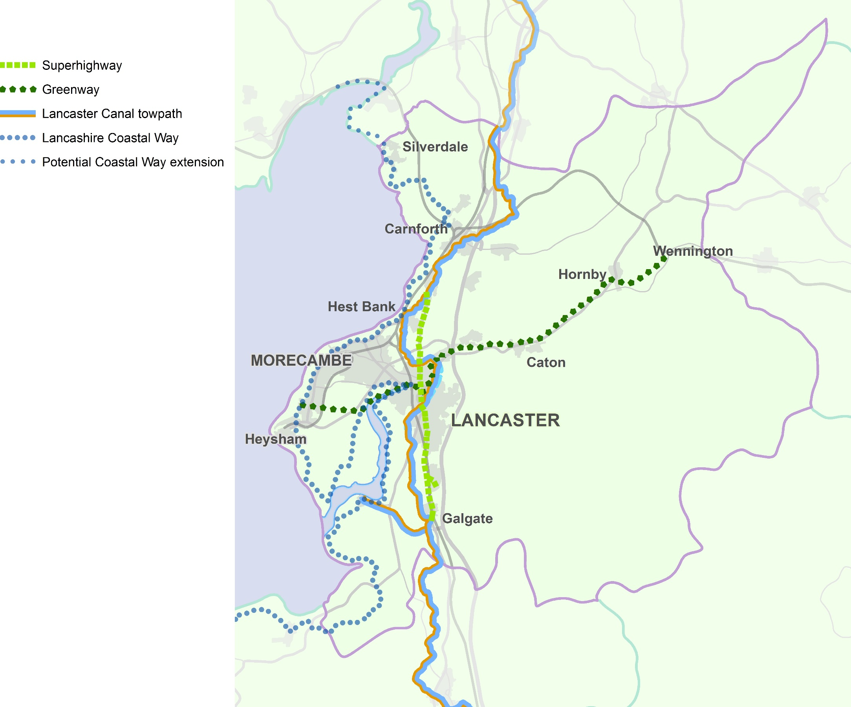

Ultra Low Lancaster

A district wide Ultra Low Emission Vehicle (ULEV) Strategy
To complement our proposals for better public transport and cycling/multiuser networks, we want to make the district an exemplar of why ULEVs must also be a core part of any local transport strategy. Whilst ULEVs may not reduce traffic numbers, they will be vital in reducing the emissions from the residual traffic in the city centre; a major factor in improving air quality and making the city centre a healthier and more pleasant place for people.

There are now few people who would argue that our society's current dependence on the car is sustainable. However, there will always be people who need to use a car and for who it would be difficult if not impossible to provide other transport that was as cost effective and functional, particularly those with mobility issues and those who live in very rural areas.

The car is therefore a crucial part of any sustainable highways and transport network, whether for private or business use. Likewise, vans and HGVs will be irreplaceable forms of transport for the foreseeable future and we are encouraging bus use.

All these vehicles have the same issues though; they cause congestion, they are resource hungry in their construction and they cause significant pollution. We therefore need to view all motor vehicles, regardless of how they are powered, in the same way we regard other undesirable but inescapable aspects of society and establish a hierarchy of use minimisation.

The hierarchy that has driven transport strategy in Lancashire for many years is:

- Minimise use – walk or cycle where possible
- Use public transport where possible
- Use motor vehicles only when there is no choice.

However, at least as far as local pollution is concerned, not all vehicles are created equal. ULEVs may be no better than their more traditional cousins in most regards, but they do at least have few or no tail pipe emissions.

The other major benefit of ULEVs are that, although they are currently more expensive to buy, they are much, much cheaper to run; pure electric vehicles in particular cost a fraction of what it costs to keep a conventional car on the road and fuelled. In the

longer term electric vehicles could keep car ownership affordable for those who need them if the relatively expensive purchase cost reduces and oil prices increase again.

The existing hierarchy therefore needs to be modified:

- Don't use a motor vehicle unless you need to
- Use ULEV public transport (buses then taxis) if you can
- Use any other public transport (buses then taxis)
- Use a ULEV
- Use conventional vehicles only if there is no choice.

ULEVs are a new technology and as with anything new and a bit different, it takes time and patience to make adopting the new a routine choice. Getting to the point at which ULEVs are normal on our roads will not happen quickly without help.

However, by making ULEV vehicles a) more common and b) giving them preferential treatment, we want to dramatically increase their uptake.

There are a number of potential strands to this:

- Buses – ULEVs on services working in the city centre, particularly on the Park and Ride service and future 'Lancaster Reach' bus rapid transit services;
- Taxis – ULEV taxis supporting access to the city centre, with local policies favouring them;
- Vans and fleet vehicles – ULEVs working in the city centre for maximum visibility and maximum benefit to reduced emissions;
- Car clubs in areas of Lancaster dependent on access via the city centre – access that other vehicles could potentially be denied;
- Car clubs to provide access across the city centre;
- Car clubs tied to Park and Ride and to rural centres, to make commuting as sustainable as possible – potentially with free Park and Ride use;
- Infrastructure - Charging points are key to establishing the market and are needed at car parks, rail stations and key business locations, but also at key locations in the rural areas;
- Infrastructure – the district's residents and businesses don't just travel in the district; key areas of influence including

Preston and South Lakes (for tourism and the domestic market) will need to have infrastructure in place as well;
- Infrastructure – households need to be able to charge vehicles at home; and
- Education – we can't rely on just making ULEVs more common, we need to actively make the case for change and make it easy for people to switch, via dedicated media and events.
Like all public sector initiatives, implementation of much of the strategy will be dependent on what funding we can source, but of all the proposals in the masterplan, this strategy probably has the widest range of partners who can bring resource to the projects. We want to work with our partners in local government, in health and with central government. We also want to work with private sector partners in the automotive industry, in public transport and with taxi operators and fleet managers.

Our engagement with a variety of partners has already begun. In December 2015, along with Lancaster City Council and Stagecoach, we were successful in securing a bid for £288,150 from the Department for Transport's Clean Bus Technology Fund. The bid aims to modify 17 buses with new technology to reduce NOx emissions by at least 50%. The buses that will be modified will operate on the 2, 2A. 2X and 3 services operating from Heysham/Morecambe to Lancaster University. These services provide a service every 10 minutes and travel round the Lancaster gyratory system, as a result of this, the modifications will impact the most on the Lancaster Air Quality Management Area.

The County Council has until now watched the developing ULEV market in order to ensure that our limited resources were not spent on infrastructure that was underutilised and, potentially, out of date when the ULEV did finally take off.

Record sales of electric cars now being recorded quarter by quarter. We therefore feel that, in Lancaster, the time and place are right to develop a strategy that will eventually help to guide the take up of ULEVs across the county and our own take up of electric fleet vehicles.

Lancashire County Council has secured funding from the Department for transport to install 150 electric vehicle charging points across Lancashire by March 2018, some of which will be located in Lancaster district.

Next Steps

This masterplan represents the beginning of a programme of highways and transport infrastructure delivery to serve the district of Lancaster over the next 15 years and beyond.

There is much to do and it will need the commitment and efforts of a variety of providers to see it through – County and District Councils, Lancashire’s Local Enterprise Partnership, Highways England, Network Rail - and the support of the private sector and developers as well.

To stand the best chance of delivery, we must get these proposals ‘ready to roll’ as soon as we can, so that we can take all opportunities to get funding for schemes that are ready to deliver. That will mean committing time and funding upfront to working up these ideas and preparing the economic case for them.

The proposals in this masterplan will affect us all. They will support and safeguard Lancaster's economic ambitions, relieve congestion, offer real choice in the way we travel, improve our health and enrich our experience in our city and town centres.

Delivery and funding of the masterplan will rely on a number of infrastructure providers and a variety of funding sources, and we will be working closely with these partners to make sure there is the guarantee of their support and assistance, with funding to follow.

Crucial to all this will be the support of residents and businesses. Too often attempts to deliver growth and new development have failed without the buy in and full support of the communities affected. We have the opportunity to make significant and long-term improvements, backed by substantial investment, to the district of Lancaster's highways and transport system.

Securing Developer Contributions
The cost of delivering the package of measures identified in this masterplan, and those that will come out of the work we propose to do, cannot be borne entirely by public sector funding. We have shown that, in areas where we can come to rely on the development industry to contribute funding to new infrastructure, we can increase investor confidence and our ability to attract other sources of funding, and in turn improve the prospects of delivery, and delivering to earlier timescales.

Investment in major new infrastructure will, increasingly, need to demonstrate an economic justification. In practice, this means a clear strategy towards bringing forward integrated development proposals for new development and economic growth alongside the infrastructure to support it. In order to deliver on our proposals, it is vital that local authorities take every opportunity to coordinate their development planning strategies with future infrastructure investment, and pursue and pool together contributions from the development industry.

The speed and certainty with which we will be able to implement new infrastructure will be directly linked to developer contributions.

Indicative Milestones
(LCC = Lancashire County Council)
Project | Delivery Agency | 2016/17 | 2017/18 | 2018/19 | 2019/20 | 2020/21 | 2021/22 | 2022/23 | 2023/24 | 2024 and beyond
Heysham to M6 Link Road  (Bay Gateway) | LCC | Road Open  Autumn 2016
Lancaster City Action Plan | LCC | Action Plan  produced | On-going Implementation through works arising from Lancaster City Movement Strategy |  |  |  |  |  |  | Works complete 2025/26
Caton Road Gateway:  M6 Junction 34 Park and Ride/Cycle | LCC/Operator | Open  Autumn 2016
HGV Movement Strategy | LCC | Strategy  Consultation | Strategy Implementation
Lancaster City Council Air Quality Action Plan | LCC/City Council | Air Quality Study initiated | Baseline assessment | Identify measures/  evaluate impacts | AQAP adopted | Monitor outcomes
Lancaster City Place Shaping:  Lancaster City Movement Study | LCC/City Council |  | Data Collection, Options Identification and Appraisal, Consultation |  | Design, Business Case and Funding |  | Works start |  |  | Works complete in 2025/26
Lancaster Reach Bus Rapid Transit Network | LCC/PT Operators | Feasibility Study completed | Project Development and Consultation |  | Design, Business Case and Funding |  | Works start |  | Works complete and services operational
Lancaster South Supporting Infrastructure:  Reconfiguration of M6 Junction 33 | LCC/HE | Initial feasibility completed | Data Collection, Options Appraisal and Consultation |  | Design, Business Case and Funding |  | Works start | Works complete
Lancaster South Supporting Infrastructure:  Local Road Network | LCC | Local Plan Consultation  Early 2017 | Local Plan Submission to SoS November 2017 | Local Plan Adopted September 2018 | Progress dependent on development of Bailrigg Garden Village concept
A6 Hala Road Junction Improvement | LCC | Design and Consultation | Works completed
A6 South Lancaster to City Centre Route Management Plan | LCC | Options Identification and Appraisal, Consultation |  | Design and Funding | Works start |  | Works complete
Ultra-Low Lancaster:  A district wide Ultra Low Emission Vehicle (ULEV) Strategy | LCC/City Council | Clean Bus Technology Implementation Starts |  |  |  |  |  |  | Implementation complete
Greyhound Bridge Major Maintenance Scheme | LCC
Morecambe Place Shaping | LCC/City Council/  Developer | Implementation starts |  |  |  |  |  |  | Implementation complete
Morecambe Bay Connectivity Study (including Carnforth Railway Station) | LCC/Cumbria CC/  Network Rail/  Train Operators |  | Study completed | Implementation will depend on an assessment of potential options
Heysham to Lancaster Greenway Route | LCC |  | Works complete
South Heysham Highway Network Review | LCC |  | Review completed
Carnforth Place Shaping | LCC/City Council |  |  |  | Option Identification and  Consultation | Design and Funding | Works  complete
Lancaster Links Integrated Multi-use/Cycling Network | LCC/City Council

Funding
(All figures £m and indicative)
Project | 2016/17 | 2017/18 | 2018/19 | 2019/20 | 2020/21 | 2021/22 | 2022/23 | 2023/24 | Total | Comments
Lancaster City Action Plan | Revenue Funding |  |  |  |  |  |  |  |  | Implementation through works arising from Lancaster City Movement Strategy.
Caton Road Gateway:  M6 Junction 34 Park and Ride/Cycle |  |  |  |  |  |  |  |  |  | Infrastructure cost included in Heysham to M6 Link Road scheme.
HGV Movement Strategy |  | 0.25 |  |  |  |  |  |  | 0.25 | LCC commitment.
Lancaster City Council Air Quality Action Plan | Revenue Funding
Lancaster City Place Shaping:  Lancaster City Movement Study |  | Revenue Funding |  | 3.5 | 4.0 | c10.0 | c10.0 | c10.0 | c57.5 | Works to continue in 2024/25 and 2025/26 at c£10m per annum. Final outturn cost dependent on scale of works and full delivery dependent on securing future Department for Transport local major transport scheme funding.
Lancaster Reach Bus Rapid Transit Network |  | Revenue Funding |  | 0.75-3.0 | 0.75-3.0 | 7.5-15 | 7.5-15 |  | c16.5-36 | Final outturn cost dependent on scale of works and full delivery dependent on securing future Department for Transport local major transport scheme funding.
Lancaster South Supporting Infrastructure:  Reconfiguration of M6 Junction 33 |  | Revenue Funding |  | 1.4-2.5 | 1.4-2.5 | c18.6-27.5 | c18.6-27.5 |  | c40-60 | Final outturn cost dependent on option and delivery subject to securing Growth Deal, developer and/or Road Investment Strategy funding.
Lancaster South Supporting Infrastructure:  Local Road Network |  |  |  | Spend profile dependent on development of Bailrigg Garden Village concept |  |  |  |  | c22.0 | Final outturn cost subject to Garden Village design considerations and delivery subject to developer funding. Assumes two crossings of the West Coast Main Line required.
A6 Hala Road Junction Improvement |  | 0.7 |  |  |  |  |  |  | 0.7 | LCC commitment.
A6 South Lancaster to City Centre Route Management Plan |  |  | 1.0 | 3.0 | 3.0 | 3.0 |  |  | c10.0 | Final outturn cost dependent on scale of works and full delivery may be dependent on securing developer contributions and future integrated transport block allocations.
Ultra-Low Lancaster:  A district wide Ultra Low Emission Vehicle (ULEV) Strategy | On-going revenue and capital requirement.  Cost subject to final design and delivery dependent on securing funding |  |  |  |  |  |  |  |  | Final outturn cost unknown.
Greyhound Bridge Major Maintenance Scheme
Morecambe Place Shaping | 0.2 |  |  |  |  |  |  |  | 0.2 | LCC Commitment 2016/17, full delivery subject to developer commitment and future integrated transport block allocations.
Morecambe Bay Connectivity Study (including Carnforth Railway Station) |  | 0.15 |  |  |  |  |  |  | 0.15 | Funding not yet committed. Potential for a financial contribution from Cumbria CC. Any interventions requiring capital funding to be included in a future revision of this masterplan.

Project | 2016/17 | 2017/18 | 2018/19 | 2019/20 | 2020/21 | 2021/22 | 2022/23 | 2023/24 | Total | Comments
Heysham to Lancaster Greenway Route | 0.4 |  |  |  |  |  |  |  | 0.4 | LCC commitment
Carnforth Place Shaping |  |  |  |  | 1.0 | 1.0 |  |  | 2.0 | Delivery subject to securing developer contributions and future integrated transport block allocations.
Total | 0.6 | 1.1 | 1.0 | 8.65-12.0 | 10.15-13.5 | c40.1-56.5 | c36.1-52.5 | c10.0 | c149.7-189.2 | Includes £20m post 2023/24

Appendix 1: Heysham to M6 Link Road
Complementary Measures

The Lancashire County Council (Torrisholme to the M6 Link
(A683 Completion of Heysham to M6 Link Road))
Order 2013

Schedule 2: Requirements

Highway approvals and complementary measures

10 – (1) No part of the authorised development is to commence until details of the proposed improvements to Junction 34 of the M6 Motorway as shown in outline on the special roads plan have been submitted in writing to, and approved in writing by, the Secretary of State for Transport.

    - The details to be submitted under sub-paragraph (1) must include:

(a) details of the interface between the link road and the existing highway alignment;
(b) details of the carriageway markings and lane destinations;
(c) details of drainage, maintenance access, visibility zone requirements, service ducts, signage and lighting;
(d) confirmation of compliance with the current Design Manual for Roads and Bridges (DMRB) and all other Department for Transport standards or with approved relaxations or departures from such standards;
(e) independent stages one and two road safety audits carried out in accordance with current DMRB standards and advice notes, stage two to take into account any recommendations of the stage one road safety audit; and
(f) a project appraisal report pursuant to the New Approach to Appraisal guidance.

(3) No part of the link road is to be opened to vehicular traffic until the highway works approved in accordance with sub-paragraph (1) have been constructed.

(4) The link road must not be opened to vehicular traffic until gateway markings or rumble strips have been marked out on the surface of the A6 to the south of Slyne with Hest village in a position to be first approved in writing by the relevant planning authority.

(5) The Park and Ride site at Junction 34 of the M6 motorway must be completed and available for use before the link road is fully opened to vehicular traffic. The Park and Ride site is to be brought into use when available road space is created on Caton Road but not more than 1 month after the link road has been fully opened. Appropriate supportive priority measures for bus services linking the Park and Ride site to Lancaster City Centre must be implemented within 12 months of the link road being fully opened to traffic.

(6) The link road must not be fully opened to vehicular traffic until an action plan of complementary traffic measures has been submitted to and approved in writing by the relevant planning authority, which must have regard to the findings of Lancaster and Morecambe Vision Board Study and include:

(a) a review of the City Centre gyratory systems;
(b) an investigation into the extension of the proposed Park and Ride network beyond the site at Junction 34 of the M6 Motorway;
(c) a detailed feasibility study for a rapid transit route from Lancaster city centre, rail station and bus station to Morecambe and Heysham; and
(d) a schedule of those measures that are to be implemented.

The action plan must aim to prevent road traffic growth within the central Lancaster area increasing to predicted “do minimum” levels between the opening and design years of the link road (thereby negating planned relief) and contain a timetable for implementation of the measures to be carried out.

(7) The complementary traffic measures set out in the schedule to the action plan approved in accordance with sub-paragraph (6) must be carried out in accordance with the approved timetable or no later than 10 years of the opening of the link road whichever is the earlier.

(8) The link road must not be fully opened to vehicular traffic until the undertaker has completed statutory consultation upon a proposal to make a traffic regulation order prohibiting HGVs from roads forming part of the A6 in central Lancaster and along the A589 Morecambe Road east of the link road, except for access.

Appendix 2: Glossary

Air Quality ~ the condition of the air around us. Pollution is often a cause of poor air quality.

Air Quality Management Area – This is a location were pollutants in the air exceed those stated within the National Air Quality Strategy for England and Wales.

Carbon Emissions ~ carbon dioxide (CO2) and carbon monoxide (CO) produced by vehicles and industrial processes.

CIL/S106 Developer Funding ~ when new developments are planned, the developer may be required to make a payment towards facilities including transport schemes, flood defences, schools, health and social care facilities, green spaces and leisure centres. This was formerly through ‘Section 106' agreements but is now through the Community Infrastructure Levy (CIL).

Congestion
The definition of congestion used in this document is shown in the table below and is based on the comparison of observed average peak hour speeds (Monday to Thursday during term time) and off-peak (00:00 to 05:00) free flow speeds.

Peak hour speed <30% of free flow speed | Severe congestion
Peak hour speed between 30 and 60% of free flow speed | Congestion
Peak hour speeds >60% of free flow speed | No congestion

Core Strategy ~ the key compulsory local development document specified in United Kingdom planning law. It sets out the vision, objectives, strategy and policies that will manage development and use of land in an area. Every other local development document is built on the principles set out in the core strategy, regarding the development and use of land in a local planning authority’s area.

Economic Development ~ long term actions to improve the standard of living and economic health of an area. Actions can involve many areas including education, infrastructure, competitiveness, environmental sustainability, social inclusion and health.

Flood Zone 2 ~ the wider area of an extreme flood from rivers or the sea.
These are areas which could be affected by a major flood, with up to a 0.1 per cent (1 in 1000) chance of occurring each year.

Flood Zone 3 ~ the area that could be affected by flooding, if there were no flood defences. This area could be flooded:
• From the sea by a flood that has a 0.5 per cent (1 in 200) or greater chance of happening each year;
• or from a river by a flood that has a 1 per cent (1 in 100) or greater chance of happening each year.

Green Belt ~ an area of open countryside or farmland between urban areas, where development is restricted to limit urban growth and prevent separate urban areas joining together over time.

High Speed Rail ~ High Speed 2 (HS2) will be the UK’s new high speed rail network, built initially between London and Birmingham. Phase 2 of HS2 will extend the route to Manchester and Leeds.

Highway Authority ~ an organisation legally responsible for looking after the highway network (roads, footways and cycle ways) in an area and which has certain legal powers as a result. In Lancashire, the County Council is the highways authority for most roads in the county.

Infrastructure ~ the basic facilities needed for society to function, such as roads, railways, communications systems, electricity, gas and water supplies, and public buildings including schools.

Integrated Transport (IT) Block ~ Government capital funding provided to County and Unitary Councils for support for small-scale transport improvement schemes.

Lancashire Enterprise Partnership (LEP) ~ a public/private sector partnership which provides leadership for the county’s economy and therefore has an important role in directing local economic development activity for job creation and growth.

Local Development Framework (LDF) ~ a set of documents setting out the policies and plans which will shape how an area develops and which make up the local plan for a local planning authority’s area.

Local Sustainable Travel Fund ~ a government fund to support measures to encourage economic growth and reduce carbon emissions.

Local Transport Plan ~ a statutory document that sets out how the County Council will provide sustainable and accessible transport capable of supporting the county’s economic growth over the next few years and beyond.

Nature Conservation Value ~ areas of the natural environment with valuable habitats or plant or animal species to be protected and enhanced that need to be considered by a planning authority when they are preparing their local plan and making decisions on planning applications.

Park and Ride ~ a system for reducing urban traffic congestion in which drivers leave their cars in parking areas on the outskirts of a town or city and travel to the city centre on public transport. Most park and ride is bus based; rail based sites are usually called ‘Parkways’.

Rolling Stock ~ the carriages and wagons that make up a train. The quality and capacity (the number of people or quantity of goods that can be carried) of rolling stock affects the level of service on a route.

Spatial Planning ~ how the public sector influences the distribution of people and activities in an area. It includes land use planning, urban planning, transport planning and environmental planning. Other related areas are also important, including economic development and community development. Spatial planning takes place on local, regional, national and international levels.

Strategic Location ~ a general location in a spatial plan where land has been allocated for major development, such as for housing or employment, but where there is as yet no detail of that development.

Sustainable ~ in this masterplan, sustainable means something that “meets the needs of the present without compromising the ability of future generations to meet their own needs”. Making plans, policies and schemes sustainable means balancing environmental, social and economic issues.

